μCap meeting PSI, Sept. 2003
draft 3-Oct-03

Introduction
The contributions to this meeting will be posted on MuCap page link run7/mumeet03.
This is a draft version. The meeting was informal with the following general agenda.

Time | Topic
Friday morning | Status & plans hydrogen chambers
Friday afternoon | Status of present run
Saturday morning | Planning for two independent TPC systems

Friday morning
- ePC2: Johny reported about significant progress with the ePC2. After N₂, removal of HV cards and careful conditioning with new gas, the chamber is operating at 2.5kV with 50nA. The bad sectors are located (about 2); the chamber will be opened next week. The total estimated time for getting it ready is about 2 months. Peter offered to try to fix the HV cards in Illinois or produce new ones. UIUC and G. Petrov will jointly instrument the ePC during an estimated one-month work period at PSI. For assembling the final MuCap e-Det staging space with DAQ access is required in spring 04.
- MuPC2 and TPC: Claude and Johny reported Progress, problems and plans for the PSI TPC project.
- Alexei reported status and progress of the PNPI wire chamber, gas circulation system and the isotope purification project. During the last half year the PNPI workshop continued construction of the gas circulation system parts: the bodies of three adsorbers-compressors, flanges and vessels for mounting of the cryogenics parts. Also, the two support units were constructed for mounting the full system. The design of the electronics for gas circulation system was continued and some equipment was ordered using the CRDF budget. PNPI prepared one hydrogen isotopes separation column for production of deuterium-depleted water. This column was used earlier with the opposite goal, for heavy water cleaning. During more than a month flushing by normal water the admixture of deuterium in the columns water decreased from 20% up to ~ 50 ppm. The next step was accumulation of the appropriate amount of protium water with deuterium admixture level near ~10 ppm for last step cleaning. The analysis of this water showed the level of deuterium (11.4 +/- 1.0) ppm. The protium gas produced by the old hydrogen generator from this water showed the level of deuterium (14.3+/- 1.5) ppm. This indicated that our protium production system became much cleaner after deuterium pollution in the last year but require continued cleaning. Now PNPI accumulated ~ 5 l very pure water with calculated purity ~ 0.1- 0.3 ppm. A special analysis is required. The production of the cathodes and anodes glass frames for the TPC2-detector was continued. We are planning to finish production the sets for two TPC units. The clean room is under construction for TPC assembling. A new vacuum pump system has been borrowed for spring 03. The goal of PNPI is to commission all these projects by May 03, so that they can be shipped to PSI afterwards.
- Gas purity in present run: Oleg presented his FADC analysis conc. capture yield, indication of impurity increase by a factor of 2 over a few days and drift time versus amplitude plots. In the earlier data the amplitude was nearly independent from drift time, whereas later it seemed to have a kink toward higher amplitudes at smaller drift distances. The direct comparison with TDC data is possible now with synchronous data, as demonstrated by Steve's new program in the afternoon. There was a discrepancy between capture yields in the TDC and FADC analyses, which was later traced to normalization problems of the FADC data. Given the fact that the last hydrogen filling was polluted at the ppm level due to the damaged Pd filter, an increase of the capture rate with time would indicate additional serious pollution not compatible with vacuum outgasing measurements and should be further analyzed. The need for analysis by the chemists and their presence for the next run were stressed.

Friday afternoon
The afternoon started with an extended discussion of our current information on muon stopping with the TPC and the earlier range measurements. This was triggered by Peter's table below, which shows that the observed stops in the TPC fall significantly short of the proposal values.
 | proposal |  | this run
 | factor | rate | factor | rate | ev/day (M) | 20day (B)
mu |  | 30000 |  | 20000 | 1728 | 34.6
tpc stops | 0.8 | 24000 | 0.3 | 6000 | 518 | 10.4
electrons | 0.665 | 15960 | 0.66 | 3960 | 342 | 6.8
PU | 0.4 | 6384 | 0.5 | 1980 | 171 | 3.4
DAQ | 1 | 6384 | 0.8 | 1584 | 137 | 2.7
mu- | 0.5 | 3192 | 0.5 | 792 | 68 | 1.4
Steve presented observed stopping distributions, Peter calculations and range measurements. At this point it is not completely clear where and why we lose. A very preliminary accounting would try to explain
- 30% losses due to muon range reduction when passing through wires
- 30% losses due to multiple scattering
- 30% stops in the TPC fiducial volume.
These numbers, however, are far from final. As regards 1) we can test that by running briefly without mPC1 and reduce it with cathode foil chambers. As regards 2) Be or Kapton windows were discussed. A more drastic approach was suggested by Peter, by eliminating mPC2 (which had troubles during this run) and building a re-entrant pipe as close as possible to the TPC. The mPC2 then would be a specially constructed standard gas MWPC located as closely as possible to the window. We decided that the new PNPI flange and mPC2 will be constructed according to this idea. As regards the window Goodfellow offers a 75um Havar foil and Claude offered to buy 2 15x15cm2 foils for 12 windows next year. Earlier purchase by other collaboration members is being discussed, so that PNPI can start testing the window system.
After this discussion we went through the status of the various subsystems. First analysis results were presented by Tom and Steve.

Saturday morning
Saturday morning was devoted to a thorough discussion of the critical TPC systems. It is clear to everybody, that a TPC failure during a run can set us back by a full year and cause significant expenses. Thus we have to try to get two independent systems ready and be able to switch between them within a week or so.
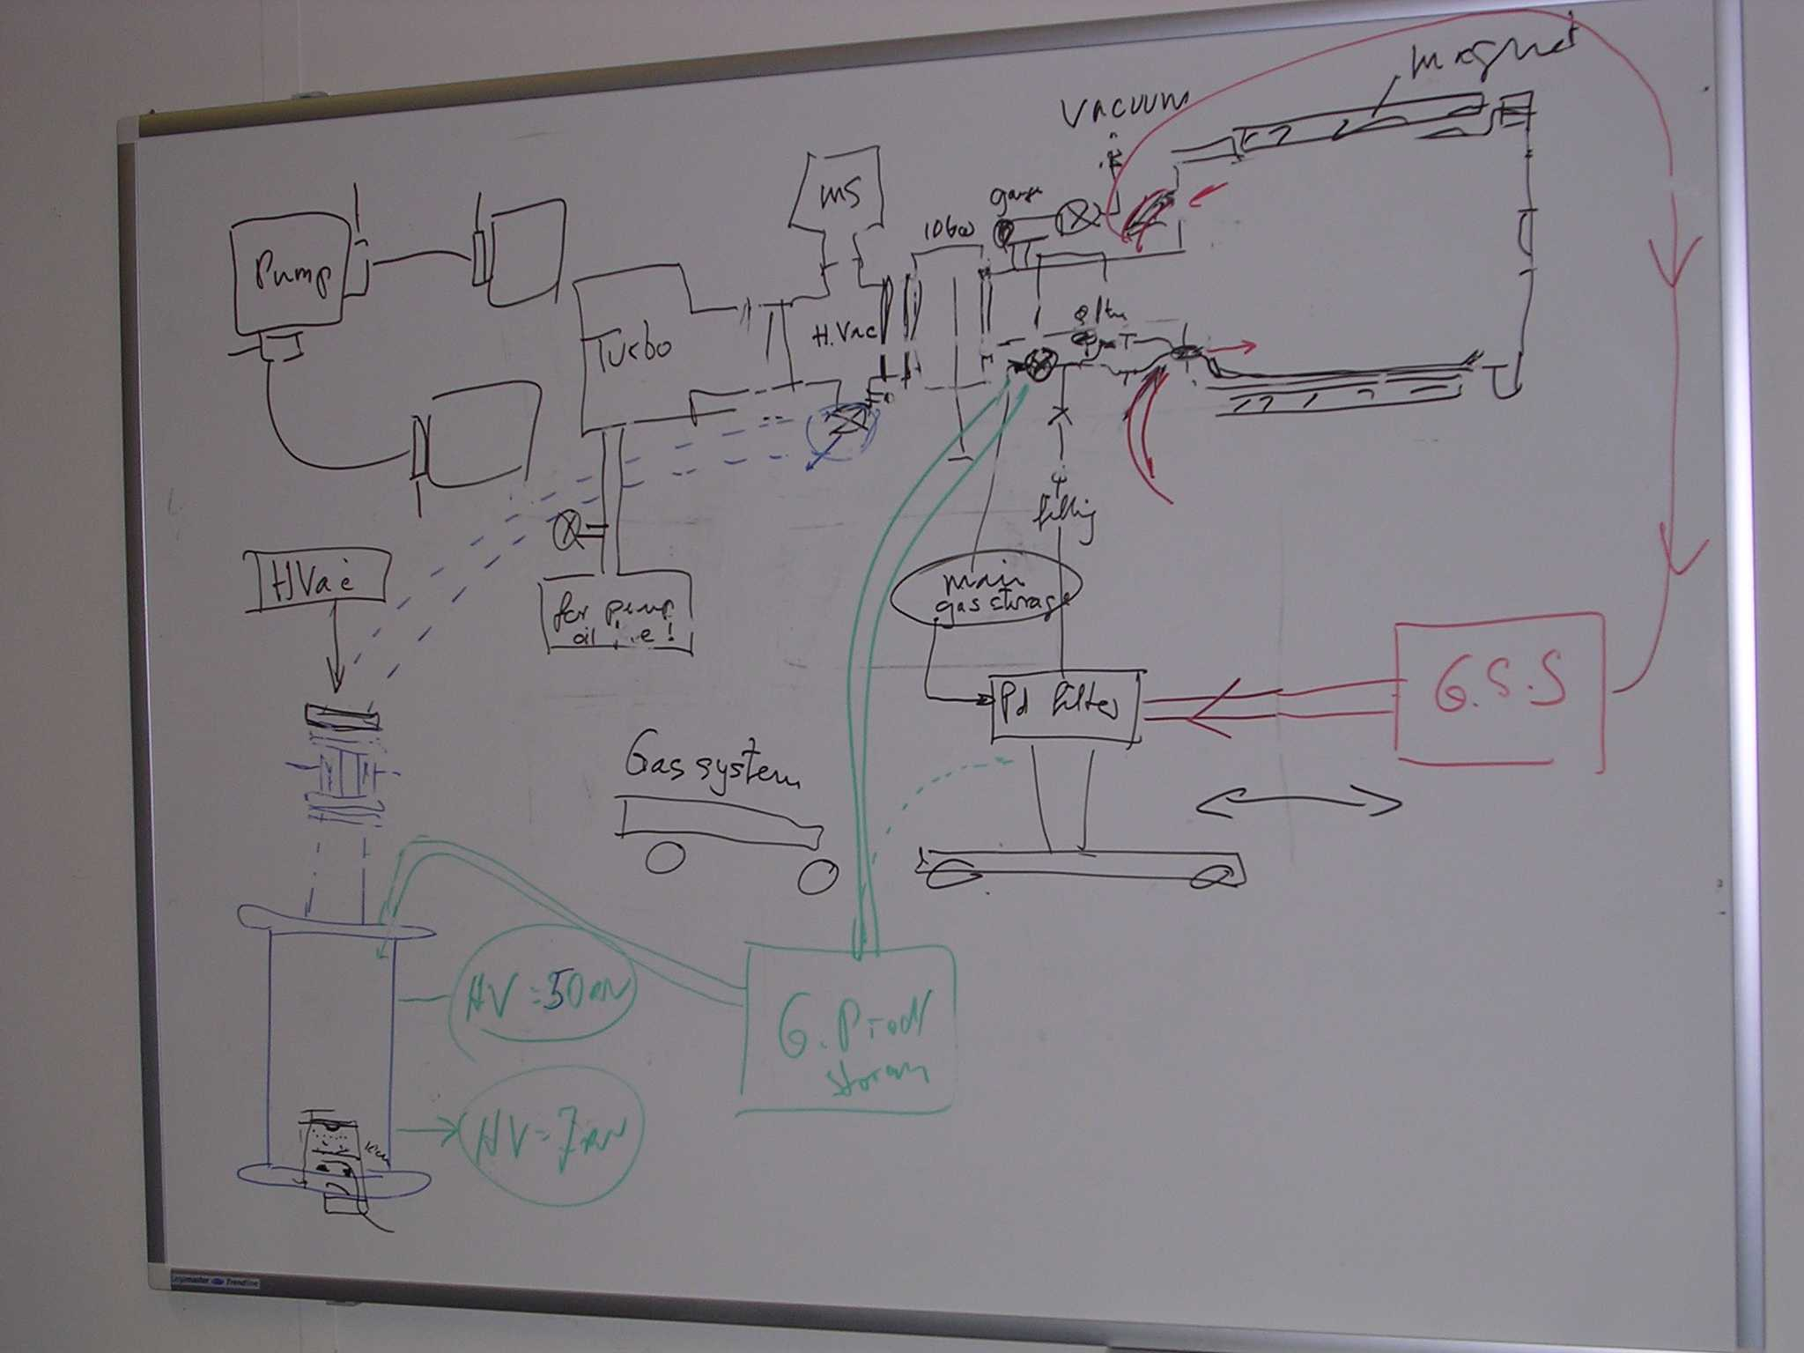
Figure 1: Claude's drawing of the gas system
We discussed the list of current bottlenecks in the independent testing and conditioning of the PSI and PNPI TPC. The main one is the high vacuum system. After Claude described the present high vacuum system and Alexei presented plans how to combine the two systems, the collaboration agreed that two independent vacuum systems should be the goal. In addition to decoupling the TPC efforts, a second vacuum system would also provide a backup of a critical component for the experiment.
The main cost items for achieving that are
- Turbo pump (Claude offered to refurbish and clean a pump he has)
- Oil-free forepump ( This has to be bought, perhaps by special fund from the Russian Academy)
- 40 kV HV system (though not ideal, we discussed the possibility of sharing one device for the beginning)
- Miscellaneous valves
Peter reminded that Tim has offered financial support for the gas system.

Task list
task | who | comment
Summary of world experience hydrogen MWPV | PNPI, PSI
Capture analysis | Steve, Oleg | Compare FADC and TDC
Capture analysis | Steve, Tom, Oleg | Systematic time dependence
Amplitude - driftime | Oleg | Is kink real?
ADC system for detector group | PSI, Peter | Plans and coordination
Forepump | Genna S. | Can this be bought by PNPI?
Second vacuum system | PNPI | Establish detailed list of items and prices so that purchase can be coordinated
Vacuum window | Peter | Try to find sponsor
Vacuum/filling system | Evgenny, Claude | document and prepare drawing
Purification system PNPI | Genna | document

Next year's schedule and beam request
Beam has to be requested in January 04. We are considering 10 weeks for a run.

