Errant muon catcher

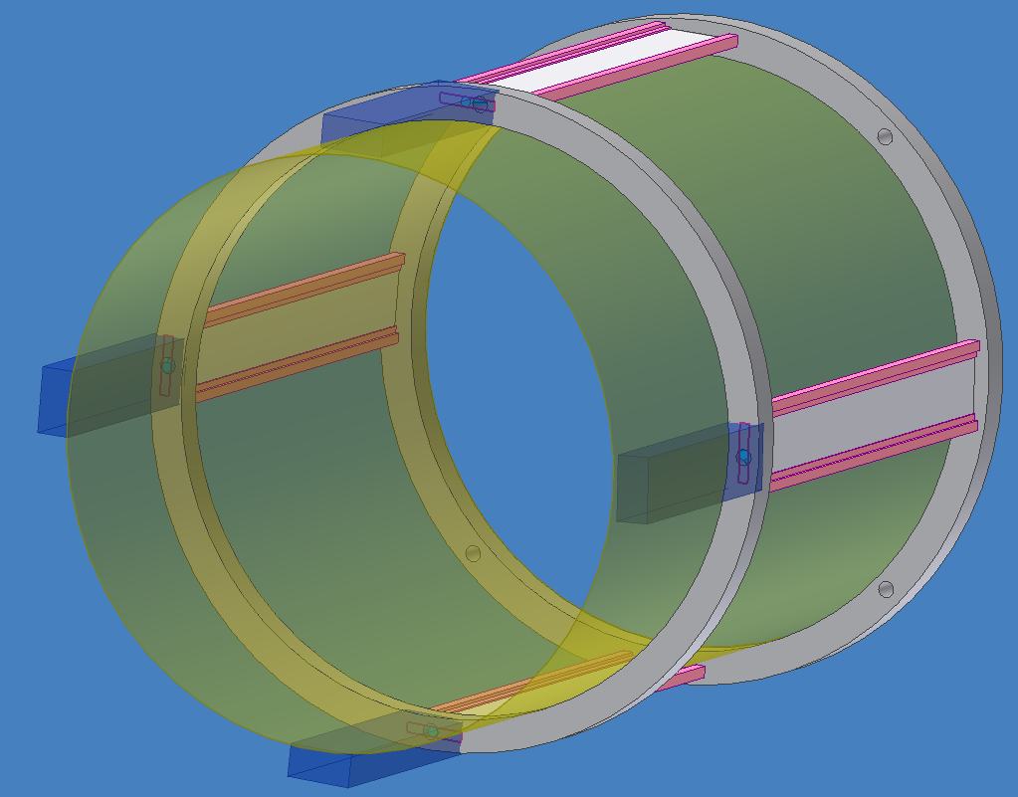
Overview: 0.5 mm scintilator, plastic support and rings, APD box. ID covered with AK3 foils with slits over scintillator. Rohacell cylinder?

Key issue is resolution of thin scintillator with APD. Small readout electronics. Mechanics Boston. Michel background. Perp. to beam more difficult.

