Muon-on-Request 2005
update 10/13/05
The following parameters determine the performance of the Muon-On-Request Scheme for MuCap.

On average we will wait T_{on}=1/R_{m} for the next muon. We have to see if we can improve our beam tune to achieve R_{m}=0.1 MHz, without compromising beam quality. Once the entrance counter detected a hit, the gate is closed within d= (d_{switch}+ d_{cable} = 200 ns + 200ns). The overall T_{on} time must be 500 ns (Mike says about 400ns), which is nearly no additional constraint as the delay is already about 400 ns. From the kicker design d_{switch}=200ns, dominated by the optical switch. The d_{cable} is a conservative estimate for discriminator and cable delay.
Because of the delayed gate closing, the probability for a 2nd muon with d is P_{d}=R_{m} d. The probability for a 2nd muon within the measuring interval is P_{m}= e R_{m} T_{off}, where e is the extinction. Both probabilities are quite acceptable, even with conservative assumptions.
As regards systematics we have to be careful about the following points:
- kicker induced electronic pick-up.
Investigate signals after kicker, beta source/pulser time distribution after kicker etc. This can be measured without beam.
- difference of accidentals within d
The pile-up protection within d is purely electronic with the muSC/muPC combination. Then, for a short time the beam is steered into the pipe before closed off. The effect of these steps can be checked by closing the kicker without incident muon signal and observing the background. The measurement procedure is similar to the previous point, but in the latter case we need real beam.
- different muon background during T_{on}.
There might be more stray muons stopping upstream of muSC or unseen by muSC, which generate delayed electron background with time structure. The measurement of this effect is similar to the 2nd point.
As we don’t know R_{m} yet, let’s plot R_{meas} (= observed decay electrons) as function of R_{m}.The figure illustrated three cases, immediate measurement after mustop, measurement starts 500 ns after mustop (avoiding the d period) and DC mode with pile-up protection.
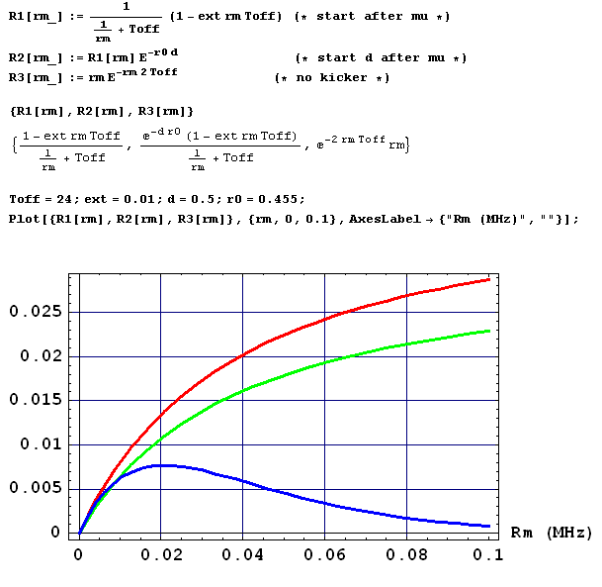
Red is R1 (start after mu signal), Green R2 (start after kicker closed) and Blue R3 (DC with ±Toff pile-up protection). The kicker gain is pretty dramatic.
A typical pulse sequence would be
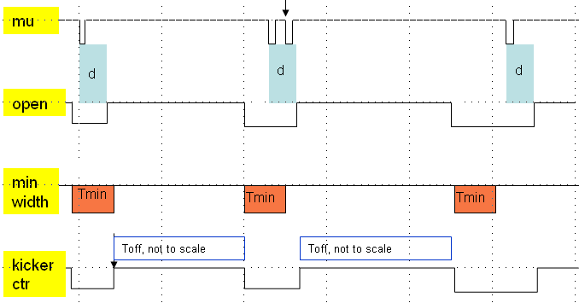
The first pulse shows an example, where the open signal is too short. The kicker control is the OR of this signal with the min width signal. The kicker is reset only after the min width signal is gone.
The second example shows 2 muon pulses within the kicker off delay. This event has to be rejected off line.
The third example is a normal pulse sequence for Muon-On-Request.

Additional thoughts, comments are welcome.

