Kicking with dispersive focus
Peter Kammel

Transport studies
Starting from JTR I tried to make a dispersive focus changing Q1-Q3. Mainly I was watching the effect of focusing on x’ and x in the kicker region, also on the transmission. Setting the focus exactly on the FS1 position deteriorates the beam properties, so I focused slightly in front of the slit. Also I tried to optimize with Q7 and Q9, with rather small effect. The present result of this exercise is called PTR.
Next I used a more iconoclastic approach, allowing for chromaticity. As this tune is optimized for narrow momentum acceptance, this deficiency might me acceptable. In this case I can make a focus at FS1 and obtain pretty impressive beam parameters. The trick is reducing Q7 strength to shift the x focus before B2 to a better position. This tune is called PTRC.
Finally, study ptrc1 shows that it is relatively straightforward to increase the acceptance of the channel in this tune.
The properties of the new tunes are described in the following table and figures.
Results for δp/p=1% (we assume FS1 is used to define the momentum band). Quad fringe field corrections are ignored to be consistent with REVMOC. Pole face curvature is turned on. Tuning simply for SLXY and F focus.

 | jtr | ptr | prtc
X @ FS1 δp=0 | 5.7 | 1.6 cm | 1.4
X,X’ @ KICK | 9.8 cm, 9.7 mrad | 21.6 cm , 8.2 mrad | 21 cm , 6.6 mrad
X,Y SLIT | 1. cm, 1.4 cm | 1.5 cm, 2.1 cm | 1.2 cm, 1.8 cm
X,Y TARGET | 1.3 cm, 2.2 cm | 2. cm, 3.1 cm | 1.72 cm, 2.46 cm
Relative Transmission  @ SLIT from REVMOC | 0.209 | 0.114 | 0.101

PS at key locations of prtc
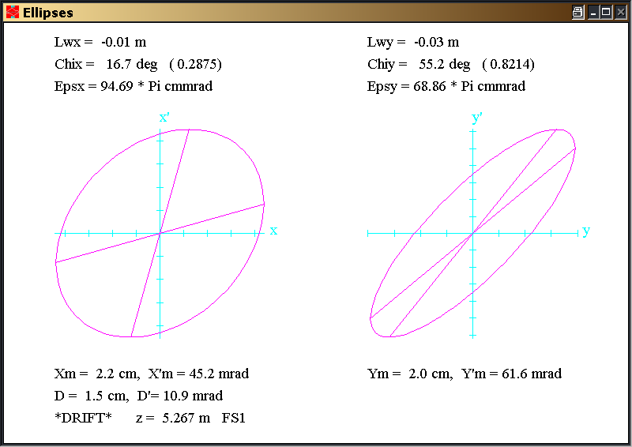 | 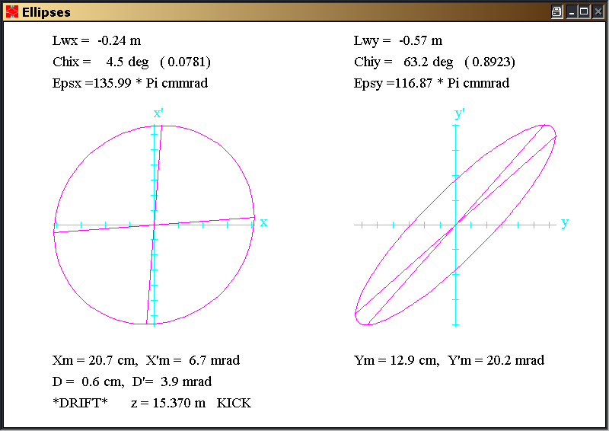
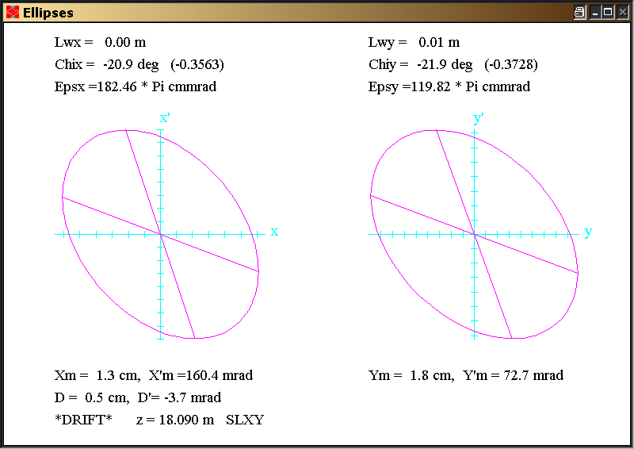 | 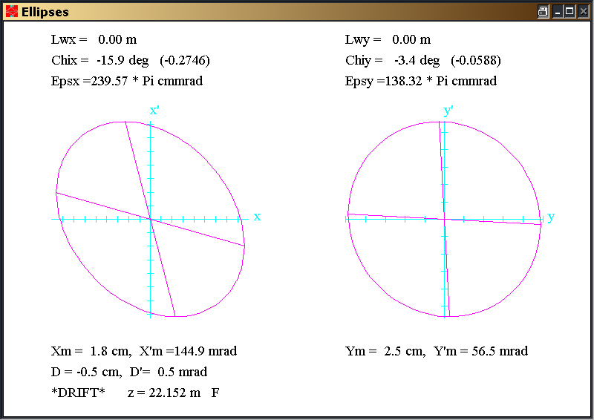
Jtr

sin-cos

ptr (first and second order envelopes)

sin-cos
*QUAD* Q1 0.474 m 0.5700 kG 12.00 cm
*QUAD* Q2 0.474 m -0.3800 kG 12.00 cm
*QUAD* Q3 0.474 m 0.1100 kG 12.00 cm
*QUAD* Q4 0.390 m 0.6309 kG 12.50 cm
*QUAD* Q5 0.390 m -0.4574 kG 12.50 cm
*QUAD* Q6 0.390 m -0.2720 kG 12.50 cm
*QUAD* Q7 0.390 m 0.5230 kG 12.50 cm
*QUAD* Q8 0.314 m -0.2600 kG 12.90 cm
*QUAD* Q9 0.314 m 0.2710 kG 12.90 cm
*QUAD* Q10 0.314 m -0.4770 kG 12.90 cm
*QUAD* Q11 0.314 m 0.7937 kG 12.90 cm
*QUAD* Q12 0.314 m -0.4770 kG 12.90 cm
*QUAD* Q13 0.366 m 0.5473 kG 12.70 cm
*QUAD* Q14 0.366 m -0.8473 kG 12.70 cm
*QUAD* Q15 0.366 m 0.5473 kG 12.70 cm

/*PLOT* ptr/
0
1.000000 ' ' 0.30000 150.00000 2.00000 30.00000
0.00000 1.00000 0.02800;
17. ' ' ;
3.0 ' ' 0.59750;
5.00 'Q1 ' 0.47400 0.57 12.00000;
3.0 ' ' 0.12000;
5.00 'Q2 ' 0.47400 -0.38 12.00000;
3.0 ' ' 0.62000;
5.00 'Q3 ' 0.47400 0.11 12.00000;
3.0 ' ' 0.72130;
16. 'KR1E' 12.0 -0.9 ;
16. 'KR1A' 13.0 1.0 ;
16.00 ' ' 5.00000 9.00000;
16.00 ' ' 7.00000 0.30000;
16.00 ' ' 8.00000 2.80000;
2.0 ' ' 24.00000;
4.000 'B1 ' 0.65950 1.48302 0.00000;
2.0 ' ' 24.00000;
3.0 ' ' 0.40330;
3.0 'SEX1' 0.32000;
3.0 'FS1 ' 0.40350;
3.0 ' ' 0.14500;
5.00 'Q4 ' 0.39000 0.63094 12.50000;
3.0 ' ' 0.21000;
5.00 'Q5 ' 0.39000 -0.45737 12.50000;
3.0 'FS2 ' 0.13300;
3.0 ' ' 0.20000;
5.00 'Q6 ' 0.39000 -0.27195 12.50000;
3.0 ' ' 0.21000;
5.00 'Q7 ' 0.39000 0.523 12.50000;
3.0 ' ' 0.82850;
3.0 'SEX2' 0.32000;
3.0 ' ' 0.37630;
20.0 ' ' 180.00000;
16. 'KR2E' 12.0 -0.4 ;
16. 'KR2A' 13.0 4.0 ;
16.00 ' ' 5.00000 9.00000;
16.00 ' ' 7.00000 0.340000;
16.00 ' ' 8.00000 2.80000;
2.0 ' ' 22.65000;
4.000 'B2 ' 0.69420 1.40891 0.00000;
2.0 ' ' 12.85400;
20.0 ' ' 180.00000;
-10. 1.0 6.0 0.0 .0001 /B16/ ;
-10. 2.0 6.0 0.0 .0001 /B26/ ;
3.0 ' ' 1.23620;
5.00 'Q8 ' 0.31400 -0.26 12.90000;
3.0 ' ' 0.21700;
5.00 'Q9 ' 0.31400 0.271 12.90000;
3.0 ' ' 0.64500;
3.0 'SEPA' 1.00000;
3.0 ' ' 0.70000;
3.0 'KICK' 1.00000;
3.0 ' ' 0.58600;
5.00 'Q10 ' 0.31400 -0.4770 12.90000;
3.0 ' ' 0.19600;
5.00 'Q11 ' 0.31400 0.7937 12.90000;
3.0 ' ' 0.19600;
5.00 'Q12 ' 0.31400 -0.4770 12.90000;
3.0 'SLXY' 0.80000;
-10. 2. 1. 0.0 .0001 /W21/ ;
-10. 4. 3. 0.0 .0001 /W43/ ;
3.0 ' ' 1.20000;
5.00 'Q13 ' 0.36600 0.5473 12.70000;
3.0 ' ' 0.13200;
5.00 'Q14 ' 0.36600 -0.8473 12.70000;
3.0 ' ' 0.13200;
5.00 'Q15 ' 0.36600 0.5473 12.70000;
3.0 'F ' 1.50000;
10. 2. 1. 0.0 .0001 /W21/ ;
10. 4. 3. 0.0 .0001 /W43/ ;
-10. -3.0 4.0 0.0 .0001 /R34/ ;
-10. -1.0 2.0 0.0 .001 /R12/ ;
SENTINEL
SENTINEL

Ptrc (first and second order)
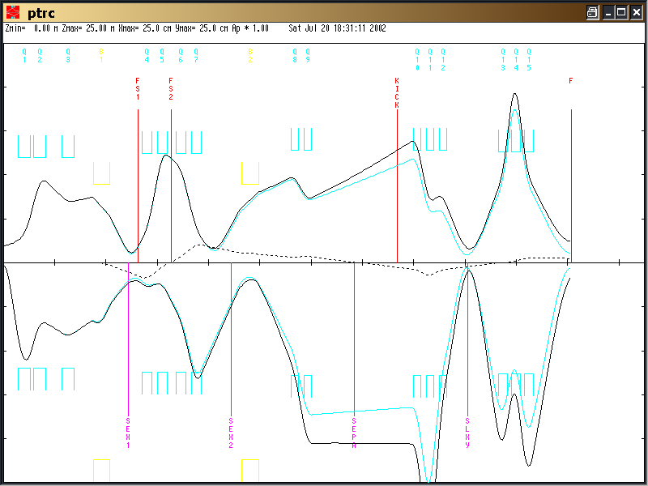

sin-cos
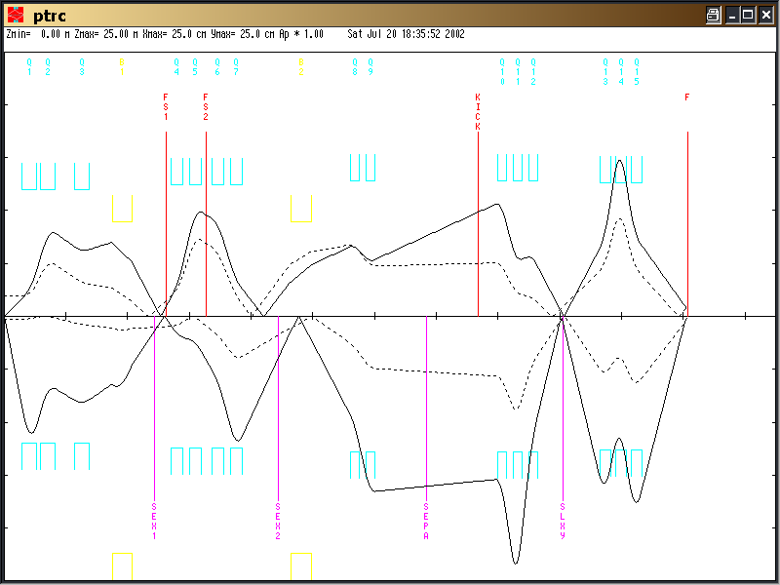
/*PLOT* ptrc/
0
1.000000 ' ' 0.30000 150.00000 2.00000 30.00000
0.00000 1.00000 0.02800;
17. ' ' ;
3.0 ' ' 0.59750;
5.00 'Q1 ' 0.47400 0.57 12.00000;
3.0 ' ' 0.12000;
5.00 'Q2 ' 0.47400 -0.39 12.00000;
3.0 ' ' 0.62000;
5.00 'Q3 ' 0.47400 0.11 12.00000;
3.0 ' ' 0.72130;
16. 'KR1E' 12.0 -0.9 ;
16. 'KR1A' 13.0 1.0 ;
16.00 ' ' 5.00000 9.00000;
16.00 ' ' 7.00000 0.30000;
16.00 ' ' 8.00000 2.80000;
2.0 ' ' 24.00000;
4.000 'B1 ' 0.65950 1.48302 0.00000;
2.0 ' ' 24.00000;
3.0 ' ' 0.40330;
3.0 'SEX1' 0.32000;
3.0 'FS1 ' 0.40350;
3.0 ' ' 0.14500;
5.00 'Q4 ' 0.39000 0.63094 12.50000;
3.0 ' ' 0.21000;
5.00 'Q5 ' 0.39000 -0.45737 12.50000;
3.0 'FS2 ' 0.13300;
3.0 ' ' 0.20000;
5.00 'Q6 ' 0.39000 -0.27 12.50000;
3.0 ' ' 0.21000;
5.00 'Q7 ' 0.39000 0.45 12.50000;
3.0 ' ' 0.82850;
3.0 'SEX2' 0.32000;
3.0 ' ' 0.37630;
20.0 ' ' 180.00000;
16. 'KR2E' 12.0 -0.4 ;
16. 'KR2A' 13.0 4.0 ;
16.00 ' ' 5.00000 9.00000;
16.00 ' ' 7.00000 0.340000;
16.00 ' ' 8.00000 2.80000;
2.0 ' ' 22.65000;
4.000 'B2 ' 0.69420 1.40891 0.00000;
2.0 ' ' 12.85400;
20.0 ' ' 180.00000;
-10. 1.0 6.0 0.0 .0001 /B16/ ;
-10. 2.0 6.0 0.0 .0001 /B26/ ;
3.0 ' ' 1.23620;
5.00 'Q8 ' 0.31400 -0.26 12.90000;
3.0 ' ' 0.21700;
5.00 'Q9 ' 0.31400 0.31 12.90000;
3.0 ' ' 0.64500;
3.0 'SEPA' 1.00000;
3.0 ' ' 0.70000;
3.0 'KICK' 1.00000;
3.0 ' ' 0.58600;
5.00 'Q10 ' 0.31400 -0.4644 12.90000;
3.0 ' ' 0.19600;
5.00 'Q11 ' 0.31400 0.7844 12.90000;
3.0 ' ' 0.19600;
5.00 'Q12 ' 0.31400 -0.4644 12.90000;
3.0 'SLXY' 0.80000;
-10. 2. 1. 0.0 .0001 /W21/ ;
-10. 4. 3. 0.0 .0001 /W43/ ;
3.0 ' ' 1.20000;
5.0A 'Q13 ' 0.36600 0.5473 12.70000;
3.0 ' ' 0.13200;
5.01 'Q14 ' 0.36600 -0.8473 12.70000;
3.0 ' ' 0.13200;
5.0A 'Q15 ' 0.36600 0.5473 12.70000;
3.0 'F ' 1.50000;
10. 2. 1. 0.0 .0001 /W21/ ;
10. 4. 3. 0.0 .0001 /W43/ ;
-10. -3.0 4.0 0.0 .0001 /R34/ ;
-10. -1.0 2.0 0.0 .001 /R12/ ;
SENTINEL SENTINEL
prtc1
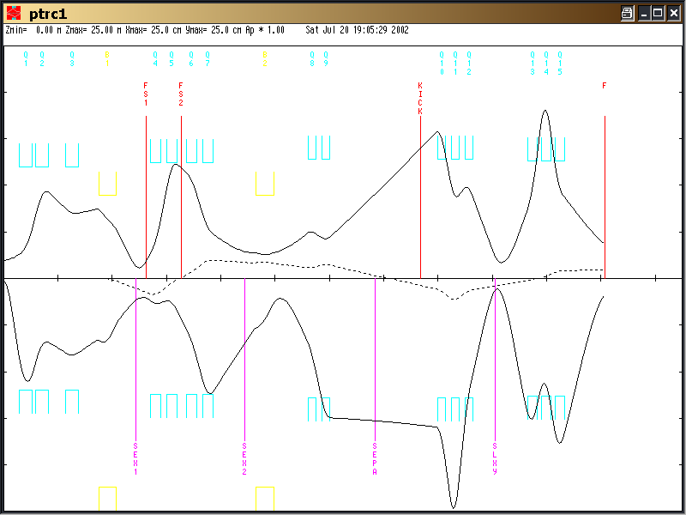

Revmoc studies
The 3 tunes were studied with REVMOC. For JTR and PTR the results agree with the transport expectations. It appears that low momenta for JTR can be cut at SF1. Momentum definition are much better for PTR, also kickability looks as good as JTR. Probably the channel momentum has to be tuned somewhat higher to make optimal use of PTR’s momentum selection.
PTRC looks much worse in REVMOV than in TRANSPORT. If I did not make a mistake, it clearly shows the price to be paid for residual achromaticity, also the transmission is not impressive.
The detailed figures and input5 files are given below.

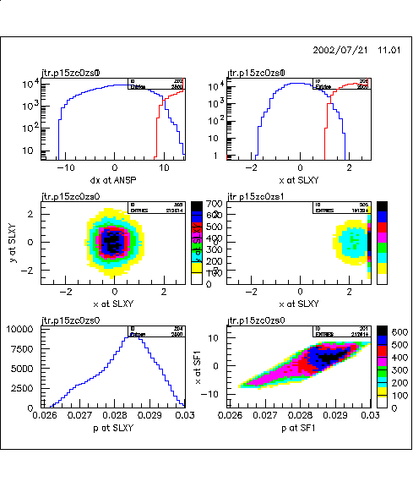
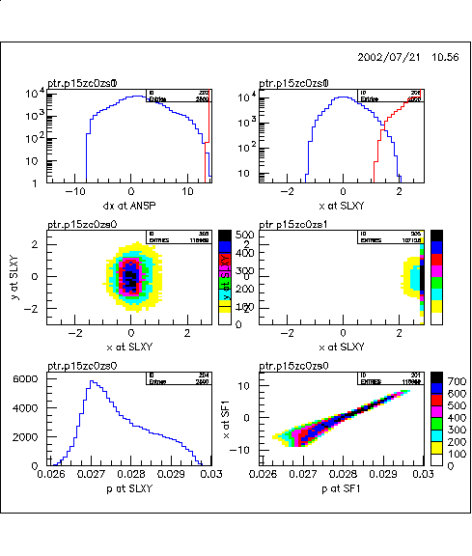
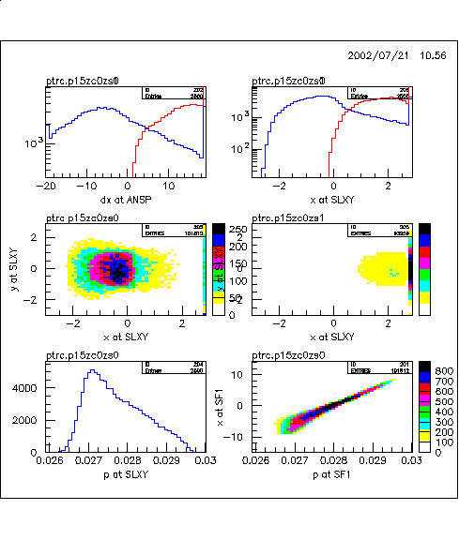

1 ptr
T T .00001 0.00001 0. 0. 0. 0.00
D BEG 0.00001 100.
D 0.59750 11.40
D AQ1 0.00001 11.40
QUAD Q1 0.47400 0.57 12.00
D 0.00001 11.40
D 0.12000 11.40
QUAD Q2 0.47400 -0.38 12.00
D 0.00001 11.40
D 0.62000 11.40
QUAD Q3 0.47400 0.11 12.00
D 0.00001 11.40
D 0.72130 15.00 -15.00 8.50 -8.50
FRIN 9.00 0.3 2.8
ENTR 24.0
BEND B1 0.65950 1.48302 0. 0. 0.028
EXIT 24.0
D 0.00001 15.00 -15.00 8.50 -8.50
D 0.40330 11.900
SEXT SEX1 0.320000 0.00000 12.50
D 0.00001 11.900
D 0.40350 11.900
D SF1 0.00001 9.10 -9.10 9.10 -9.10
D 0.14500 11.90
QUAD Q4 0.39000 0.63094 12.50
D 0.00001 11.90
D 0.21000 11.90
QUAD Q5 0.39000 -0.45737 12.50
D 0.00001 11.90
D 0.1330 11.90
D 0.00001 9.10 -9.10 9.10 -9.10
D 0.20000 11.90
QUAD Q6 0.39000 -0.27195 12.50
D 0.00001 11.90
D 0.21000 11.90
QUAD Q7 0.39000 0.523 12.50
D 0.00001 11.90
D 0.82850 11.90
SEXT SEX2 0.32000 0.00000 12.50
D 0.3763 15.00 -15.00 8.50 -8.50
ROTATE 180.
FRIN 9.00 0.34 2.8
ENTR 22.65
BEND B2 0.69420 1.40891 0. 0. 0.028
EXIT 12.854
D 0.00001 15.00 -15.00 8.50 -8.50
ROTATE 180.
D 1.23620 12.30
QUAD Q8 0.31400 -0.26 12.90
D 0.00001 12.30
D 0.21700 12.30
QUAD Q9 0.31400 0.271 12.90
D 0.00001 12.30
D 0.64500 6.5 -6.5 10.0 -10.0
SEP POSI 0.700 0.0 0.0 0.0 0.0 0.0 0.0 0.0
D 0.00001 6.5 -6.5 10.0 -10.0
D 1.00000 7.5 -7.5 10.0 -10.0
SEP KICK 1.00 0.0 0.0 0.0 0.0 0.0 0.0 0.0
!SEP KICK 1.00 1.5 0.0 0.0 0.0 0.0 0.0 0.0 ! kick on
D 0.00001 7.5 -7.5 10.0 -10.0
D ANSP 0.58600 12.30
QUAD Q10 0.31400 -0.4770 12.90
D 0.00001 12.30
D 0.19600 12.30
QUAD Q11 0.31400 0.7937 12.90
D 0.00001 12.30
D 0.19600 12.30
QUAD Q12 0.31400 -0.4770 12.90
D 0.00001 12.30
D SLXY 0.80000 11.0 -11.0 15. -15.
!D SLXY 0.80000 1.0 -1.0 2.5 -2.5 ! collimator active
D 1.20000 12.1
QUAD Q13 0.36600 0.5473 12.70
D 0.00001 12.10
D 0.13200 12.10
QUAD Q14 0.36600 -0.8473 12.70
D 0.00001 12.10
D 0.13200 12.10
QUAD Q15 0.36600 0.5473 12.70
D AQ15 0.00001 12.10
D F 1.50000 100.
XSIZE 0.6001 400.00001
YSIZE 4.0001 100.00001
P 0.02800 0.0042 0.028 .00001 0. 0.00
!P 0.02800 0.0000 0.028 .00001 0. 0.00 ! zero delta
MASS * .105659 0. 0. 1000000.
1. .05
GROUP 1. 1000.000 0. 0.0 0. 1.
NSPAC 10. -1.
2. 2. 2. 2. 2. 2. 2. 2. 2. 2.
P SF1 50. 0.0042 0.028
X SF1 50. 30.
X ANSP 50. 20.
DX ANSP 50. 30.
P ANSP 50. 0.0042 0.028
DX ANSP 50. 60.
P SLXY 50. 0.0042 0.028
X SLXY 50. 4.
X SLXY 50. 6.
Y SLXY 50. 6.
X SLXY 50. 6.
X F 50. 10.
Y SLXY 50. 6.
Y F 50. 10.
X AQ15 50. 30.
X F 50. 10.
Y AQ15 50. 30.
Y F 50. 10.
DX ANSP 50. 60.
X SLXY 50. 6.
END

1 ptrc
T T .00001 0.00001 0. 0. 0. 0.00
D BEG 0.00001 100.
D 0.59750 11.40
D AQ1 0.00001 11.40
QUAD Q1 0.47400 0.57 12.00
D 0.00001 11.40
D 0.12000 11.40
QUAD Q2 0.47400 -0.39 12.00
D 0.00001 11.40
D 0.62000 11.40
QUAD Q3 0.47400 0.11 12.00
D 0.00001 11.40
D 0.72130 15.00 -15.00 8.50 -8.50
FRIN 9.00 0.3 2.8
ENTR 24.0
BEND B1 0.65950 1.48302 0. 0. 0.028
EXIT 24.0
D 0.00001 15.00 -15.00 8.50 -8.50
D 0.40330 11.900
SEXT SEX1 0.320000 0.00000 12.50
D 0.00001 11.900
D 0.40350 11.900
D SF1 0.00001 9.10 -9.10 9.10 -9.10
D 0.14500 11.90
QUAD Q4 0.39000 0.6309 12.50
D 0.00001 11.90
D 0.21000 11.90
QUAD Q5 0.39000 -0.4574 12.50
D 0.00001 11.90
D 0.1330 11.90
D 0.00001 9.10 -9.10 9.10 -9.10
D 0.20000 11.90
QUAD Q6 0.39000 -0.27 12.50
D 0.00001 11.90
D 0.21000 11.90
QUAD Q7 0.39000 0.45 12.50
D 0.00001 11.90
D 0.82850 11.90
SEXT SEX2 0.32000 0.00000 12.50
D 0.3763 15.00 -15.00 8.50 -8.50
ROTATE 180.
FRIN 9.00 0.34 2.8
ENTR 22.65
BEND B2 0.69420 1.40891 0. 0. 0.028
EXIT 12.854
D 0.00001 15.00 -15.00 8.50 -8.50
ROTATE 180.
D 1.23620 12.30
QUAD Q8 0.31400 -0.26 12.90
D 0.00001 12.30
D 0.21700 12.30
QUAD Q9 0.31400 0.31 12.90
D 0.00001 12.30
D 0.64500 6.5 -6.5 10.0 -10.0
SEP POSI 0.700 0.0 0.0 0.0 0.0 0.0 0.0 0.0
D 0.00001 6.5 -6.5 10.0 -10.0
D 1.00000 7.5 -7.5 10.0 -10.0
SEP KICK 1.00 0.0 0.0 0.0 0.0 0.0 0.0 0.0
!SEP KICK 1.00 1.5 0.0 0.0 0.0 0.0 0.0 0.0 ! kick on
D 0.00001 7.5 -7.5 10.0 -10.0
D ANSP 0.58600 12.30
QUAD Q10 0.31400 -0.4644 12.90
D 0.00001 12.30
D 0.19600 12.30
QUAD Q11 0.31400 0.7844 12.90
D 0.00001 12.30
D 0.19600 12.30
QUAD Q12 0.31400 -0.4644 12.90
D 0.00001 12.30
D SLXY 0.80000 11.0 -11.0 15. -15.
!D SLXY 0.80000 1.0 -1.0 2.5 -2.5 ! collimator active
D 1.20000 12.1
QUAD Q13 0.36600 0.5473 12.70
D 0.00001 12.10
D 0.13200 12.10
QUAD Q14 0.36600 -0.8473 12.70
D 0.00001 12.10
D 0.13200 12.10
QUAD Q15 0.36600 0.5473 12.70
D AQ15 0.00001 12.10
D F 1.50000 100.
XSIZE 0.6001 400.00001
YSIZE 4.0001 100.00001
P 0.02800 0.0042 0.028 .00001 0. 0.00
!P 0.02800 0.0000 0.028 .00001 0. 0.00 ! zero delta
MASS * .105659 0. 0. 1000000.
1. .05
GROUP 1. 1000.000 0. 0.0 0. 1.
NSPAC 10. -1.
2. 2. 2. 2. 2. 2. 2. 2. 2. 2.
P SF1 50. 0.0042 0.028
X SF1 50. 30.
X ANSP 50. 20.
DX ANSP 50. 40.
P ANSP 50. 0.0042 0.028
DX ANSP 50. 60.
P SLXY 50. 0.0042 0.028
X SLXY 50. 4.
X SLXY 50. 6.
Y SLXY 50. 6.
X SLXY 50. 6.
X F 50. 10.
Y SLXY 50. 6.
Y F 50. 10.
X AQ15 50. 30.
X F 50. 10.
Y AQ15 50. 30.
Y F 50. 10.
DX ANSP 50. 60.
X SLXY 50. 6.
END

Conclusions
In contrast to earlier concerns, this study suggests that a dispersively focused kicked beam seems feasible. This option should be studied experimentally and theoretically.

Further work
- We should check wether 2nd order optimization and inclusion of quad fringe field corrections makes any difference.
- The tunes should be compared with our standard tunes in turtle.
- We have to translate the jtr/ptr dimensions to our experimental geometry, in particular the last two triplets.
- Higher transmission studies should be performed, the poor REVMOC performance of JTRC should be understood better.

