Jaap’s report
discussion and some studies

http://ten.npl.uiuc.edu/~kammel/doc_mulan/

Peter Kammel

1 Transport studies 2
2 Revmoc studies 11
3 Peter’s tunes and variants 22
3.1 jt1.dat: simple improved jt tune 22
3.2 pnb.dat: new nb kick tune 23
3.3 pd.dat: increased transmission (?) jd tune 26
4 Conclusion and tuning strategy 30

Transport studies

Assumptions

- initial conditions

HWHM | x (cm) | x’ (mrad) | y (cm) | y’ (mrad) | δp
standard | 0.3 | 150 | 2 | 30 | 4
test | 0.5 |  | 3 |  | 0

- layout
  - standard two symmetric triplets
  - optional two doublets
- curvature of bends neglected, marginal
- no PSI fringe field corrections for quads

Strategy and Performance

- beam properties at end of kicker, second order waist (i.e. dependent on δp assumption)

HWHM | x | x’ | y | y’
1st order | 6.1 | 7.8 | 7.7 | 26.1
2nd order | 16.5 | 10.4 | 19.3 | 52.5

- chromatic second order corrections important, geometric aberrations small
- sextupoles turned off, introduce large non-chromatic aberrations
- beam properties at SLXY

HWHM | x | x’ | y | y’
1st order | 0.56 | 80.4 | 0.96 | 62
2nd order | 3.0 | 151 | 3.01 | 67

- beam properties at F

HWHM | x | x’ | y | y’
1st order | 0.54 | 84 | 0.84 | 70
2nd order | 3.72 | 171 | 5.44 | 85

Comments

- chromatic 2nd order dominant, optimization in 2nd order necessary
- SLXY and F not perfect waist
- non bend plane needs study
- SLXY focus condition: x(SLXY)=R12 x’(KICK), R11=0
in 1st order independent of R12 !

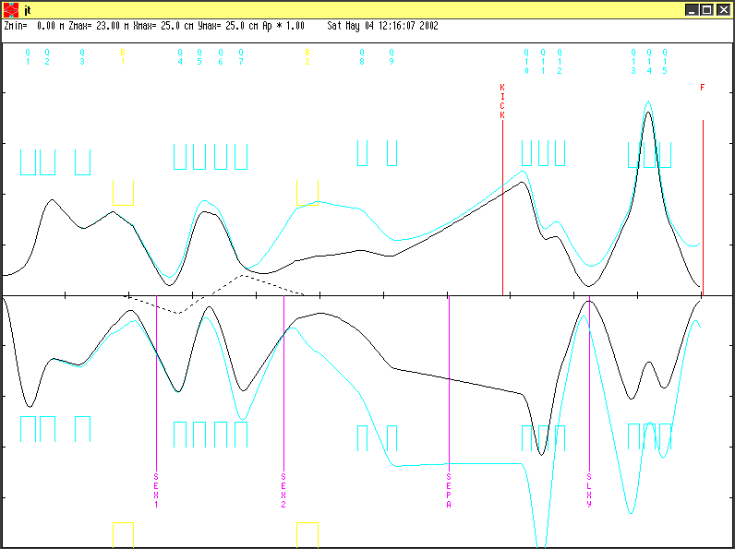

Figure 1: jt.dat, first and second order

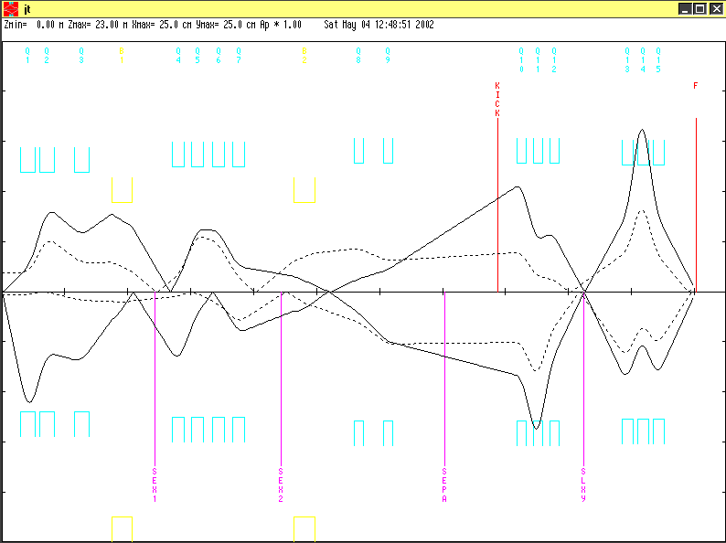
Figure 2: sin/cos, first order

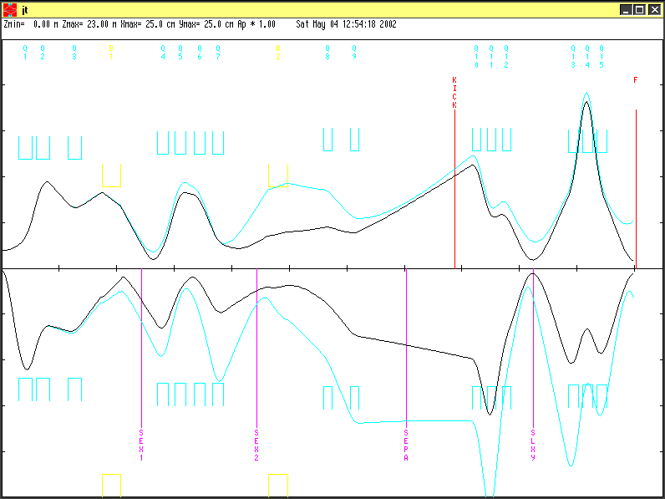
Figure 3: p HWHM=4 %, 0%

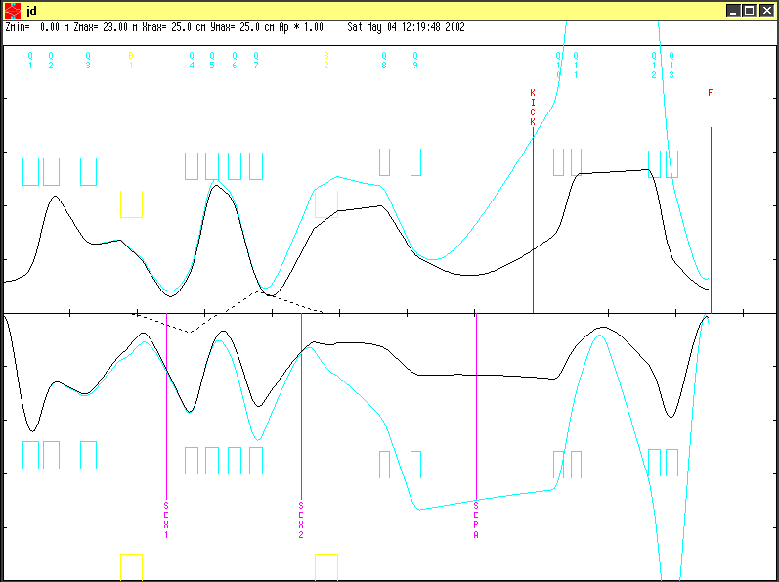

Figure 4: jd.dat, first and second order
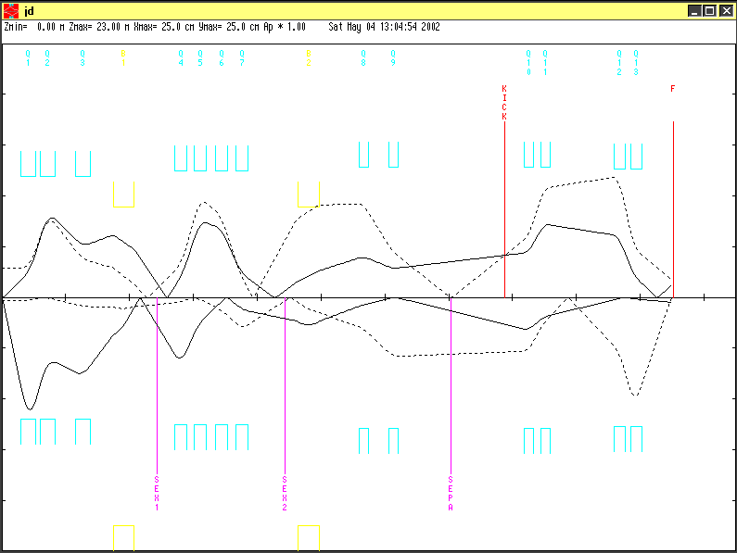
Figure 5: sin/cos

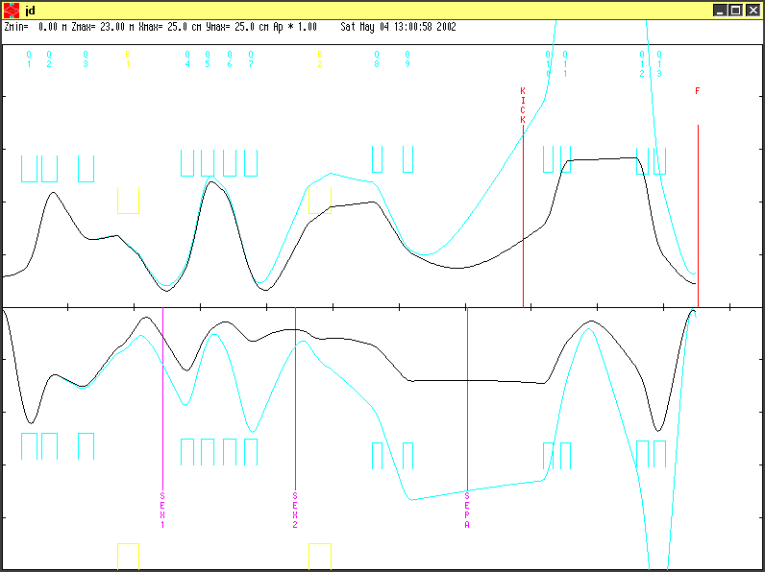

Figure 6: 4/0 % HWHM p

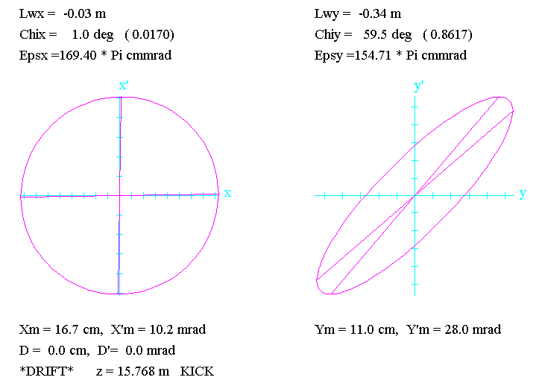
Kick
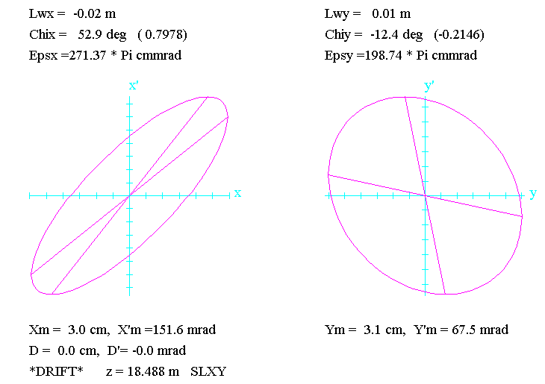
SLXY

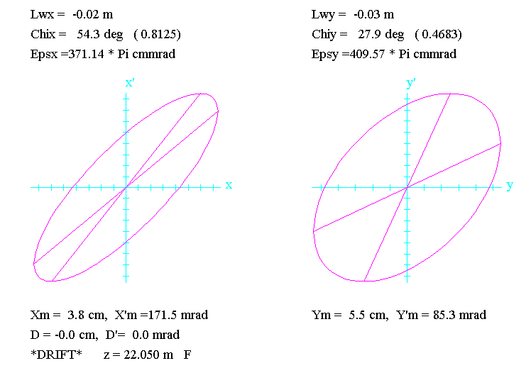
F

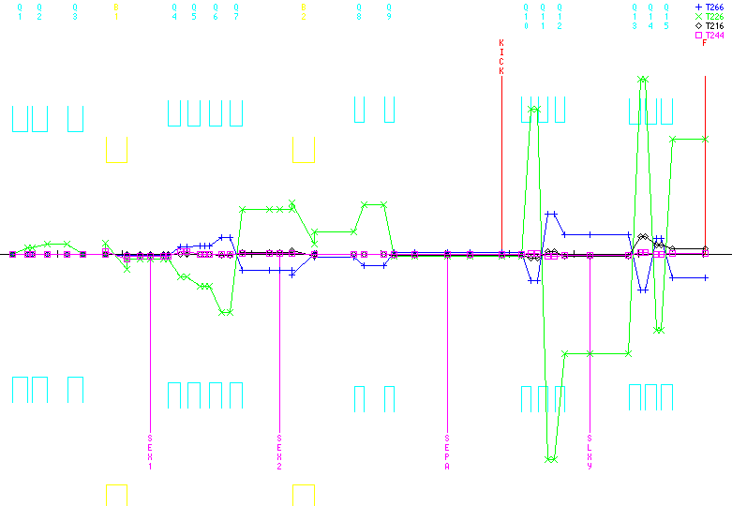
Figure 7: jt tune, selected T2jk
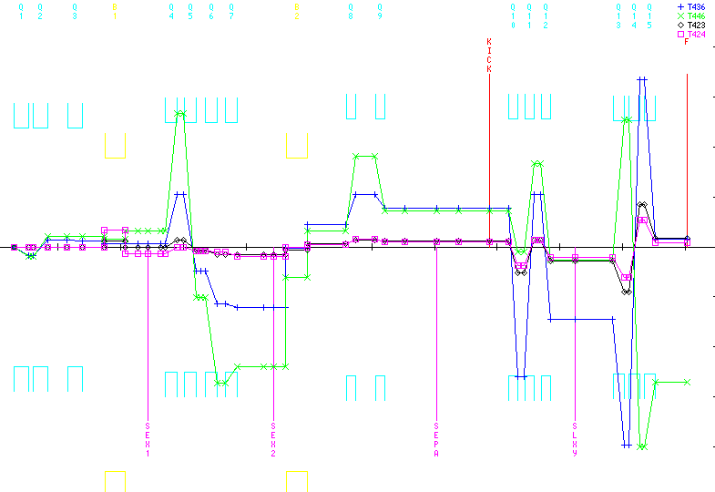
Figure 8: jt tune, selected T4jk
/*PLOT* jd/
0
1.000000 ' ' 0.30000 150.00000 3.00000 30.00000
0.00000 4.00000 0.02800;
17. ' ' ;
3.0 ' ' 0.59750;
5.00 'Q1 ' 0.47400 0.59112 12.00000;
3.0 ' ' 0.11950;
5.00 'Q2 ' 0.47400 -0.43200 12.00000;
3.0 ' ' 0.62000;
5.00 'Q3 ' 0.47400 0.18584 12.00000;
3.0 ' ' 0.72130;
16.00 ' ' 5.00000 9.00000;
16.00 ' ' 7.00000 0.30000;
16.00 ' ' 8.00000 2.80000;
2.0 ' ' 24.00000;
4.000 'B1 ' 0.65950 1.48302 0.00000;
2.0 ' ' 24.00000;
3.0 ' ' 0.40130;
3.0 'SEX1' 0.32000;
3.0 ' ' 0.41350;
3.0 ' ' 0.13500;
5.00 'Q4 ' 0.39000 0.63212 12.50000;
3.0 ' ' 0.21000;
5.00 'Q5 ' 0.39000 -0.45737 12.50000;
3.0 ' ' 0.14150;
3.0 ' ' 0.14150;
5.00 'Q6 ' 0.39000 -0.27195 12.50000;
3.0 ' ' 0.26000;
5.00 'Q7 ' 0.39000 0.52178 12.50000;
3.0 ' ' 0.82850;
3.0 'SEX2' 0.32000;
3.0 ' ' 0.37630;
20.0 ' ' 180.00000;
2.0 ' ' 22.65000;
4.000 'B2 ' 0.69420 1.40891 0.00000;
2.0 ' ' 12.85400;
20.0 ' ' 180.00000;
3.0 ' ' 1.23620;
5.00 'Q8 ' 0.31400 -0.21759 12.90000;
3.0 ' ' 0.61700;
5.00 'Q9 ' 0.31400 0.20785 12.90000;
3.0 ' ' 0.64500;
3.0 'SEPA' 1.00000;
3.0 ' ' 0.70000;
3.0 'KICK' 1.00000;
3.0 ' ' 0.58600;
5.00 'Q10 ' 0.31400 0.41471 12.90000;
3.0 ' ' 0.19600;
5.00 'Q11 ' 0.31400 -0.33011 12.90000;
3.0 ' ' 0.80000;
3.0 ' ' 1.20000;
5.00 'Q12 ' 0.36600 -0.43926 12.70000;
3.0 ' ' 0.13200;
5.00 'Q13 ' 0.36600 0.69583 12.70000;
3.0 'F ' 1.00000;
SENTINEL
SENTINEL
/*PLOT* jt/
0
1.000000 ' ' 0.30000 150.00000 2.00000 30.00000
0.00000 4.00000 0.02800;
17. ' ' ;
3.0 ' ' 0.59750;
5.00 'Q1 ' 0.47400 0.59112 12.00000;
3.0 ' ' 0.11950;
5.00 'Q2 ' 0.47400 -0.41200 12.00000;
3.0 ' ' 0.62000;
5.00 'Q3 ' 0.47400 0.18584 12.00000;
3.0 ' ' 0.72130;
16.00 ' ' 5.00000 9.00000;
16.00 ' ' 7.00000 0.30000;
16.00 ' ' 8.00000 2.80000;
2.0 ' ' 24.00000;
4.000 'B1 ' 0.65950 1.48302 0.00000;
2.0 ' ' 24.00000;
3.0 ' ' 0.40130;
3.0 'SEX1' 0.32000;
3.0 ' ' 0.41350;
3.0 ' ' 0.13500;
5.00 'Q4 ' 0.39000 0.63212 12.50000;
3.0 ' ' 0.21000;
5.00 'Q5 ' 0.39000 -0.45737 12.50000;
3.0 ' ' 0.14150;
3.0 ' ' 0.14150;
5.00 'Q6 ' 0.39000 -0.27195 12.50000;
3.0 ' ' 0.26000;
5.00 'Q7 ' 0.39000 0.52178 12.50000;
3.0 ' ' 0.82850;
3.0 'SEX2' 0.32000;
3.0 ' ' 0.37630;
20.0 ' ' 180.00000;
2.0 ' ' 22.65000;
4.000 'B2 ' 0.69420 1.40891 0.00000;
2.0 ' ' 12.85400;
20.0 ' ' 180.00000;
3.0 ' ' 1.23620;
5.00 'Q8 ' 0.31400 -0.14759 12.90000;
3.0 ' ' 0.61700;
5.00 'Q9 ' 0.31400 0.17785 12.90000;
3.0 ' ' 0.64500;
3.0 'SEPA' 1.00000;
3.0 ' ' 0.70000;
3.0 'KICK' 1.00000;
3.0 ' ' 0.58600;
5.00 'Q10 ' 0.31400 -0.49776 12.90000;
3.0 ' ' 0.19600;
5.00 'Q11 ' 0.31400 0.82379 12.90000;
3.0 ' ' 0.19600;
5.00 'Q12 ' 0.31400 -0.49776 12.90000;
3.0 'SLXY' 0.80000;
3.0 ' ' 1.20000;
5.00 'Q13 ' 0.36600 0.61452 12.70000;
3.0 ' ' 0.13200;
5.00 'Q14 ' 0.36600 -0.91114 12.70000;
3.0 ' ' 0.13200;
5.00 'Q15 ' 0.36600 0.61452 12.70000;
3.0 'F ' 1.00000;
SENTINEL
SENTINEL

Revmoc studies

(PK changed revmoc to include cernlib plotting)

Assumptions

- initial conditions: x(FWHM)=0.6, y(FWHM)=4 cm, p(FWHM)=15%
- specific elements

 | Δx (cm) | Δy(cm) | desciption
KICK | 15 | 20 | kicker
ANSP |  |  | thin drift space after KICK
SLXY |  |  | kicker slit
AQ15 |  |  | collimator after last quad
F |  |  | target 1m after last quad

Performance

- transmission , all slits open

 | trans(%) | rate(6 cm) MHz | rate(4 cm) MHz
Q9 | 35.5 | 45 | 32
F | 23.7 |  | 21.4

- momentum acceptance 9% FWHM, 10.5 % FWQM
- separation not dependent on x width source distribution (0.6 to 1 cm), but transmission decreases by 15%
- unkicked beam
  - SLXY x<3cm, y<6cm, slit of ±1cm in x contains 90%
  - for of center momenta x’ mostly positive due to T₂₆₆δ², but in fact small (fig.8)?
  - complixated x vs p plot at SLXY, tail to positive x side

- kicked beam
  - 1.5 kV/cm gives 21 mr (compared to divergence of ±10 mr)
  - positive (up) kicking favourable
kick | transmission( ±1cm x SLXY) % | final
0 | 90
-1.5 kV/cm | 1.3
+ 1.5 kV/cm | 0

- final beam spot
  - polarity of final triplet
  - collimator AQ15

 | bend plane (dim in cm) |  |  | non-bend plane (dim in cm) |  |  | source | rate | trans
case | FWHM | FWQM | FWTM | FWHM | FWQM | FWTM | (cm) | (MHz) | (%)
trip bend foc | 1.8 | 2.4 | 3.3 | 3.0 | 4.5 | 6.6 | 4 | 20 | 24
with slit,coll | 1.8 | 2.4 | 3.3 | 3.3 | 4.5 | 5.1 | 6 | 20 | 17
trip nbend foc | 2.1 | 3.0 | 4.8 | 3.0 | 4.5 | 6.0 | 4 | 20 | 24
with slit, coll | 1.8 | 2.4 | 3.0 | 3.3 | 4.5 | 5.1 | 6 | 20 | 17
10 (dublet) | 1.2 | 1.8 | 2.1 | 3.6 | 4.2 | 4.8 | 6 | 20 | 17
11 (dublet) |  |  |  |  |  |  | 4 |  | too small

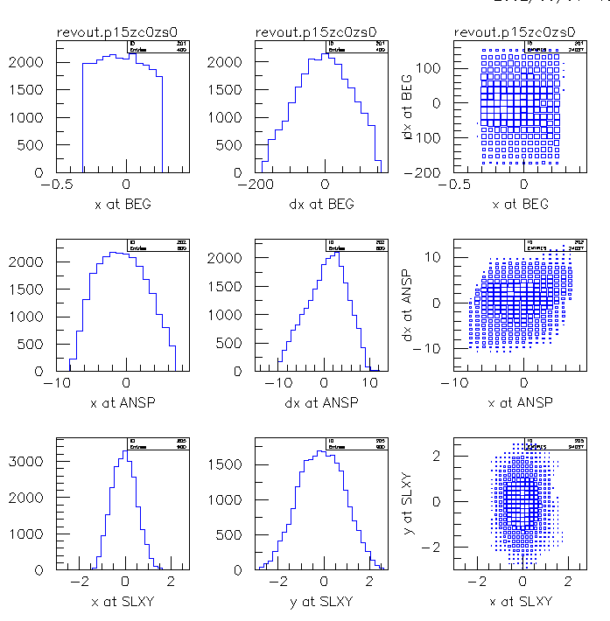

Figure 9: unkicked

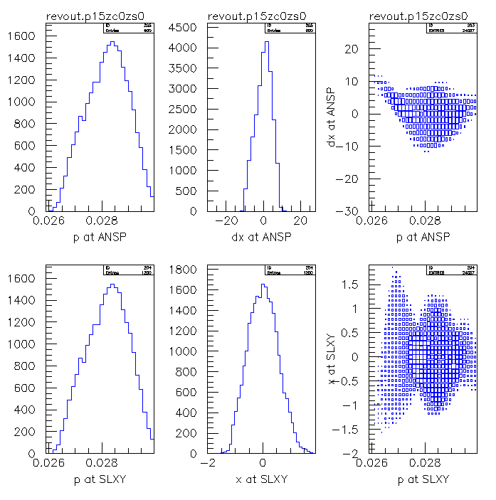

Figure 10: unkicked

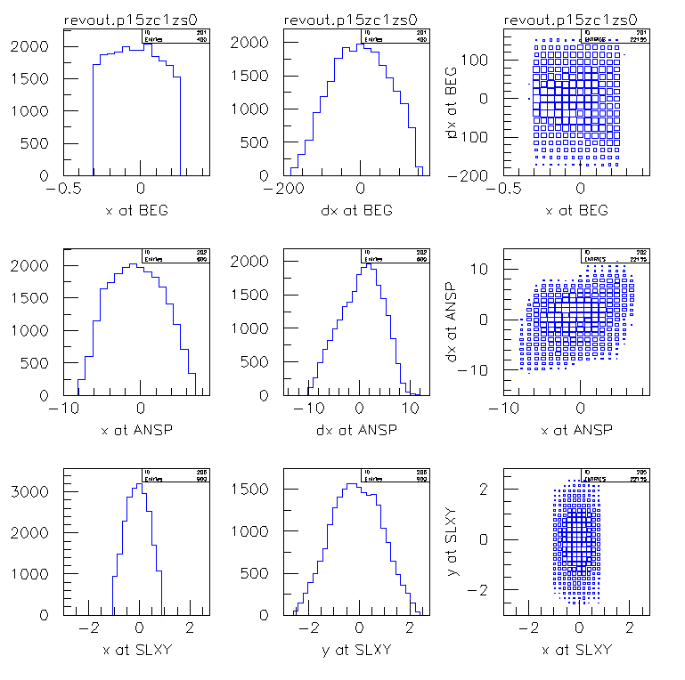

Figure 11: unkicked, SLXY to 1cm
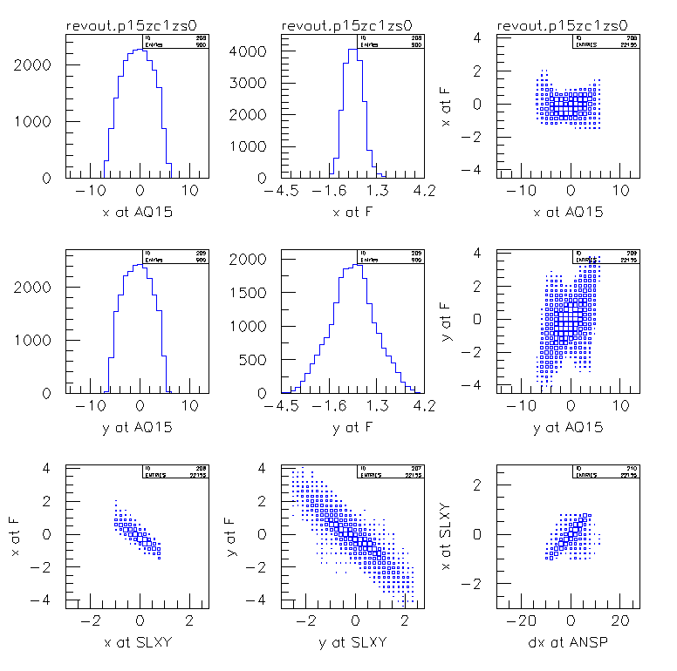
Figure 12: unkicked, SLXY to 1cm, target beam spot
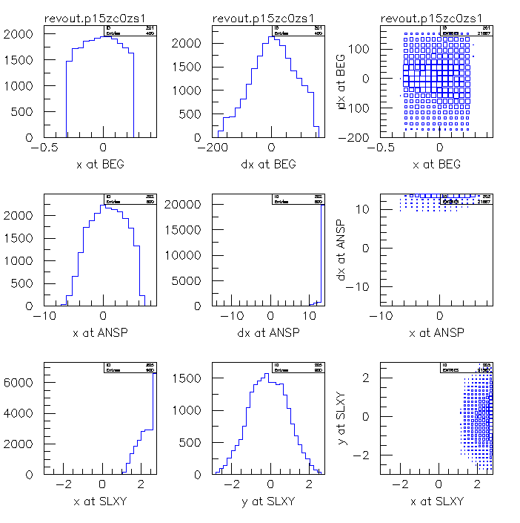
Figure 13: kicked with +1.5 kV/cm
1 doornew_bp_3a_report.rev april 16 2002
T T .00001 0.00001 0. 0. 0. 0.00
D BEG 0.00001 100.
D 0.59750 11.40
QUAD Q1 0.47400 0.59112 12.00
D 0.00001 11.40
D 0.11950 11.40
QUAD Q2 0.47400 -0.42200 12.00
D 0.00001 11.40
D 0.62000 11.40
QUAD Q3 0.47400 0.18584 12.00
D 0.00001 11.40
D 0.72130 15.00 -15.00 8.50 -8.50
FRIN 9.00 0.3 2.8
ENTR 24.0
BEND B1 0.65950 1.48302 0. 0. 0.028
EXIT 24.0
D 0.00001 15.00 -15.00 8.50 -8.50
D 0.40130 11.900
SEXT SEX1 0.320000 0.00000 12.50
D 0.00001 11.900
D 0.41350 99.90
D 0.13500 11.90
QUAD Q4 0.39000 0.63212 12.50
D 0.00001 11.90
D 0.21000 11.90
QUAD Q5 0.39000 -0.45737 12.50
D 0.00001 11.90
D 0.14150 99.90
D 0.14150 11.90
QUAD Q6 0.39000 -0.27195 12.50
D 0.00001 11.90
D 0.26000 11.90
QUAD Q7 0.39000 0.52178 12.50
D 0.00001 11.90
D 0.82850 11.90
SEXT SEX2 0.32000 0.00000 12.50
D 0.3763 15.00 -15.00 8.50 -8.50
ROTATE 180.
ENTR 22.65
BEND B2 0.69420 1.40891 0. 0. 0.028
EXIT 12.854
D 0.00001 15.00 -15.00 8.50 -8.50
ROTATE 180.
D 1.23620 12.30
QUAD Q8 0.31400 -0.14759 12.90
D 0.00001 12.30
D 0.61700 12.30
QUAD Q9 0.31400 0.17785 12.90
D 0.00001 12.30
D 0.64500 7.5 -7.5 10.0 -10.0
SEP POSI 1.00 0.0 0.0 0.0 0.0 0.0 0.0 0.0
D 0.00001 7.5 -7.5 10.0 -10.0
D 0.64500 7.5 -7.5 10.0 -10.0
SEP KICK 1.00 0. 0.0 0.0 0.0 0.0 0.0 0.0
D 0.00001 7.5 -7.5 10.0 -10.0
D ANSP 0.58600 12.30
QUAD Q10 0.31400 -0.49776 12.90
D 0.00001 12.30
D 0.19600 12.30
QUAD Q11 0.31400 0.82379 12.90
D 0.00001 12.30
D 0.19600 12.30
QUAD Q12 0.31400 -0.49776 12.90
D 0.00001 12.30
D SLXY 0.80000 11.0 -11.0 15. -15.
D 1.20000 12.1
QUAD Q13 0.36600 0.61452 12.70
D 0.00001 12.10
D 0.13200 12.10
QUAD Q14 0.36600 -0.91114 12.70
D 0.00001 12.10
D 0.13200 12.10
QUAD Q15 0.36600 0.61452 12.70
D AQ15 0.00001 12.10
D F 1.00000 100.
XSIZE 0.6001 400.00001
YSIZE 4.0001 100.00001
P 0.02800 0.0042 0.028 .00001 0. 0.00
MASS * .105659 0. 0. 1000000.
1. .05
GROUP 1. 100.000 0. 0.0 0. 1.
NSPAC 10. -1.
2. 2. 2. 2. 2. 2. 2. 2. 2. 2.
X BEG 20. 1.
DX BEG 20. 400.
X ANSP 20. 20.
DX ANSP 30. 30.
P ANSP 30. 0.0042 0.028
DX ANSP 30. 60.
P SLXY 30. 0.0042 0.028
X SLXY 40. 4.
X SLXY 30. 6.
Y SLXY 30. 6.
X SLXY 30. 6.
X F 30. 9.
Y SLXY 30. 6.
Y F 30. 9.
X AQ15 30. 30.
X F 30. 9.
Y AQ15 30. 30.
Y F 30. 9.
DX ANSP 30. 60.
X SLXY 30. 6.
END

PARTICLES FINALLY REJECTED FROM THOSE INITIALLY ACCEPTED

Z(M) LAB TYP ENER TOO LOW MULT. SCAT. OUT ABSORBED NUC. SCAT. LOSS 3-BODY DECAYS TOT # REJECT. % LEFT
9 .000 T TARG
9 .000 BEG DRIFT
9 .598 DRIFT .000 6173.000 .000 .000 .000 6173.000 93.82700
9 1.072 Q1 QUAD
9 1.072 DRIFT .000 16641.000 .000 .000 .000 16641.000 77.18600
9 1.191 DRIFT .000 3697.000 .000 .000 .000 3697.000 73.48901
9 1.665 Q2 QUAD
9 1.665 DRIFT .000 8403.000 .000 .000 .000 8403.000 65.08601
9 2.285 DRIFT .000 127.000 .000 .000 .000 129.000 64.95701
9 2.759 Q3 QUAD
9 2.759 DRIFT .000 7.000 .000 .000 .000 7.000 64.95000
9 3.480 DRIFT .000 5863.000 .000 .000 .000 5863.000 59.08701
9 3.480 FRING
9 3.480 ENTR
9 4.140 B1 BEND
9 4.140 EXIT
9 4.140 DRIFT
9 4.541 DRIFT
9 4.861 SEX1 SEXT
9 4.861 DRIFT .000 1386.000 .000 .000 .000 1386.000 57.70100
9 5.275 DRIFT
9 5.410 DRIFT .000 7934.000 .000 .000 .000 7934.000 49.76701
9 5.800 Q4 QUAD
9 5.800 DRIFT .000 62.000 .000 .000 .000 63.000 49.70401
9 6.010 DRIFT .000 479.000 .000 .000 .000 479.000 49.22501
9 6.400 Q5 QUAD
9 6.400 DRIFT .000 1333.000 .000 .000 .000 1333.000 47.89201
9 6.541 DRIFT
9 6.683 DRIFT
9 7.073 Q6 QUAD
9 7.073 DRIFT .000 259.000 .000 .000 .000 259.000 47.63301
9 7.333 DRIFT .000 4051.000 .000 .000 .000 4051.000 43.58201
9 7.723 Q7 QUAD
9 7.723 DRIFT .000 1830.000 .000 .000 .000 1830.000 41.75201
9 8.551 DRIFT .000 .000 .000 .000 .000 1.000 41.75101
9 8.871 SEX2 SEXT
9 9.247 DRIFT .000 1431.000 .000 .000 .000 1431.000 40.32001
9 9.247 ROTAT
9 9.247 ENTR
9 9.942 B2 BEND
9 9.942 EXIT
9 9.942 DRIFT .000 658.000 .000 .000 .000 659.000 39.66101
9 9.942 ROTAT
9 11.178 DRIFT .000 357.000 .000 .000 .000 358.000 39.30301
9 11.492 Q8 QUAD
9 11.492 DRIFT .000 551.000 .000 .000 .000 551.000 38.75201
9 12.109 DRIFT .000 2291.000 .000 .000 .000 2291.000 36.46101
9 12.423 Q9 QUAD
9 12.423 DRIFT .000 668.000 .000 .000 .000 668.000 35.79301
9 13.068 DRIFT .000 6235.000 .000 .000 .000 6235.000 29.55801
9 14.068 POSI SEPA
9 14.068 DRIFT .000 557.000 .000 .000 .000 557.000 29.00101
9 14.713 DRIFT .000 385.000 .000 .000 .000 387.000 28.61401
9 15.713 KICK SEPA
9 15.713 DRIFT .000 1023.000 .000 .000 .000 1023.000 27.59101
9 16.299 ANSP DRIFT .000 108.000 .000 .000 .000 108.000 27.48301
9 16.613 Q10 QUAD
9 16.613 DRIFT .000 17.000 .000 .000 .000 18.000 27.46501
9 16.809 DRIFT .000 181.000 .000 .000 .000 182.000 27.28301
9 17.123 Q11 QUAD
9 17.123 DRIFT
9 17.319 DRIFT
9 17.633 Q12 QUAD
9 17.633 DRIFT
9 18.433 SLXY DRIFT
9 19.633 DRIFT
9 19.999 Q13 QUAD
9 19.999 DRIFT .000 699.000 .000 .000 .000 699.000 26.58401
9 20.131 DRIFT .000 2494.000 .000 .000 .000 2494.000 24.09001
9 20.497 Q14 QUAD
9 20.497 DRIFT .000 52.000 .000 .000 .000 53.000 24.03701
9 20.629 DRIFT
9 20.995 Q15 QUAD
9 20.995 AQ15 DRIFT
9 21.995 F DRIFT

Peter’s tunes and variants

jt1.dat: simple improved ? jt tune
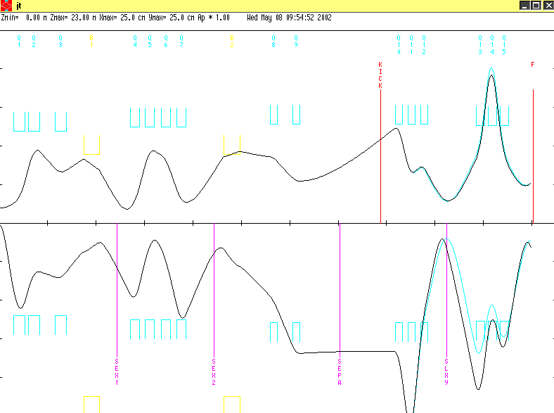
Figure 14: jt1 and jt
Main difference:
jt: 5.00 'Q11 ' 0.31400 0.82379 12.90000;
jt1: 5.00 'Q11 ' 0.31400 0.80500 12.90000;

gives 50% better SLXY x focus.
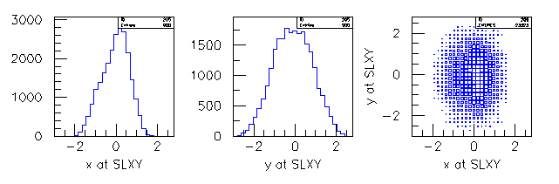
However, x resolution worse in revmoc!

pnb.dat: new nb kick tune
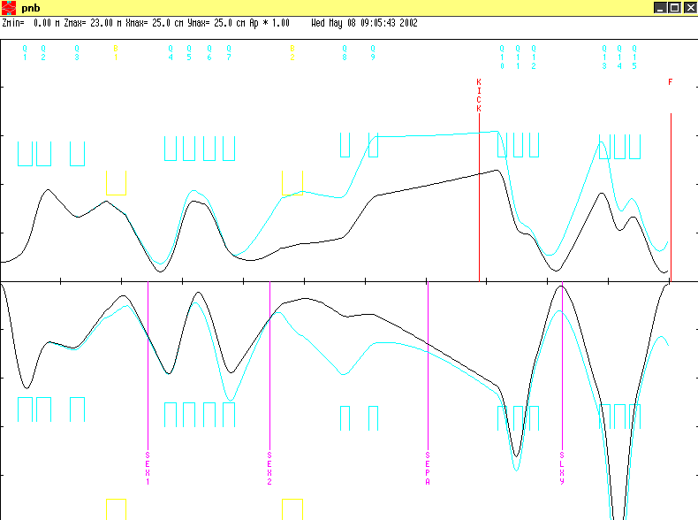
Figure 15: pnb1.dat after 1st order focusing

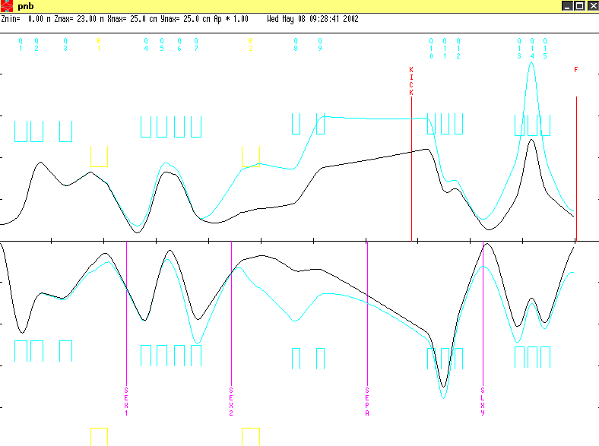
Figure 16: pnb.dat optimized in 2nd order (by hand)
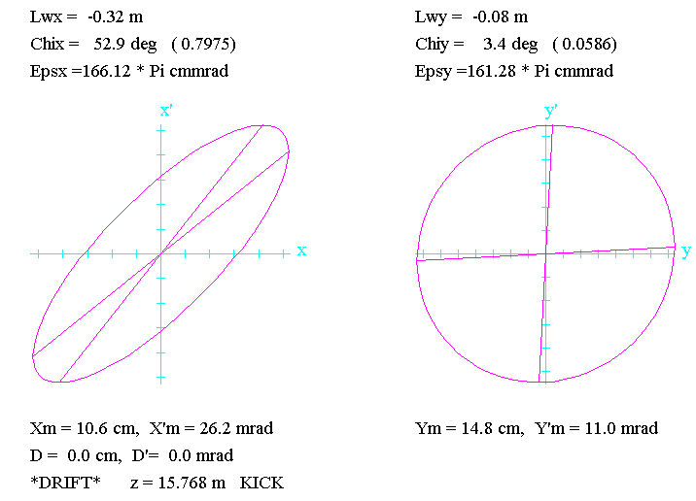

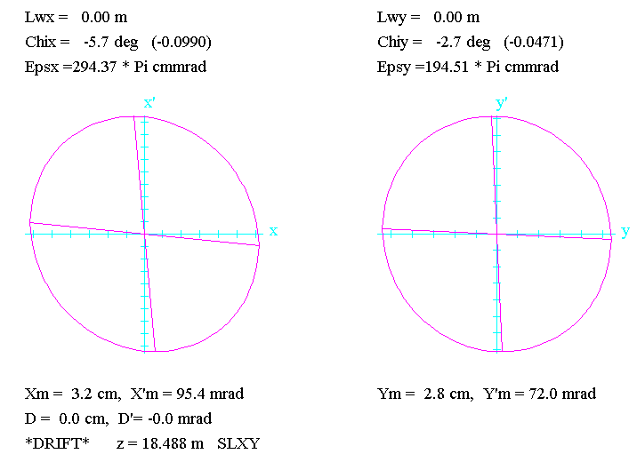

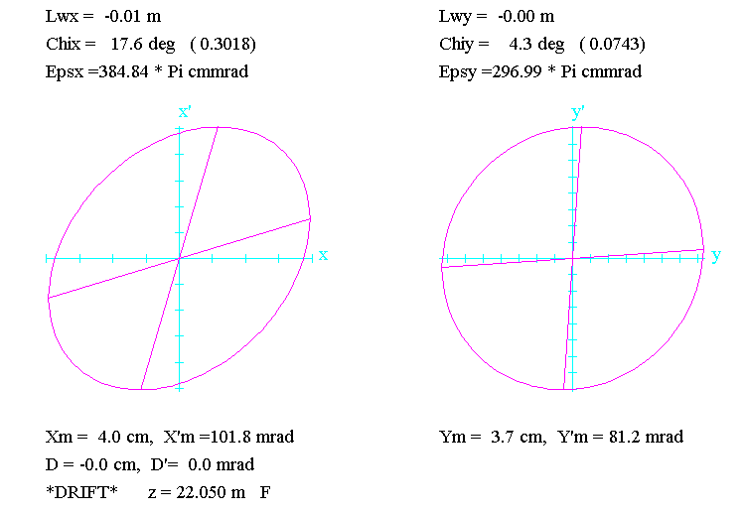
Figure 17: phase space for pnb

/*PLOT* pnb/
0
1.000000 ' ' 0.30000 150.00000 2.00000 30.00000
0.00000 4.00000 0.02800;
17. ' ' ;
3.0 ' ' 0.59750;
5.00 'Q1 ' 0.47400 0.59112 12.00000;
3.0 ' ' 0.11950;
5.00 'Q2 ' 0.47400 -0.41200 12.00000;
3.0 ' ' 0.62000;
5.00 'Q3 ' 0.47400 0.18584 12.00000;
3.0 ' ' 0.72130;
16.00 ' ' 5.00000 9.00000;
16.00 ' ' 7.00000 0.30000;
16.00 ' ' 8.00000 2.80000;
2.0 ' ' 24.00000;
4.000 'B1 ' 0.65950 1.48302 0.00000;
2.0 ' ' 24.00000;
3.0 ' ' 0.40130;
3.0 'SEX1' 0.32000;
3.0 ' ' 0.41350;
3.0 ' ' 0.13500;
5.00 'Q4 ' 0.39000 0.63212 12.50000;
3.0 ' ' 0.21000;
5.00 'Q5 ' 0.39000 -0.45737 12.50000;
3.0 ' ' 0.14150;
3.0 ' ' 0.14150;
5.00 'Q6 ' 0.39000 -0.27195 12.50000;
3.0 ' ' 0.26000;
5.00 'Q7 ' 0.39000 0.52178 12.50000;
3.0 ' ' 0.82850;
3.0 'SEX2' 0.32000;
3.0 ' ' 0.37630;
20.0 ' ' 180.00000;
2.0 ' ' 22.65000;
4.000 'B2 ' 0.69420 1.40891 0.00000;
2.0 ' ' 12.85400;
20.0 ' ' 180.00000;
3.0 ' ' 1.23620;
5.00 'Q8 ' 0.31400 0.30 12.90000;
3.0 ' ' 0.61700;
5.00 'Q9 ' 0.31400 -0.185 12.90000;
3.0 ' ' 0.64500;
3.0 'SEPA' 1.00000;
3.0 ' ' 0.70000;
3.0 'KICK' 1.00000;
3.0 ' ' 0.58600;
5.0B 'Q10 ' 0.31400 -0.42 12.90000;
3.0 ' ' 0.19600;
5.01 'Q11 ' 0.31400 0.77 12.90000;
3.0 ' ' 0.19600;
5.0B 'Q12 ' 0.31400 -0.42 12.90000;
3.0 'SLXY' 0.80000;
-10. -1.0 2.0 0.0 .001 /A12 / ;
-10. -3.0 4.0 0.0 .001 /A34 / ;
3.0 ' ' 1.20000;
5.0A 'Q13 ' 0.36600 0.61983 12.70000;
3.0 ' ' 0.13200;
5.01 'Q14 ' 0.36600 -.90 12.70000;
3.0 ' ' 0.13200;
5.0A 'Q15 ' 0.36600 0.61983 12.70000;
3.0 'F ' 1.00000;
-10. -1.0 2.0 0.0 .001 /A12 / ;
-10. -3.0 4.0 0.0 .001 /A34 / ;
SENTINEL
SENTINEL

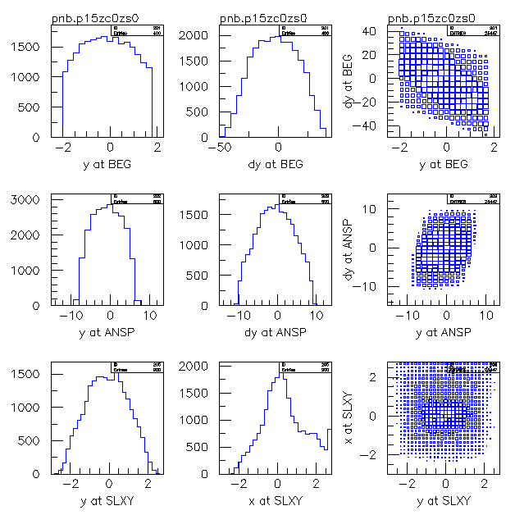
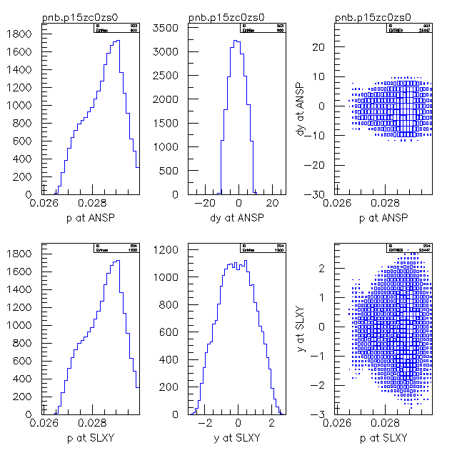
Figure 18: unkicked
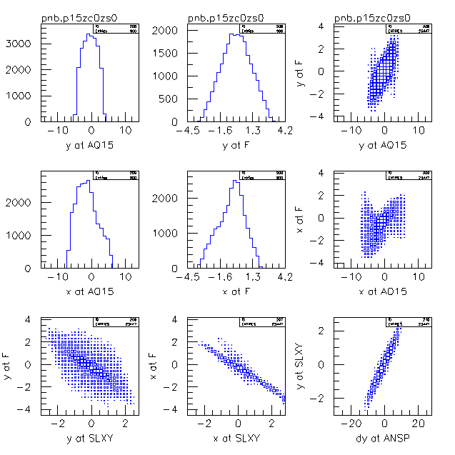
Figure 19: unkicked correlations
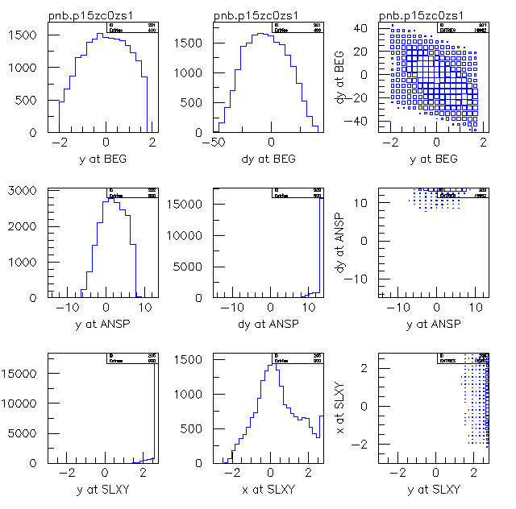
Figure 20: kicked with 1.5 kV/cm

Conclusion: Non-bend kick not impossible, but with present effort not convincing. Similar transmission as jt.

pd.dat: increased transmission (?) jd tune
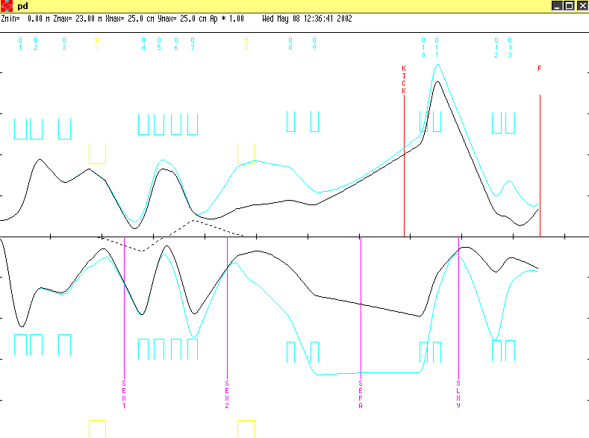
Figure 21: pd first and second order

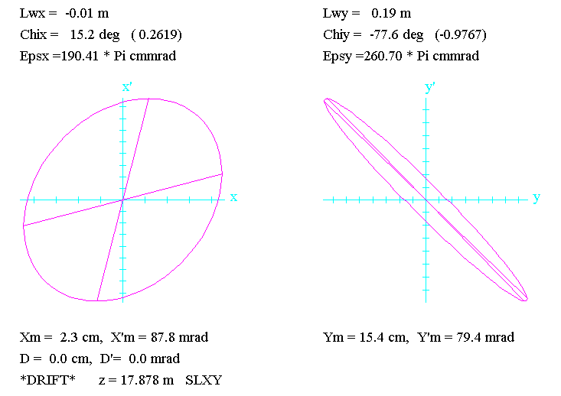 | 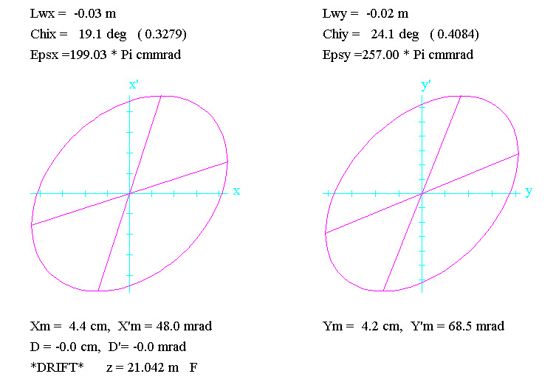

Figure 22: pd: slit and target

Yet to be tested with revmoc. Final focus not ideal yet.
/*PLOT* pd/
0
1.000000 ' ' 0.30000 150.00000 2.00000 30.00000
0.00000 4.00000 0.02800;
17. ' ' ;
3.0 ' ' 0.59750;
5.00 'Q1 ' 0.47400 0.59112 12.00000;
3.0 ' ' 0.11950;
5.00 'Q2 ' 0.47400 -0.41200 12.00000;
3.0 ' ' 0.62000;
5.00 'Q3 ' 0.47400 0.18584 12.00000;
3.0 ' ' 0.72130;
16.00 ' ' 5.00000 9.00000;
16.00 ' ' 7.00000 0.30000;
16.00 ' ' 8.00000 2.80000;
2.0 ' ' 24.00000;
4.000 'B1 ' 0.65950 1.48302 0.00000;
2.0 ' ' 24.00000;
3.0 ' ' 0.40130;
3.0 'SEX1' 0.32000;
3.0 ' ' 0.41350;
3.0 ' ' 0.13500;
5.00 'Q4 ' 0.39000 0.63212 12.50000;
3.0 ' ' 0.21000;
5.00 'Q5 ' 0.39000 -0.45737 12.50000;
3.0 ' ' 0.14150;
3.0 ' ' 0.14150;
5.00 'Q6 ' 0.39000 -0.27195 12.50000;
3.0 ' ' 0.26000;
5.00 'Q7 ' 0.39000 0.52178 12.50000;
3.0 ' ' 0.82850;
3.0 'SEX2' 0.32000;
3.0 ' ' 0.37630;
20.0 ' ' 180.00000;
2.0 ' ' 22.65000;
4.000 'B2 ' 0.69420 1.40891 0.00000;
2.0 ' ' 12.85400;
20.0 ' ' 180.00000;
3.0 ' ' 1.23620;
5.00 'Q8 ' 0.31400 -0.14759 12.90000;
3.0 ' ' 0.61700;
5.00 'Q9 ' 0.31400 0.17785 12.90000;
3.0 ' ' 0.64500;
3.0 'SEPA' 1.00000;
3.0 ' ' 0.70000;
3.0 'KICK' 1.00000;
3.0 ' ' 0.58600;
5.00 'Q10 ' 0.31400 0.45 12.90000;
3.0 ' ' 0.19600;
5.00 'Q11 ' 0.31400 -0.490 12.90000;
3.0 'SLXY' 0.70;
-10. -1.0 2.0 0.0 .001 /A12 / ;
-10. -3.0 4.0 0.0 .001 /A34 / ;
3.0 ' ' 1.30000;
5.01 'Q12 ' 0.36600 0.65 12.70000;
3.0 ' ' 0.13200;
5.01 'Q13 ' 0.36600 -0.60 12.70000;
3.0 'F ' 1.00000;
10. -1.0 2.0 0.0 .001 /A12 / ;
-10. -3.0 4.0 0.0 .001 /A34 / ;
-10. 12. 1. 0.0 .001 /r21 / ;
-10. 13. 4.0 0.0 .001 /r34 / ;
SENTINEL
SENTINEL

Conclusion and tuning strategy

- Conclusions
  - 2nd order (chromatic aberrations) critically important
  - intensity tight
  - kicker possible

- Further work
  - How do we share the work
  - Study all transport tunes with revmoc/turtle
  - Stability of results ?
    - Sensitivity to changes
    - include curved poles and PSI fringe field
    - Full tracking calc (Zgoubi)

  - how to diagnose what’s going on during the test run

  - choice of momentum bin
    - measure energy distribution with calibrated Si det or mu+ edge (equivalent?)
    - higher momentum tune naturally reduces momentum bin

- Tuning strategy
  - beam hardware
    - establish channel hardware set-up
    - Jaap suggests use of sepa for kicking
    - Kicker geometry must be realistic, H and W
    - Triplet or doublet
    - vertical/horizontal kick
  - establish tuning/measuring plan

