Brief summary of beam studies

Peter et al., Sunday, August 18, 2003

Overview
From 14-Aug to 17-Aug we performed beam studies to
- Search for possible sources of the low stopping fraction and potentially wide range distribution observed during the test TPC run.
- Quantify the contribution of each beam element on scattering and range width.
- Gain information concerning the relative merits of various TPC target window choices.
The main set-up was (seen in muon direction)

name | description | dimensions | distance
PC | Peter collimator | 2mm lead, 35mm hole | On beam window
Mu | Mu counter | 0.5mm, 5x5 cm2 scint | Directly behind
MuPC1 | Wire chamber | 100mu Mylar, ~3cm wide, 5x5 cm2 | directly behind
CC | Cenap’s collimator | 5mm plastic, 40mm hole, simulates entrance TPC hole | 8 cm from Mu
windows | 100um Fe or 1 mm Be or 0.3 mm Mylar | Simulates TPC entrance window | 8 cm from Mu
foils | X foils of 100 mu Mylar each | Add stopping mass | On SS
SS | Stop scintillator | 5 mm, 13 (hor) x12(vert) cm2 | Dist (variable) to CC

The standard experimental condition included PC, Mu, CC and SS, other elements optional at various conditions. For scattering studies the following distances were chosen

Dist (cm) |  | notation
5 | At mPC2 position | MuPC2
15 | At TPC entrance | TPC1
30 | At TPC center | TPC2
45 | At TPC exit | TPC3

Two basic measurement were done
- Range measurement with SS at MuPC2 position, and possible some foils
- Scattering (and range) measurements with SS at various distances.
The basic signal for both measurements was (mu*SS)/mu, i.e. the fraction of the mu rate seen by the coincidence mu and SS(to exclude Michel electrons).

For several addition measurements (SS only, beam tuning, collimator tuning and corrections) we refer to the e-log entries. Note also that not all measurements are reliable and consistent, because the CC alignment was not stable.
Some photos of the set-up are given below.

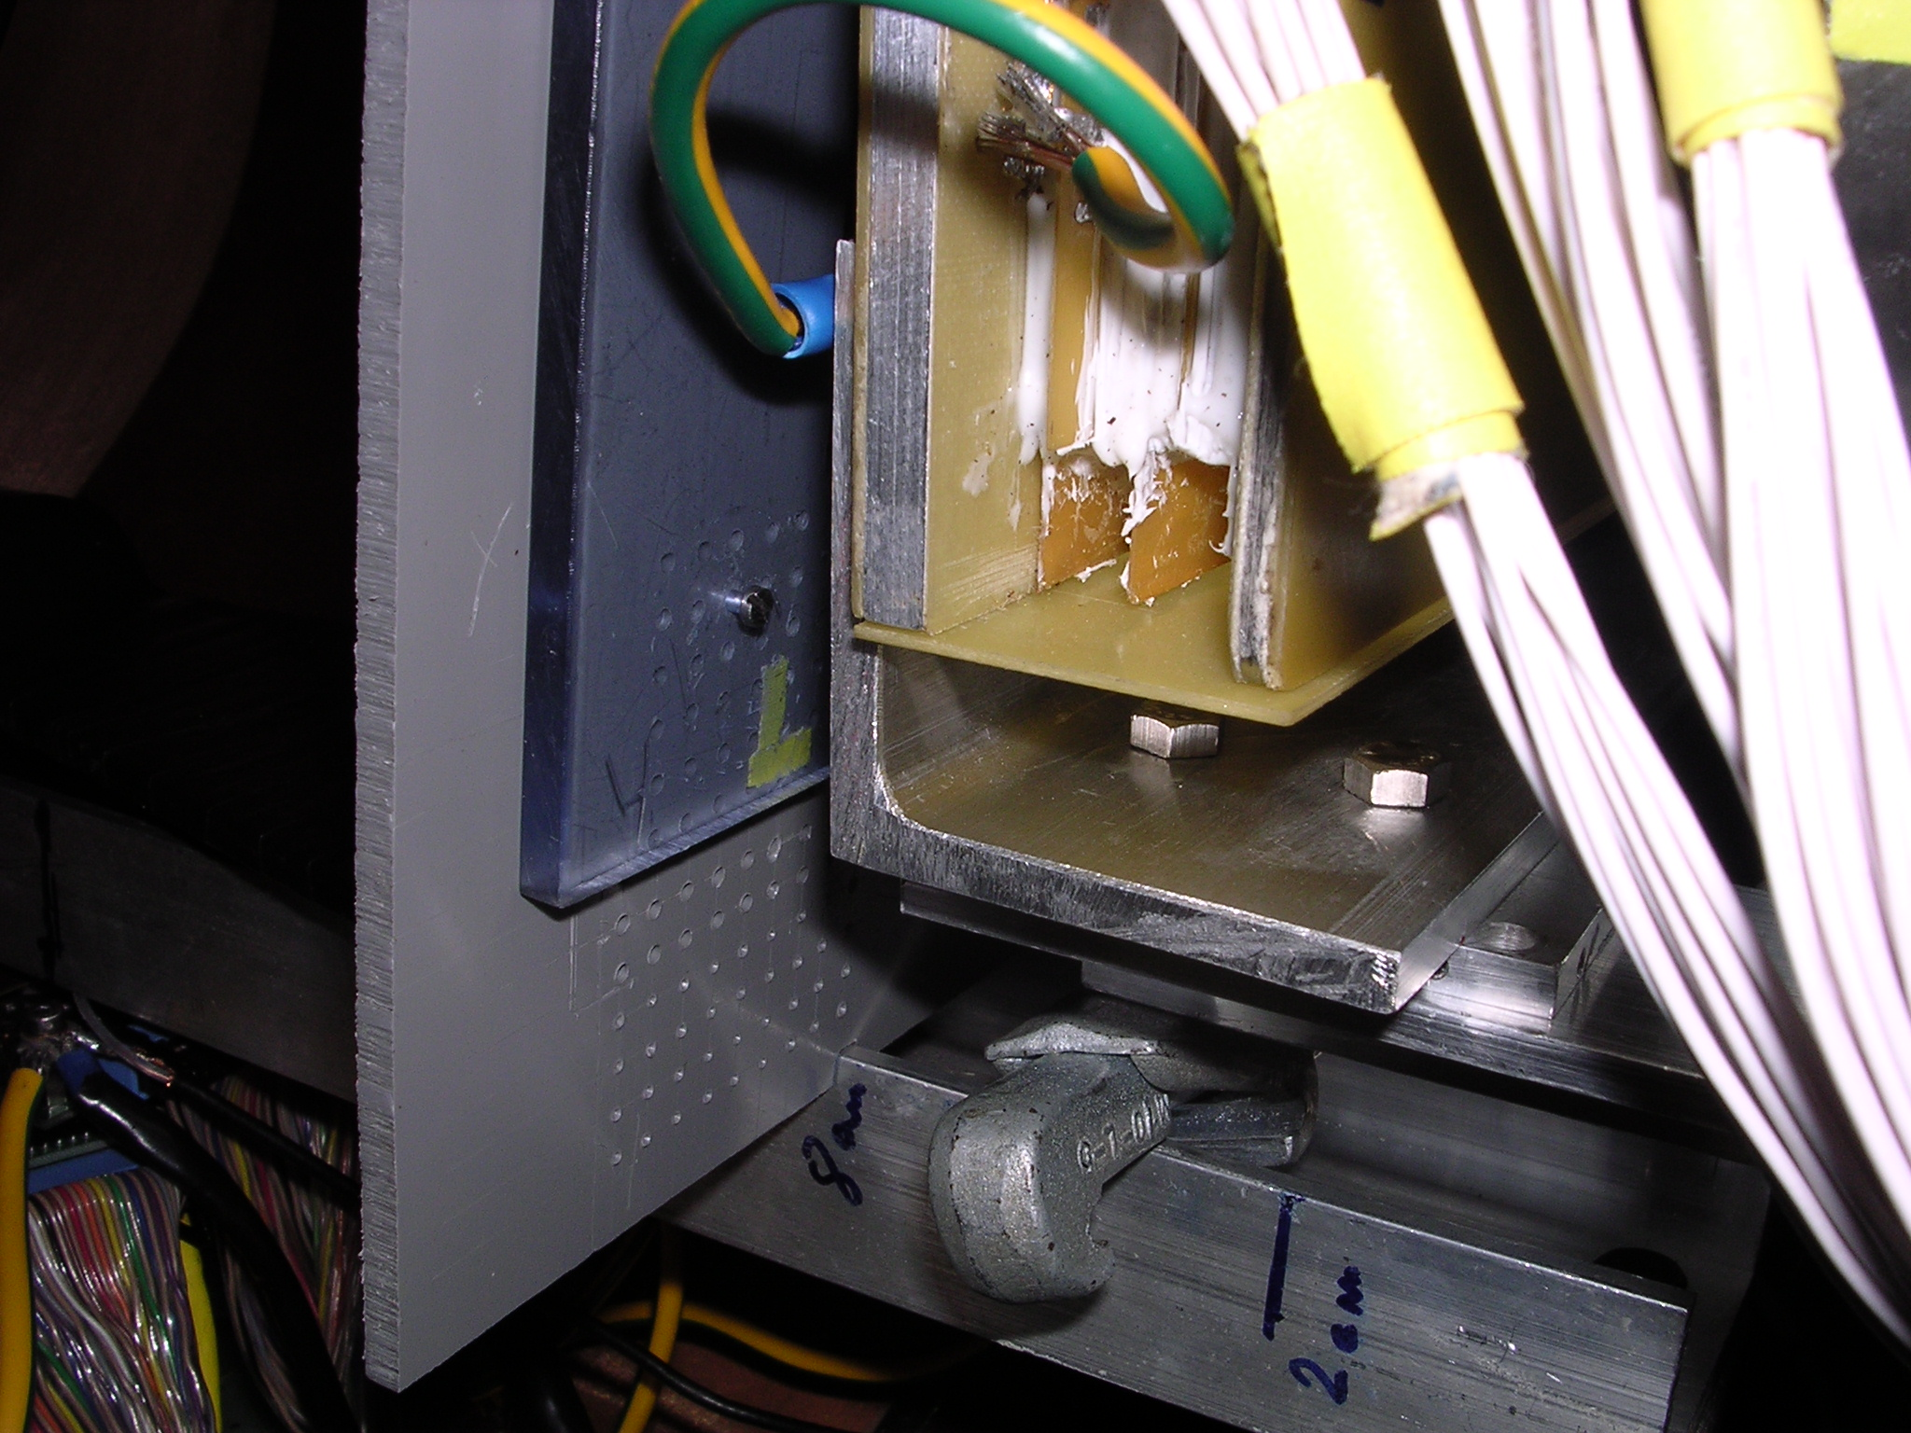
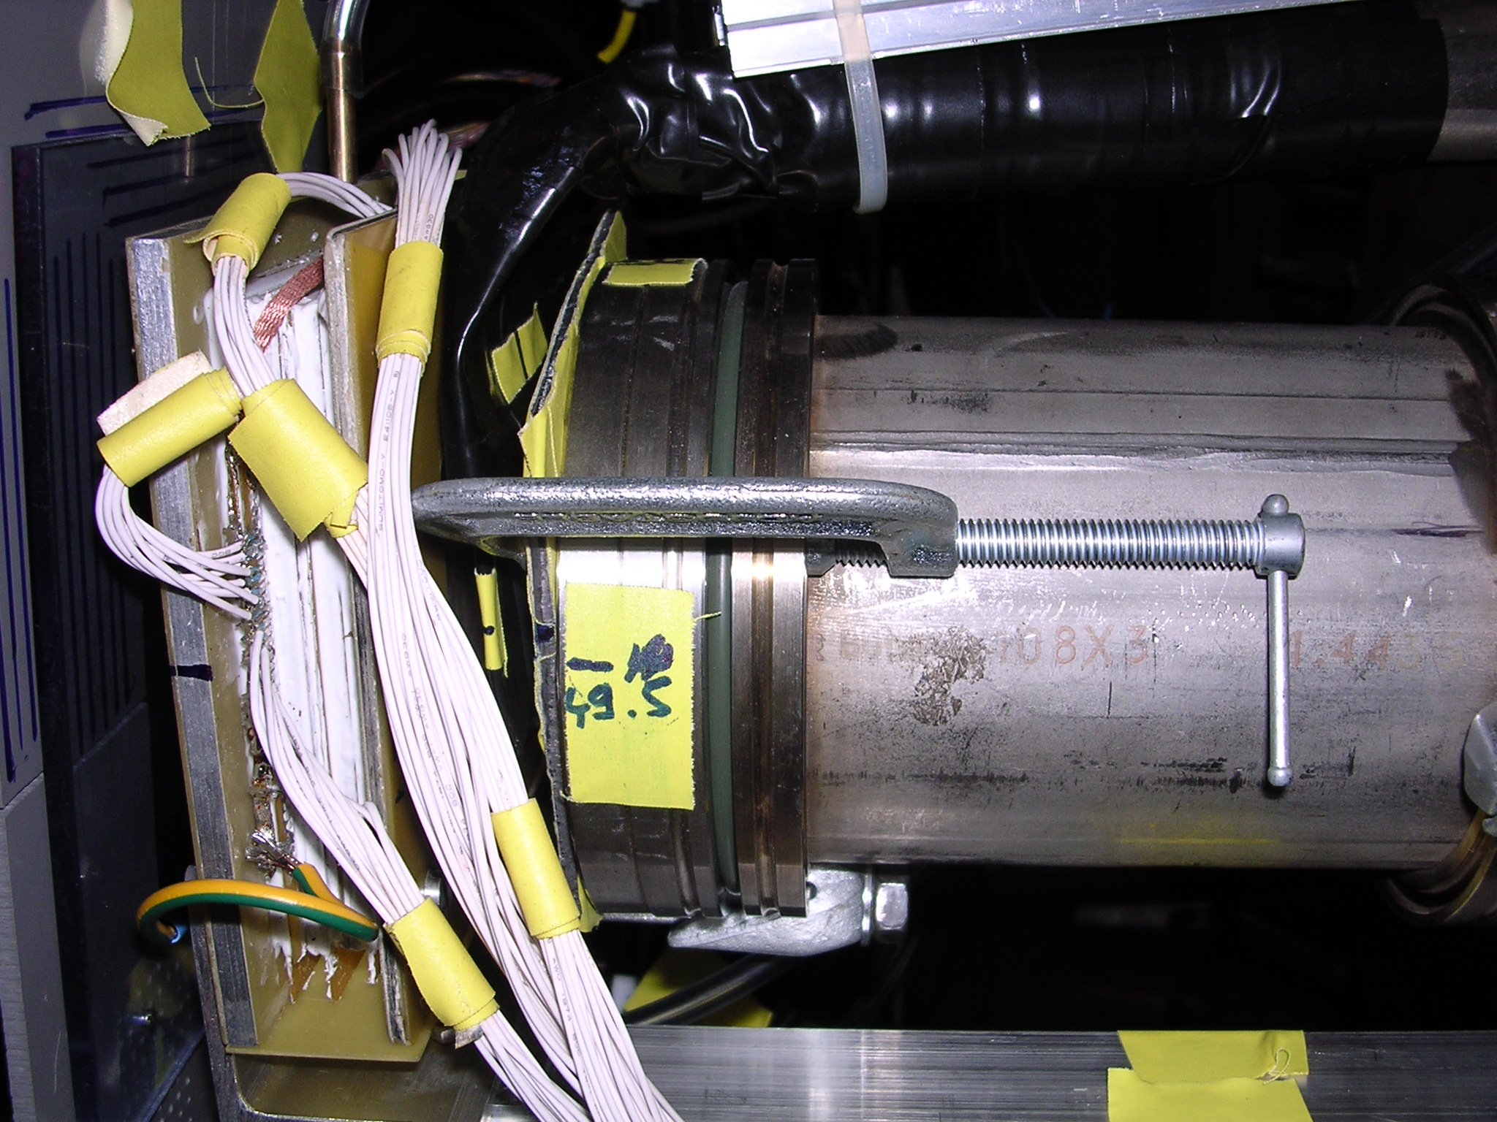
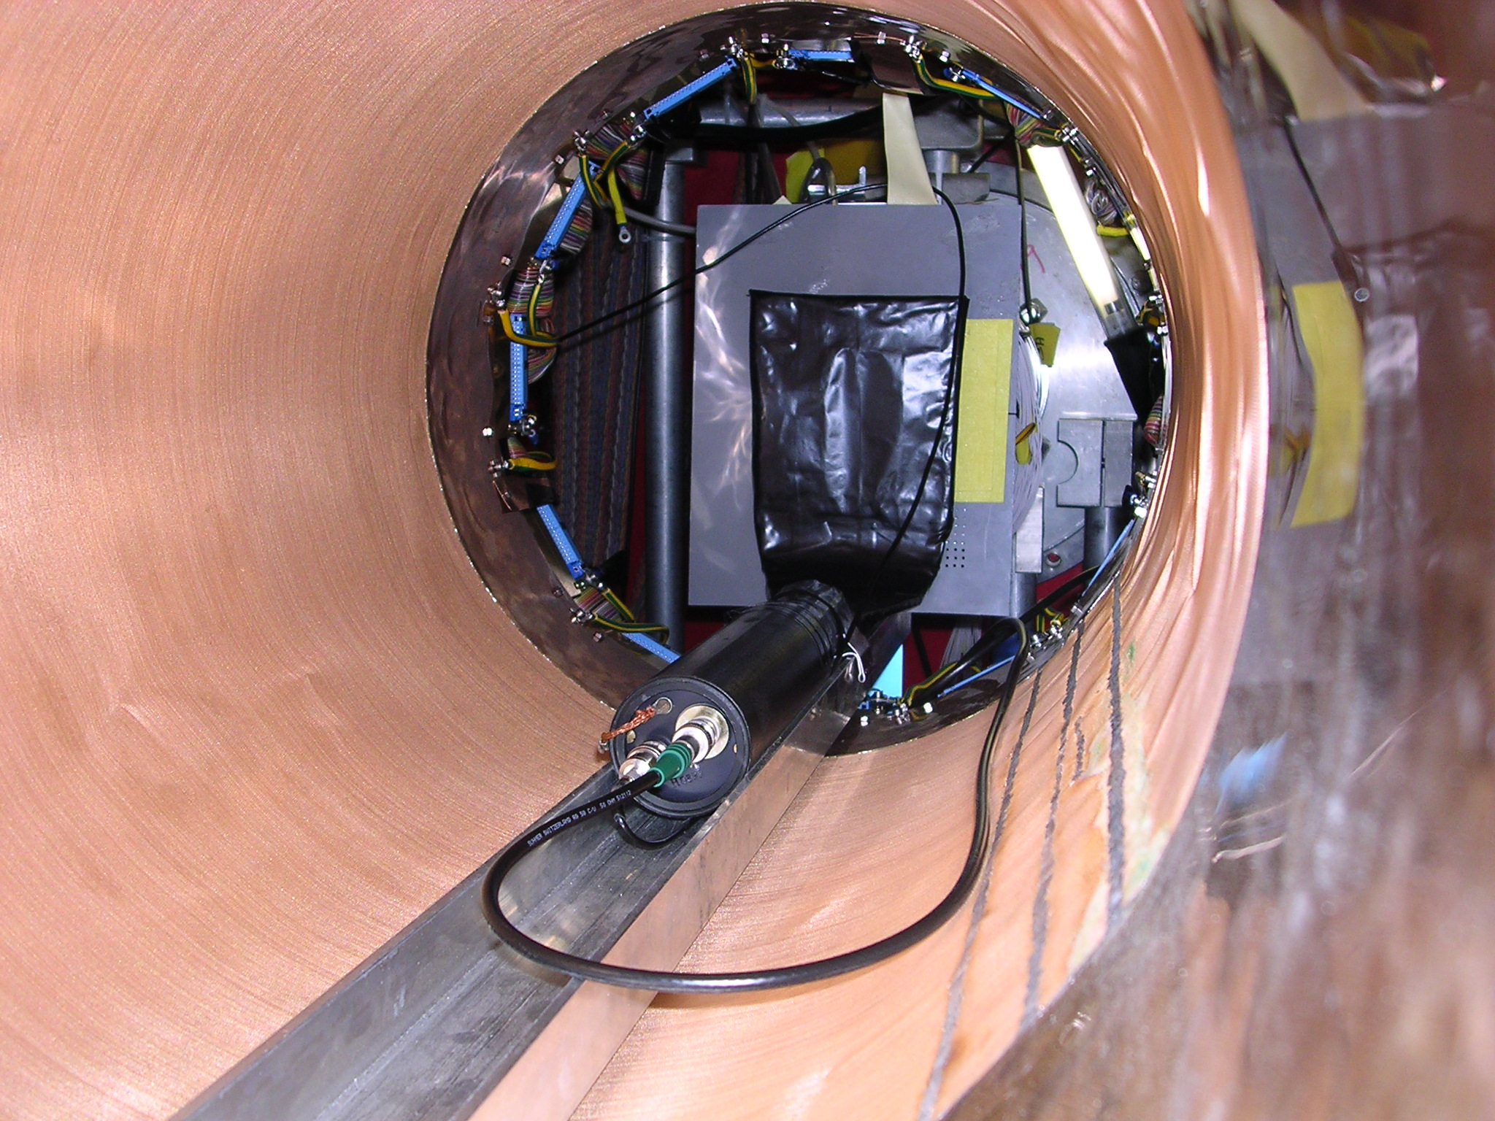

Results
For access to the numerical results as root files refer to the e-log entries.

Range measurements
The following figure presents the main results, further results are given in section 2.2 for SS in MuPC2 position.

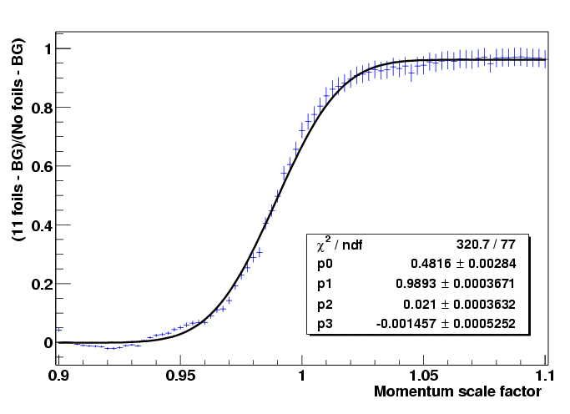  SS only, p current norm | 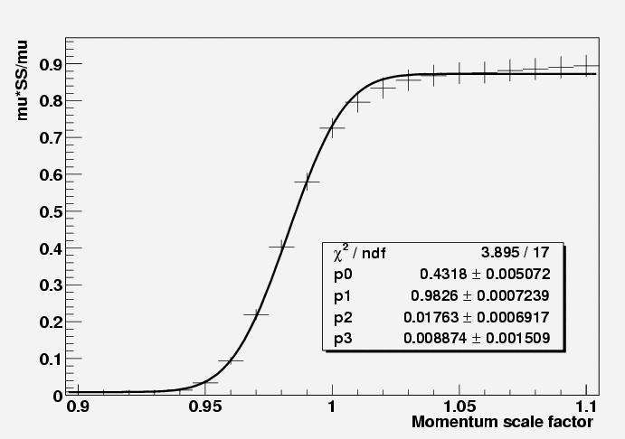  Mu + SS
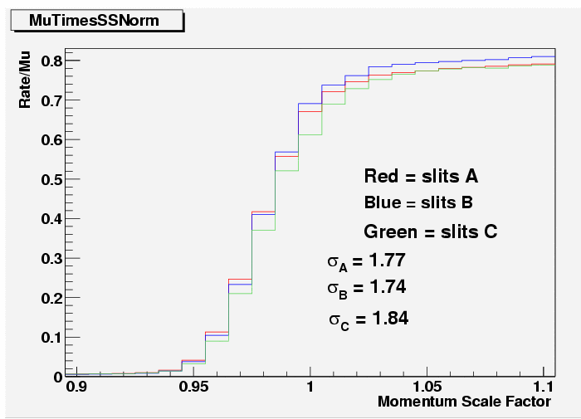  Mu + SS, different slits | 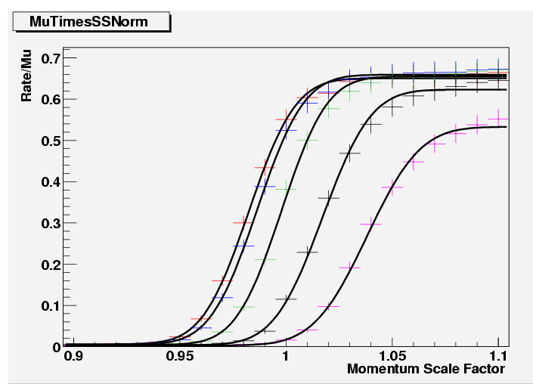  Mu+foils+SS

The fitted sigmas of the range distribution (resulting from an Erf fit) are collected in the table. Given are momentum corresponding to range center and the sigma of the momentum distribution (all given as scale factors of the nominal 34MeV/c tune). Probably the results have errors of 5% (estimated from fit consistency, fit errors are rather <1%).
configuration | Central momentum (%) | Sigma (%)
11foil+SS | 98.6 | 1.82
Mu+6foil+SS, slit A, B, C | 97.9 | 1.76,1.74, 1.84
Mu+mPC1+6(7)foil+SS | 100 | 2.02 (1.92)
Mu+mPC1+Fe+SS | 97.4 | 2.10
Mu+mPC1+Be+SS | 110 | 1.9

Scattering (and range) measurements
The following figure presents the main results.

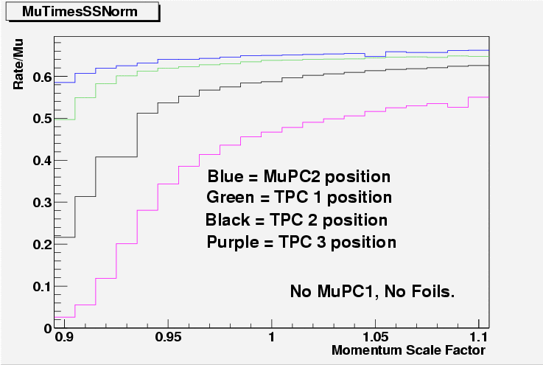 | 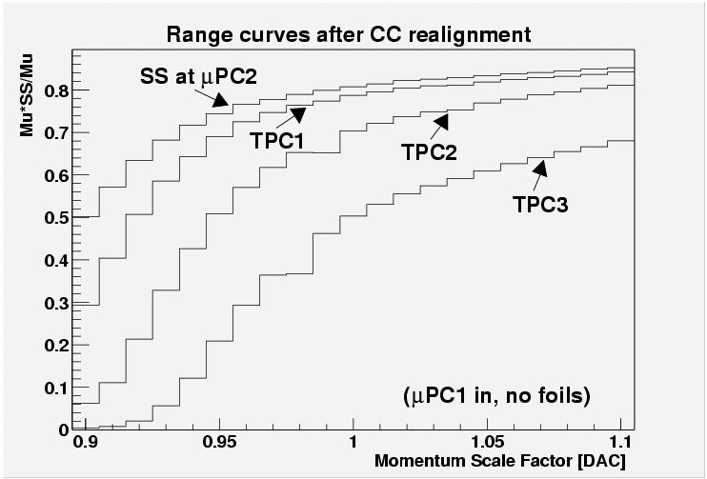
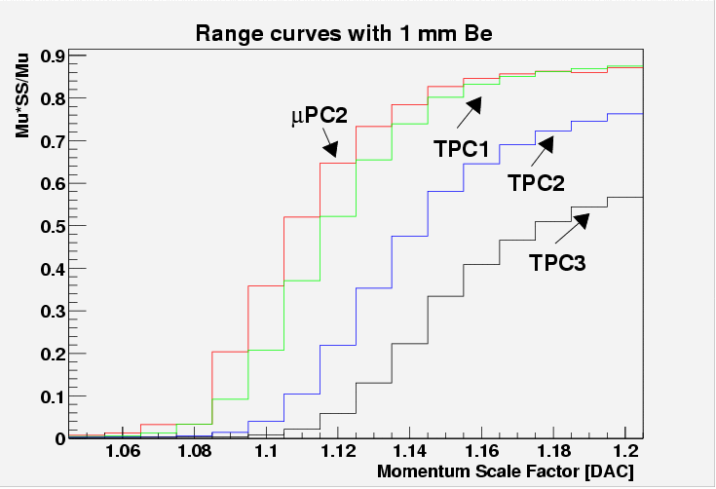 | 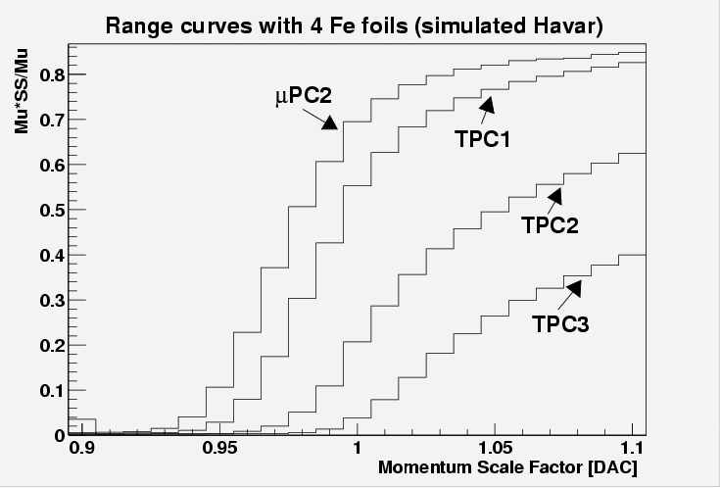
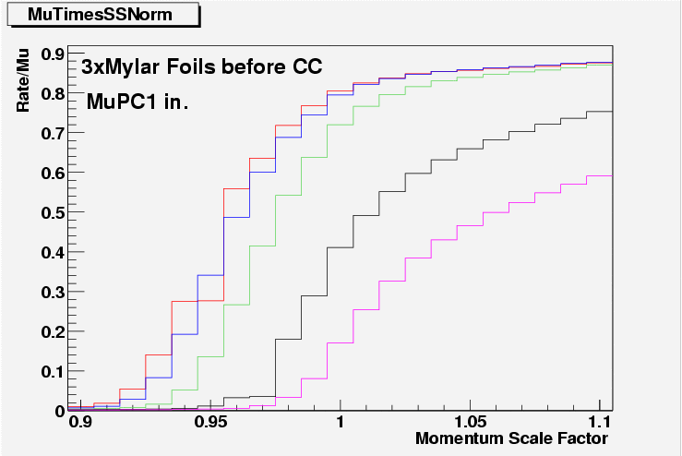

MPC1 beam profile
The MPC1 beam profile was measured for two coincidence conditions. a) coincidence with mu counter (image of PC), b) coincidence with SS counter (effect of CC image). Momentum 34MeV/c.

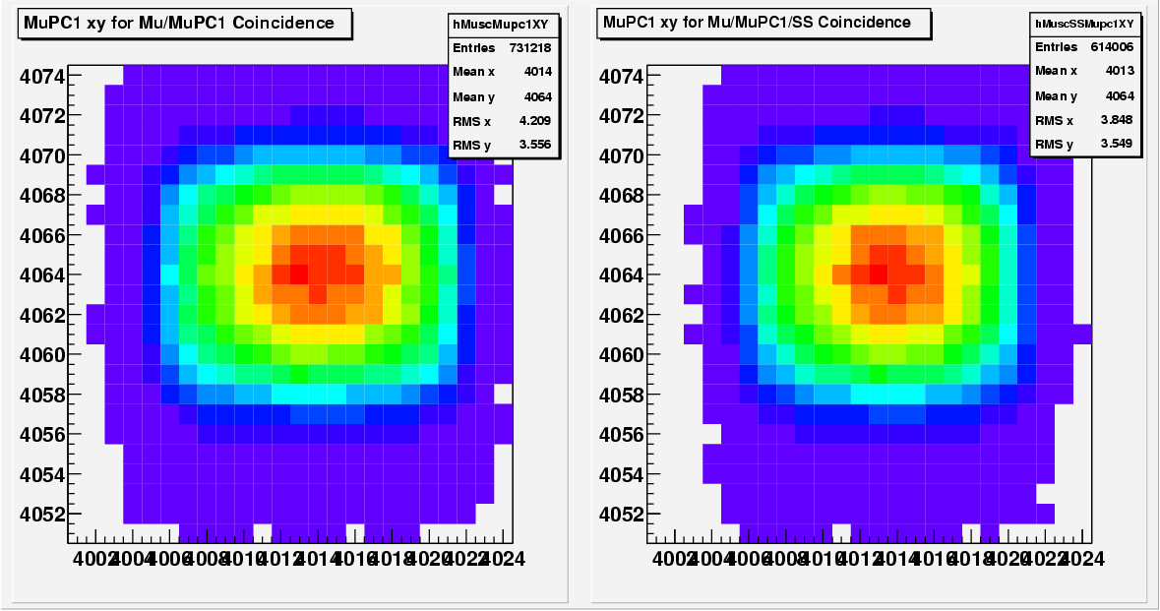

Estimated beam divergence
At the muPC1 chamber the estimated muon beam divergences are approximately sigma(x') = 30 mrad, sigma(y') = 60 mrad (Claude’s calculations).

Required Monte Carlo Simulation
In order to predict the expected muon stopping distribution for the present run and for future runs with different window choices Monte Carlo simulations are required.
The present data highly constrains the MC model, and thus should allow robust predictions.
For a MC simulation the phase space of the beam at the mPC1 position is required. The measured beam profile as well as Claude’s x’,y’ predictions should define reasonable starting values. Then these initial condition can be tested with e.g. the mu+SS configuration, where scattering is small. Potentially the x’,y’ assumptions have to be slightly adjusted to describe the data.
The next step is the real description of the various window situations. As regards the absolute range one has to account for the dead layer in SS, given by its threshold set above minimal ionizing particles (electrons in this case).
If reasonable agreement between data and MC can be achieved, the tuned model can be use to predict stopping distribution and optimal momentum for different window choices.

