μCap beam study
Peter Kammel
version 26 January 2002

Introduction
We study muon stopping properties in variants of the final μCap setup. Two potential problems show up.
- lateral scattering is significant
- μPC1/2 tracking possibly gets compromised by window scattering.

Simple estimate
First we simply estimate the range and scattering in a spreadsheet. Havar approximated by Fe with density 8.3 g/cm3.

The carbon range table is calculated by SRIM and parametrized.
From this rough exercise we conclude

Srim – Geant comparison for simplified geometry
First let’s compare SRIM and GEANT for a simplified geometry. The results for 3.77 MeV muon energy are shown below.

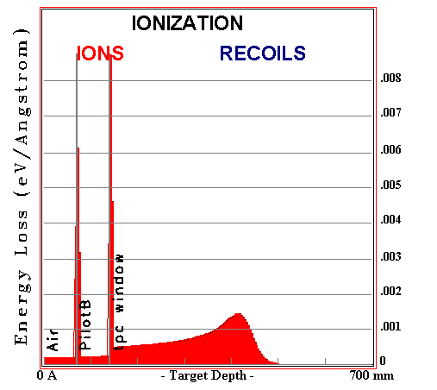 | 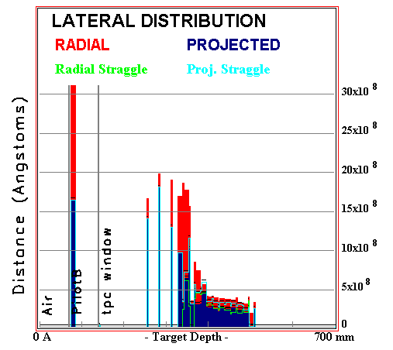
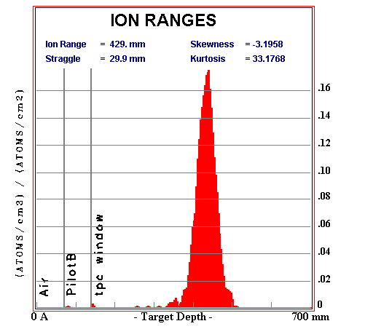 | 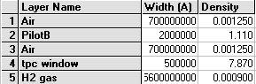
 | 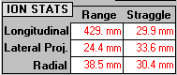 | lat rms from fit  23 mm  long rms from fit  24 mm
One has to be careful with the rms, as a few large angle scatterers can affect the results. This is shown in the fig. below where the distributions are fitted instead of simple rms calculation. These results are also entered into the table.
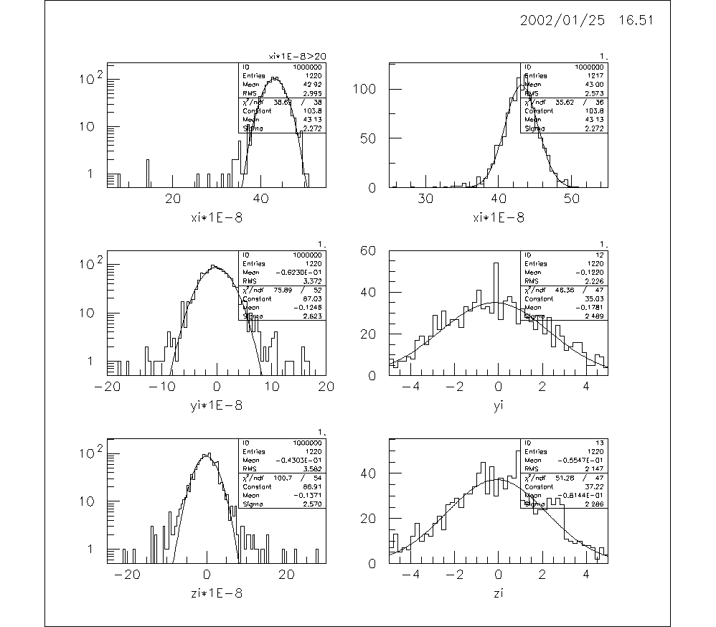
The equivalent GEANT calculation (p=28.2 MeV/c) is based on GMU, using the same scint and entrance window. The air length is 11 cm and 1 cm corresponds to the gas of mPC1/2 (to balance the higher density of the PC gas 3 cm of air have been added to the SRIM geometry above). Upper row shows pencil beam, lower row show radially extended beam with momentum spread.
fig: geant
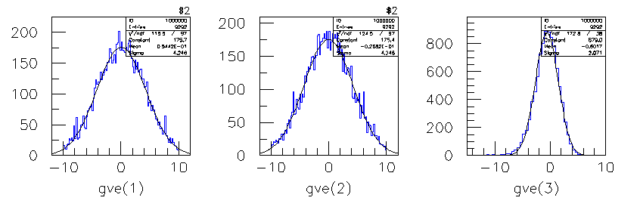
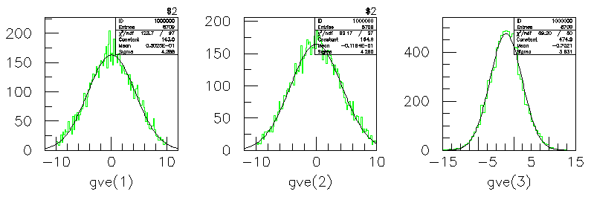
The srim and geant calculations agree well regarding the range straggling, but not concerning the multiple scattering. Geant predict ~2x larger angular scattering. If this due to the program or due to remaining differences in the geometry (PC gas, havar more carefully modeled in geant) is unclear.
 | long rms (mm) | lat rms (mm)
SRIM | 23 | 24
GEANT | 21 | 42
GEANT beam  (r=18mm, 3% FWHM momentum spread) | 38 | 43

The significant scattering FWHM>57mm (dominated by Havar) raises another question. Does that mean that even perfect tracking with mPC1 and 2 only allows an x stopping point reconstruction within this resolution? Then mPC tracking seems rather useless. I have to think about that more carefully and a direct GEANT reconstruction study is certainly desirable.

SRIM calculation
After these studies we proceed to a full physics calculation of the straggling and scattering with SRIM. Pencil beam of monoengetic muons in z direction assumed as initial condition. The materials are (excuse the strange Angstrom notation)
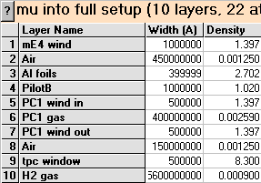
Definitions
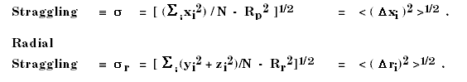
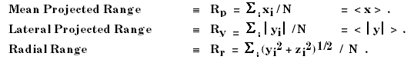
The results are consistent with the estimate above. Straggle is given in rms.
The FWHM then are approximately
Longitudinal straggle FWHM | 7.0 cm
Lateral straggle FWHM | 7.0 cm
The lateral straggle, which has to be folded over the natural beam size of 3.6 cm diameter as defined by the entrance counter, is quite significant and will lead to substantial losses in the vertical direction (effectively 9 cm fiducial height requiring a wall safety gap of 1.5cm). Detailed figures of this simulation are given below. If the GEANT results were to be true, these losses would be even larger than indicated in fig. geant lower row.
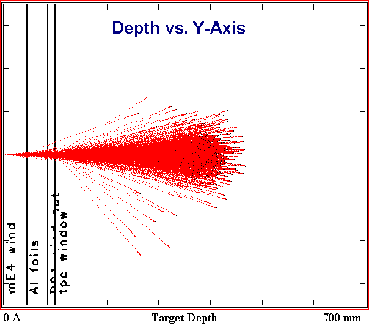 | 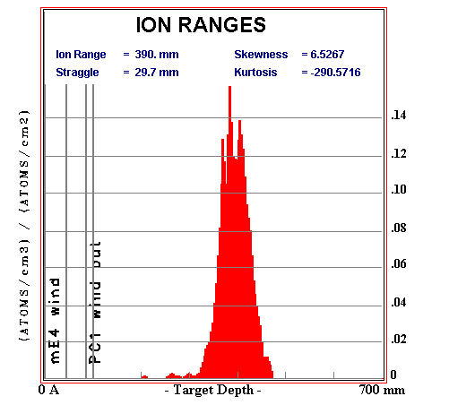
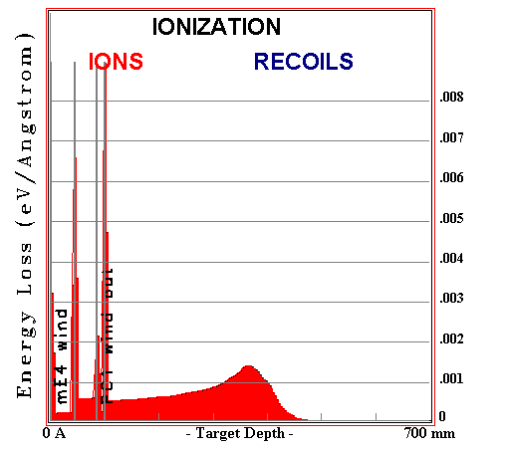 | 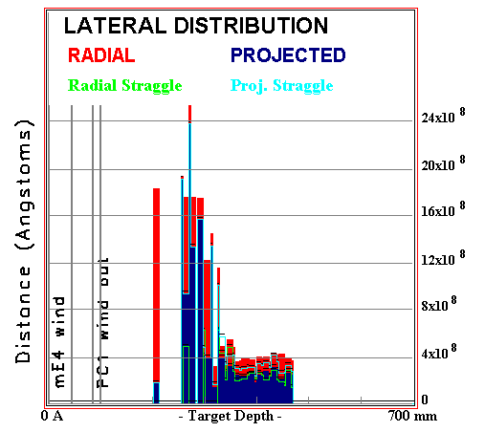
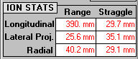 | scint thickness | Mev | long rms from fit (mm) | lat rms from fit (mm)
 | 0.1 mm | 4.2 | 27.6 | 27.5
 | 0.2 mm | 4.4 | 30 | 29
 | 0.7 mm | 5.1 | 37 | 28
Figures show results of 0.1 mm scint simulation.
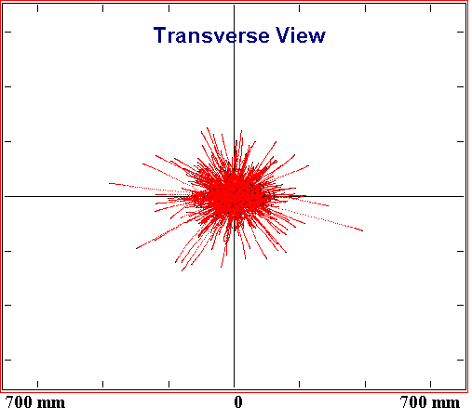 | 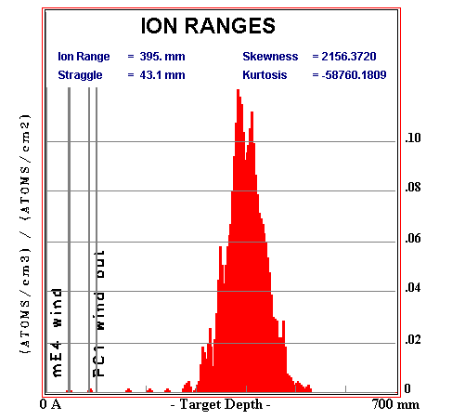
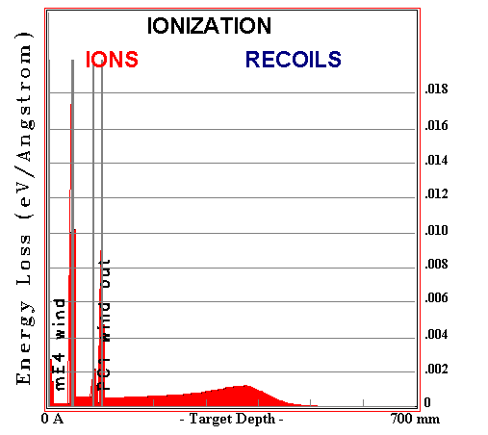 | 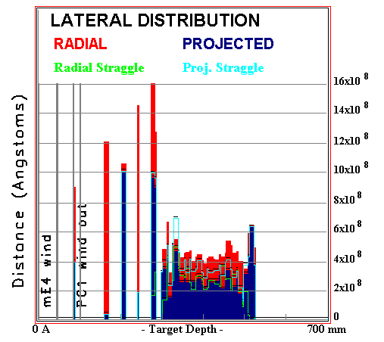
Figures show results of 0.7 mm scint simulation.
The range straggling deteriorates by 34% with the 0.7 scintillators, the angular scattering is nearly the same.

Window and scintillator studies
We now study the effect of replacing the Havar window with low Z material of similar mass. For the calculation we used 0.2 mm Kapton.
Finally we tried to use a 0.8 mm Be window.

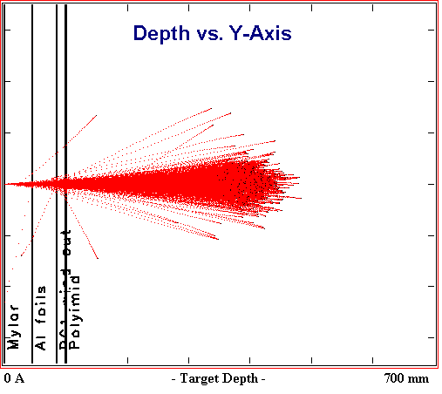 | 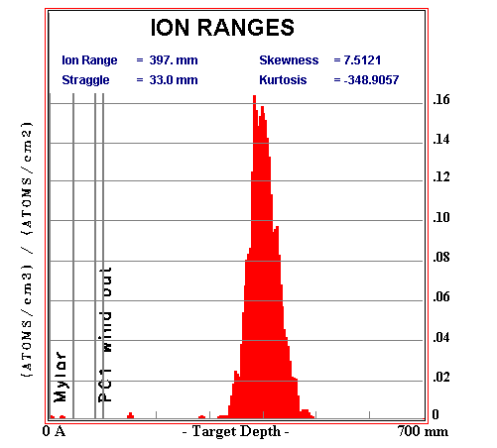

condition | mu T  MeV | longit rms from fit (mm) | lateral rms from fit (mm)
0.1 mm scint | 4.2 | 27.6 | 27.5
0.2 mm scint | 4.4 | 30 | 29
0.7 mm scint | 5.1 | 37 | 28
0.1 mm scint  0.2 Kapton window | 4.2 | 25 | 19.5
0.1 mm scint  0.8mm Be window | 5.5 | 41 | 19.5

Lower Z windows can significantly (40% for 0.2 mm Kapton) reduce multiple scattering. No big difference between Kapton and Be in the present study, but that – of course – depends on the actual thickness which can be used for the pressure window.

Caveats and further work
The effect of the wires should be included. The mPC tracking resolution should be studied with GEANT. Can we confirm/refute the discrepancies between SRIM/GEANT based on out 1999 data? The Kapton window option should be tested. Finally we will measure the stopping distribution, but we should prepare supplemental windows if scattering turns out to be a problem.

http://www.srim.org/

