More Beam Studies

http://ten.npl.uiuc.edu/~kammel/doc_mulan/

Peter Kammel

1 Overview 2
2 Studies 2
2.1 jts and sensitivity to Q8/Q9 3
2.2 Differences between Jaap and Paul model, reality 7
2.2.1 Transport 7
2.2.2 Revmoc 10
2.3 Doublet-doublet, triplet-triplet, doublet-triplet optimization 17
3 Conclusions and further work 27
3.1 Conclusions 27
3.1.1 basic beamline geometry 27
3.1.2 Basic measuring program 27
3.2 Further work 29
4 Appendix: Summer 2001 tunes: Paul (x1) and Jaap(d1) 30

Overview

This study is a follow-up to Jaap’s piE3 beam report (J1) and Peter’s discussion paper (P1) at the MuLan meeting. Several issues addressed in these reports are more systematically studied here, including
- kicker sensitivity to Q8/Q9
- differences between different models and reality
- specific studies for available beam geometry in MuLan 2002 run
- measurement program for MuLan 2002 run

Table 1: summary main tunes

Studies

jts and sensitivity to Q8/Q9
Changed distance Q8,Q9 from
5.00 'Q8 ' 0.31400 -0.14759 12.90000;
3.0 ' ' 0.61700;
5.00 'Q9 ' 0.31400 0.17785 12.90000;
to
5.00 'Q8 ' 0.31400 -0.26 12.90000;
3.0 ' ' 0.21700;
5.00 'Q9 ' 0.31400 0.271 12.90000;

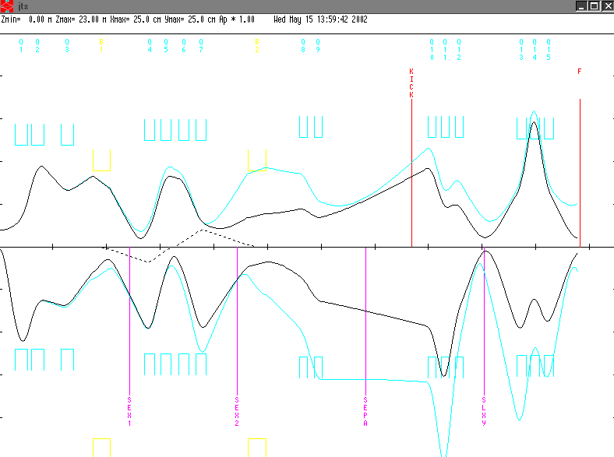
Figure 1: jts tune
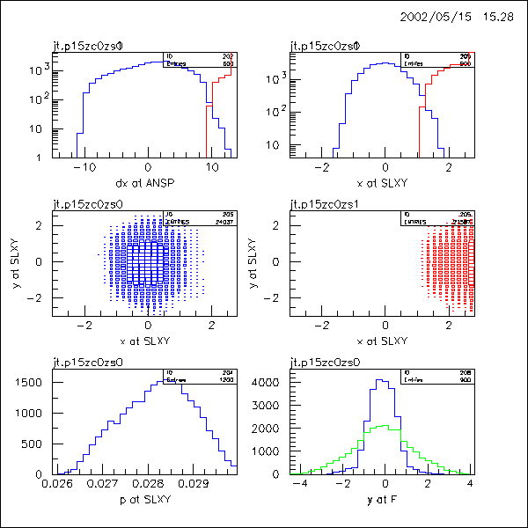
Figure 2: jt revmoc
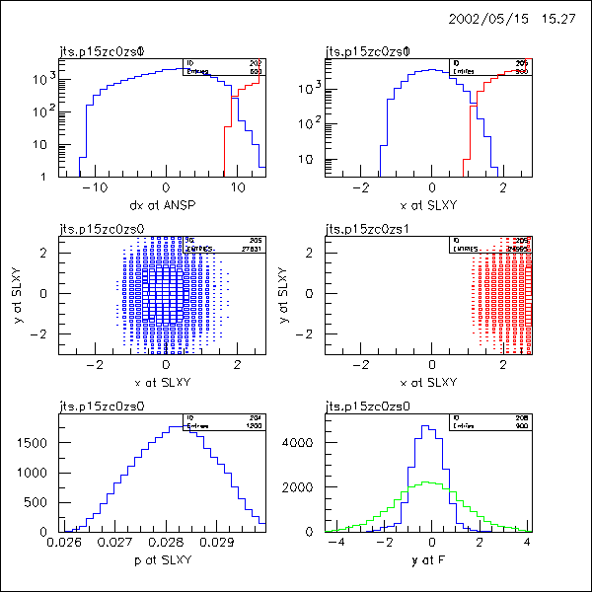
Figure 3: jts revmoc
The Q8 setting determine the size of the x beam in the kicker region, the Q9 settings determine whether the beam is parallel or not. Thus both affect the divergence x’ in the kicker region.
First we study Q9 for 0.271 , 0.285 (+5%, jts9p) and 0.258 (-5% jts9m) kG. In tranport the effect at SLXY seem small, so we don’t even try to refocus the triplet. –5% gives small improvement, +5% gives deterioriation. Probably this effect can be fixed with triplet optimzation, as it is less evident in x’.

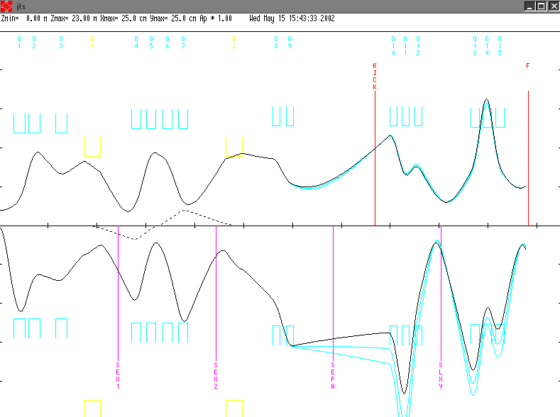
Figure 4: Q9 variation
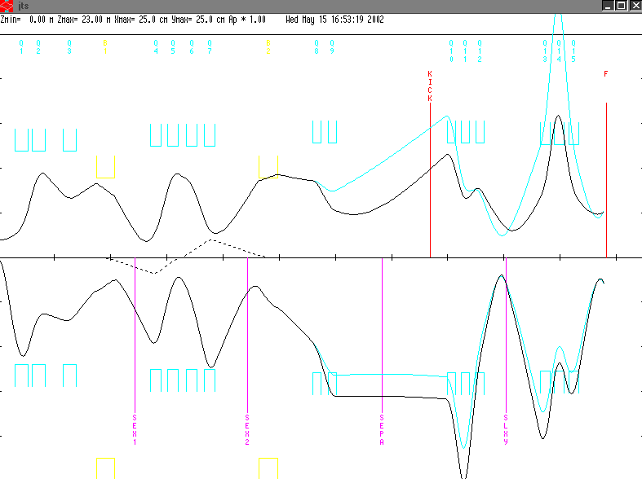
Figure 5: Q8 field reduction

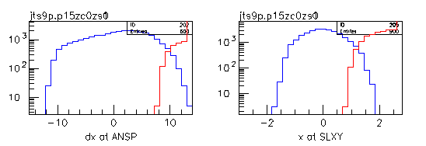
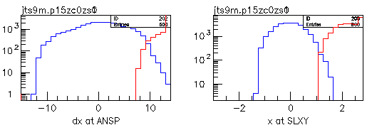
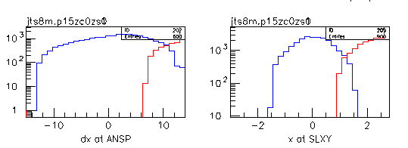
Figure 6: +- 5% variation of Q9 (first, second row), much smaller Q8 (3rd row).
Next we study Q8. We make the beam a bit smaller and tune Q9 to mimimize x’ in the kick region (jts8m)
5.00 'Q8 ' 0.31400 -0.100 12.90000;
3.0 ' ' 0.21700;
5.00 'Q9 ' 0.31400 +0.190 12.90000;
The separation seems a bit worse. A much smaller x envelope needs a polarity change in Q8/Q9. As Gerco is studying smaller kicker gaps, this study will not be done here.

Differences between Jaap and Paul model, reality
effect |  | comment
1 | element distances
2 | target distance 1.5 m | required by MuLan
3 | bend poleface curvature
4 | quad PSI fringe field corrections
5 | slits retract to 9.1 cm, separator 13 cm gap
6 | quad pole faces r=12.0 cm
7 | turn on separator

Transport
First correct 1 and 2, retune with achromatic and 1st order target focus condition (jtn.dat).

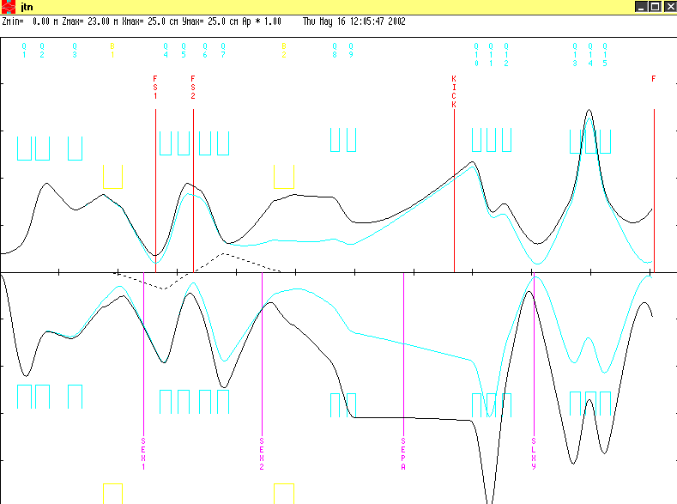
Figure 7: jtn.dat
Next study bend pole face curvature. Small effect.

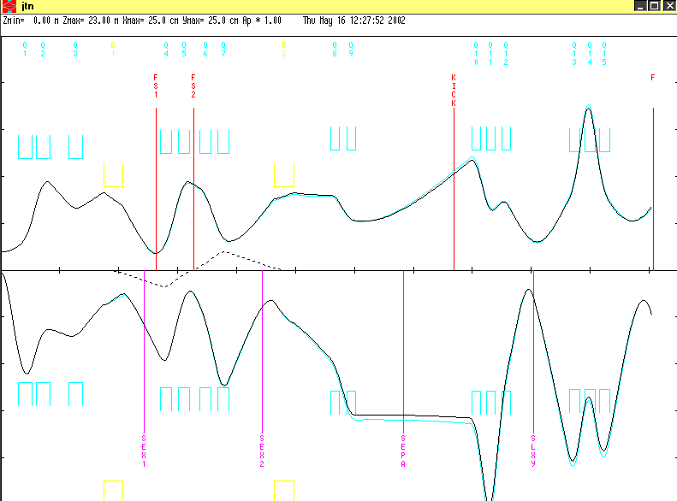
Figure 8: with/without pole face curvature

Next PSI(GIOS) fringe field corrections for quads. Not such a big effect.

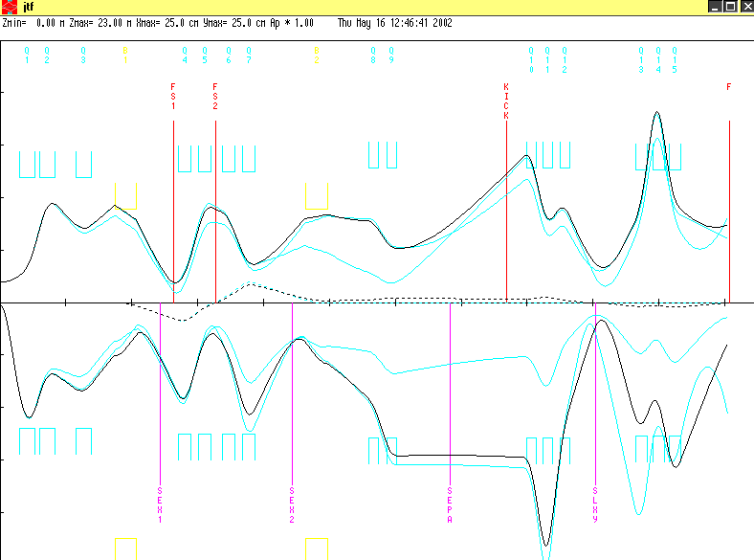.
Figure 9: with/without fringe field correction, 1 st order also shown

Retune imposing achromaticity and first order target focus in SLXY and F (jtf.dat).

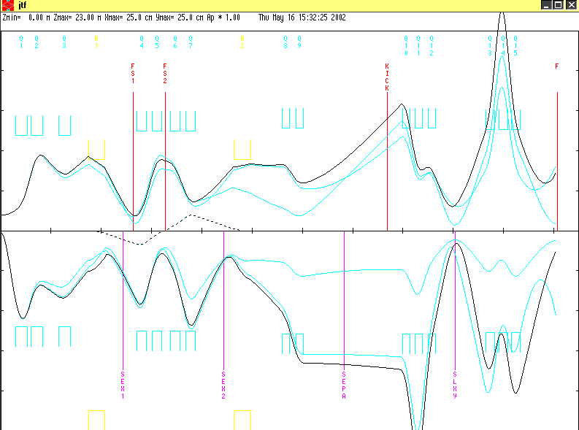
Figure 10: jtf.dat 1st and 2nd order, compared to jtn

Table 2: magnet settings for optimized tune with/without fringe corrections
Conclusion of this exercise within transport:
- updated geometry should be used (jtn.dat)
- pole face curvature small effect
- PSI fringe field corrections rather small local effect, but discrepancies propagate thorugh long channel. Retuning with fringe field corrections (jtf.dat) differs from jtn by up to 10%. Effect most significant in the last focusing triplet, but smaller retuning of achromaticity and SLXY focus required. Direct comparison of doublet/riplet with Zgoubi could clarify if PSI corrections more realistic. Otherwise experimental tuning of last 10% required.

Revmoc
First we fix the geometries and pole curvatures a’la jtn.dat. We also include the pole curvatures and redo a 1st order tranport tune. The resultsin file is jtr.dat and translated into input5.jtr. We ignore the fringe fields as they are not included in revmoc. Then we include the other Monte Carlo specific corrections by comparing input5.jtr with Paul’s turte file (bend curvature not supported in revmoc).
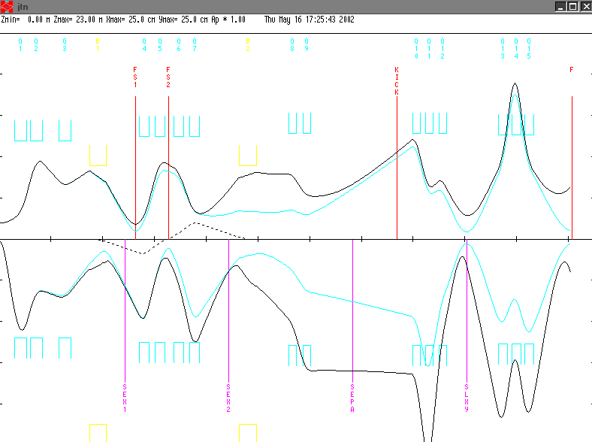
Figure 11: jtr.dat, start for revmoc studies

/*PLOT* jtr/
0
1.000000 ' ' 0.30000 150.00000 2.00000 30.00000
0.00000 4.00000 0.02800;
17. ' ' ;
3.0 ' ' 0.59750;
5.00 'Q1 ' 0.47400 0.59112 12.00000;
3.0 ' ' 0.12000;
5.00 'Q2 ' 0.47400 -0.41200 12.00000;
3.0 ' ' 0.62000;
5.00 'Q3 ' 0.47400 0.18584 12.00000;
3.0 ' ' 0.72130;
16. 'KR1E' 12.0 -0.9 ;
16. 'KR1A' 13.0 1.0 ;
16.00 ' ' 5.00000 9.00000;
16.00 ' ' 7.00000 0.30000;
16.00 ' ' 8.00000 2.80000;
2.0 ' ' 24.00000;
4.000 'B1 ' 0.65950 1.48302 0.00000;
2.0 ' ' 24.00000;
3.0 ' ' 0.40330;
3.0 'SEX1' 0.32000;
3.0 'FS1 ' 0.40350;
3.0 ' ' 0.14500;
5.00 'Q4 ' 0.39000 0.63094 12.50000;
3.0 ' ' 0.21000;
5.00 'Q5 ' 0.39000 -0.45737 12.50000;
3.0 'FS2 ' 0.13300;
3.0 ' ' 0.20000;
5.00 'Q6 ' 0.39000 -0.27195 12.50000;
3.0 ' ' 0.21000;
5.00 'Q7 ' 0.39000 0.53321 12.50000;
3.0 ' ' 0.82850;
3.0 'SEX2' 0.32000;
3.0 ' ' 0.37630;
20.0 ' ' 180.00000;
16. 'KR2E' 12.0 -0.4 ;
16. 'KR2A' 13.0 4.0 ;
16.00 ' ' 5.00000 9.00000;
16.00 ' ' 7.00000 0.340000;
16.00 ' ' 8.00000 2.80000;
2.0 ' ' 22.65000;
4.000 'B2 ' 0.69420 1.40891 0.00000;
2.0 ' ' 12.85400;
20.0 ' ' 180.00000;
-10. 1.0 6.0 0.0 .0001 /B16/ ;
-10. 2.0 6.0 0.0 .0001 /B26/ ;
3.0 ' ' 1.23620;
5.00 'Q8 ' 0.31400 -0.26 12.90000;
3.0 ' ' 0.21700;
5.00 'Q9 ' 0.31400 0.271 12.90000;
3.0 ' ' 0.64500;
3.0 'SEPA' 1.00000;
3.0 ' ' 0.70000;
3.0 'KICK' 1.00000;
3.0 ' ' 0.58600;
5.00 'Q10 ' 0.31400 -0.50936 12.90000;
3.0 ' ' 0.19600;
5.00 'Q11 ' 0.31400 0.83509 12.90000;
3.0 ' ' 0.19600;
5.00 'Q12 ' 0.31400 -0.50936 12.90000;
3.0 'SLXY' 0.80000;
-10. 2. 1. 0.0 .0001 /W21/ ;
-10. 4. 3. 0.0 .0001 /W43/ ;
3.0 ' ' 1.20000;
5.00 'Q13 ' 0.36600 0.54713 12.70000;
3.0 ' ' 0.13200;
5.00 'Q14 ' 0.36600 -0.84757 12.70000;
3.0 ' ' 0.13200;
5.00 'Q15 ' 0.36600 0.54713 12.70000;
3.0 'F ' 1.50000;
-10. 2. 1. 0.0 .0001 /W21/ ;
-10. 4. 3. 0.0 .0001 /W43/ ;
-10. -3.0 4.0 0.0 .0001 /R34/ ;
-10. -1.0 2.0 0.0 .001 /R12/ ;
SENTINEL
SENTINEL

input5.jtr

1 jtr
T T .00001 0.00001 0. 0. 0. 0.00
D BEG 0.00001 100.
D 0.59750 11.40
D AQ1 0.00001 11.40
QUAD Q1 0.47400 0.59112 12.00
D 0.00001 11.40
D 0.12000 11.40
QUAD Q2 0.47400 -0.41200 12.00
D 0.00001 11.40
D 0.62000 11.40
QUAD Q3 0.47400 0.18584 12.00
D 0.00001 11.40
D 0.72130 15.00 -15.00 8.50 -8.50
FRIN 9.00 0.3 2.8
ENTR 24.0
BEND B1 0.65950 1.48302 0. 0. 0.028
EXIT 24.0
D 0.00001 15.00 -15.00 8.50 -8.50
D 0.40330 11.900
SEXT SEX1 0.320000 0.00000 12.50
D 0.00001 11.900
D 0.40350 11.900
D 0.00001 9.10 -9.10 9.10 -9.10
D 0.14500 11.90
QUAD Q4 0.39000 0.63094 12.50
D 0.00001 11.90
D 0.21000 11.90
QUAD Q5 0.39000 -0.45737 12.50
D 0.00001 11.90
D 0.1330 11.90
D 0.00001 9.10 -9.10 9.10 -9.10
D 0.20000 11.90
QUAD Q6 0.39000 -0.27195 12.50
D 0.00001 11.90
D 0.21000 11.90
QUAD Q7 0.39000 0.53321 12.50
D 0.00001 11.90
D 0.82850 11.90
SEXT SEX2 0.32000 0.00000 12.50
D 0.3763 15.00 -15.00 8.50 -8.50
ROTATE 180.
FRIN 9.00 0.34 2.8
ENTR 22.65
BEND B2 0.69420 1.40891 0. 0. 0.028
EXIT 12.854
D 0.00001 15.00 -15.00 8.50 -8.50
ROTATE 180.
D 1.23620 12.30
QUAD Q8 0.31400 -0.26 12.90
D 0.00001 12.30
D 0.21700 12.30
QUAD Q9 0.31400 0.271 12.90
D 0.00001 12.30
D 0.64500 6.5 -6.5 10.0 -10.0
SEP POSI 0.700 0.0 0.0 0.0 0.0 0.0 0.0 0.0
D 0.00001 6.5 -6.5 10.0 -10.0
D 1.00000 7.5 -7.5 10.0 -10.0
SEP KICK 1.00 0.0 0.0 0.0 0.0 0.0 0.0 0.0
!SEP KICK 1.00 1.5 0.0 0.0 0.0 0.0 0.0 0.0 ! kick on
D 0.00001 7.5 -7.5 10.0 -10.0
D ANSP 0.58600 12.30
QUAD Q10 0.31400 -0.50936 12.90
D 0.00001 12.30
D 0.19600 12.30
QUAD Q11 0.31400 0.83509 12.90
D 0.00001 12.30
D 0.19600 12.30
QUAD Q12 0.31400 -0.50936 12.90
D 0.00001 12.30
D SLXY 0.80000 11.0 -11.0 15. -15.
!D SLXY 0.80000 1.0 -1.0 2.5 -2.5 ! collimator active
D 1.20000 12.1
QUAD Q13 0.36600 0.54713 12.70
D 0.00001 12.10
D 0.13200 12.10
QUAD Q14 0.36600 -0.84757 12.70
D 0.00001 12.10
D 0.13200 12.10
QUAD Q15 0.36600 0.54713 12.70
D AQ15 0.00001 12.10
D F 1.50000 100.
XSIZE 0.6001 400.00001
YSIZE 4.0001 100.00001
P 0.02800 0.0042 0.028 .00001 0. 0.00
!P 0.02800 0.0000 0.028 .00001 0. 0.00 ! zero delta
MASS * .105659 0. 0. 1000000.
1. .05
GROUP 1. 1000.000 0. 0.0 0. 1.
NSPAC 10. -1.
2. 2. 2. 2. 2. 2. 2. 2. 2. 2.
X BEG 50. 1.
DX BEG 50. 400.
X ANSP 50. 20.
DX ANSP 50. 30.
P ANSP 50. 0.0042 0.028
DX ANSP 50. 60.
P SLXY 50. 0.0042 0.028
X SLXY 50. 4.
X SLXY 50. 6.
Y SLXY 50. 6.
X SLXY 50. 6.
X F 50. 10.
Y SLXY 50. 6.
Y F 50. 10.
X AQ15 50. 30.
X F 50. 10.
Y AQ15 50. 30.
Y F 50. 10.
DX ANSP 50. 60.
X SLXY 50. 6.
END

Proschka, Paul’s turtle file for mixed mode

/PIE3 Run12, 27.4 MeVc, LB32, p34 ASKs set to bend by 60 degree/
100000
13. 10.0 ; (observe all magnet apertures)
16. 3.0 206.77 /MU/ ;
16. 20.0 .0 ; (homogeneous initial distribution)
1. .2 200.0 4.0 200.0 .0 10.0 0.0274 /BEAM/ ;
17. /2nd/ ;
6. 1. 0.15 /BEAX/ ; (slit in x)
6. 3. 2. /BEAY/ ; (slit in y)
16. 190. 0. 100. ; (store histo on metafile)
50. 11. 22. 38. 0.1 /HI01/ ; (histo stuff 50xx)
50.1 1. -.4 .4 0.01 /ACX/ ;
50.1 3. -7. 7. 0.2 /ACX/ ;
50.1 2. -250. 250. 5. /ACXR/ ;
50.1 4. -80. 80. 2. /ACYR/ ;
3. .32 ; (drift)
6. 1. 10. 3. 10. /TESH/ ; (define aperture due to shield near TgtE)
(half axis of ellipse)
3. .28 ;
16. 100.0 16.0 16.0 ; (quads have circ aperture of r=16)
16. 101.0 11.5 ; (quads have hyperbolic apertures)
16. 25.0 .157 ; (quad fringe field sequence)
16. 26.0 -.023 ;
16. 27.0 .049 ;
16. 28.0 -.306 ;
2. 1000.00 ;
5. .474 .5487 12.0 /QTD1/ ;
2. 1000.00 ;
3. .1195 ;
2. 1000.00 ;
5. .474 -.3577 12.0 /QTD2/ ;
2. 1000.00 ;
3. .62 ;
2. 1000.00 ;
5. .474 .1169 12.0 /QTB1/ ;
2. 1000.00 ;
3. .6955 ;
16. 12.0 -.9 /KR1E/ ; (bend in/out radii)
16. 13.0 1.0 /KR1A/ ;
16. 5.0 9.0 ; (bend fringe)
16. 7.0 .3 /K1/ ;
16. 8.0 2.8 /K2/ ;
2. 24.0 /IN1/ ; (face rotation)
4. .7 1.367 .0 /ASK1/ ;
2. 24.0 /OUT1/ ;
3. .38 ;
18. .3 .2192 16.0 /HSA1/ ;
3. .4135 /FS71/ ;
6. 1. 9.1 /71OU/; (slits)
6. 3. 9.1 /71LR/;
3. .1405 ;
16. 100.0 16.0 16.0 ;
16. 101.0 12.0 ; (different hyp boundary)
16. 25.0 .117 ; (diff fringe corrections)
16. 26.0 -.0113 ;
16. 27.0 .036 ;
16. 28.0 -.265 ;
2. 1000.00 ;
5. .39 .5482 12.5 /QSK1/ ;
2. 1000.00 ;
3. .21 ;
2. 1000.00 ;
5. .39 .1204 12.5 /QSK2/ ;
2. 1000.00 ;
3. .1666 /FS72/ ;
6. 1. 9.1 /72OU/; (slits)
6. 3. 9.1 /72LR/;
3. .1666 ;
2. 1000.00 ;
5. .39 -.5728 12.5 /QSK3/ ;
2. 1000.00 ;
3. .21 ;
2. 1000.00 ;
5. .39 .5689 12.5 /QSK4/ ;
2. 1000.00 ;
3. .8385 ;
18. .3 .0424 16.0 /HSA2/ ;
( 18. .3 .000 16.0 /HSA2/ ;)
3. .355 ;
20. 180.0 ; (rotation)
16. 12.0 -.4 /KR1E/ ;
16. 13.0 4.0 /KR1A/ ;
16. 5.0 9.0 ;
16. 7.0 .34 /K1/ ;
16. 8.0 2.8 /K2/ ;
2. 22.65 /IN2/ ;
4. .7 1.367 .0 /ASK2/ ;
2. 12.854 /OUT2/ ;
20. 180.0 ;
3. .5475 ;
18. .3 0.0313 16.0 /HSD1/ ;
3. .36 ;
16. 100.0 16.0 16.0 ; (quad boundaries again)
16. 101.0 12.0 ;
2. 1000.00 ;
5. .314 .3601 12.9 /QSB1/ ;
2. 1000.00 ;
3. .217 ;
2. 1000.00 ;
5. .314 -.030 12.9 /QSB2/ ;
2. 1000.00 ;
3. 0.2 ;
(now the 320 ISO shutter and "balg")
(now the 320 ISO shutter and "balg" and Sep entrance)
3. 0.295 ;
(now rotate the beam by 90 degree to exchange x and y)
(the SEP instruction assume the E-field parallel to x)
(here, x is vertical and the E-field horizontal)
20. -90. ; (rotation)
16. 3.0 206.77 /MU/ ;
-16. 3.0 1. /E+/ ;
16. 5. 11. /SDY/ ; (width/2 ?)
16. 4. 6.5 /SDX/ ; (gap/2 ?)
27. .01 .0 .0 /S1/ ; (L m, E kV/cm, B kG)
27. .10 .0 -.005 /S2/ ;
27. .05 .0 -.0126 /S3/ ;
27. .05 4.55 -.04 /S4/ ;
27. .10 9.1 -.131 /S5/ ;
27. .10 9.1 -.142 /S6/ ;
27. .10 9.1 -.142 /S6/ ;
27. .10 9.1 -.131 /S7/ ;
27. .10 9.1 -.106 /S8/ ;
27. .10 9.1 -.0733 /S9/ ;
27. .05 4.55 -.04 /S10/;
27. .05 .0 -.0126 /S11/;
27. .10 .0 -.005 /S12/;
27. .0 .0 .0 /S13/;
16. 4. 60. ;
16. 5. 12. ;
20. 90. ;
(end of Sep, next ISO 320 shutter with additional tube)
3. 0.24 ;
3. 0.196 ;
2. 1000.00 ;
5. .314 -.6795 12.9 /QSB3/ ;
2. 1000.00 ;
3. .196 ;
2. 1000.00 ;
5. .314 .8904 12.9 /QSB4/ ;
2. 1000.00 ;
(from viewing the Quads in the area the QSB74 stops now)
(there is no additional drift length, so, "our" drift length start now)
3. 0.814 ;
53.1 ;
( 16. 180.0 77.0 1.0 ;)
3. 0. /TAR/;
SENTINEL
SENTINEL

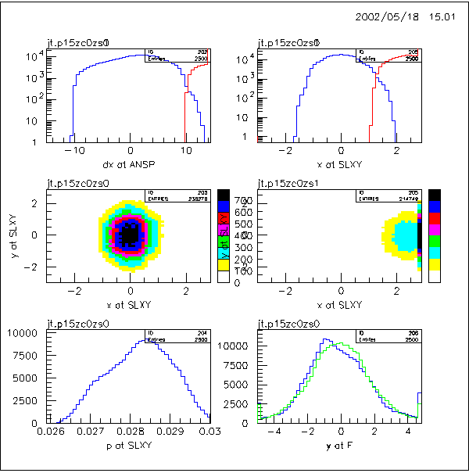
Figure 12: jt, ignore F, because not optimized on 1.5 m
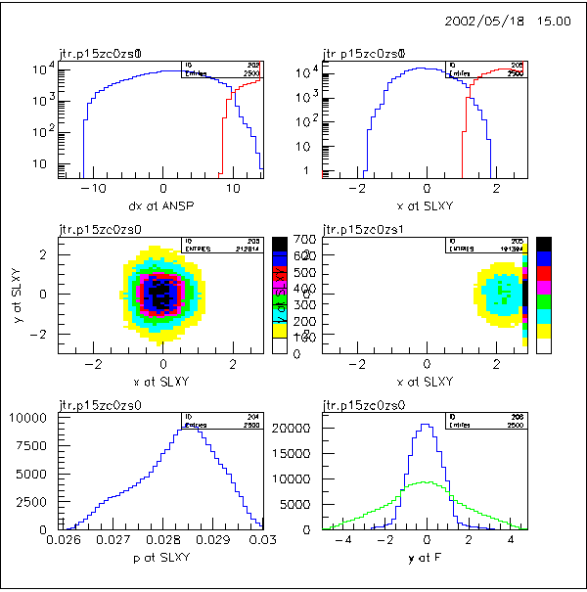
Figure 13: jtr with updates and refinements
Thus jtr pretty consistent with jt. Magnet and geometry changes (apart from Q8,Q9 and F) less than 5 %. Transmission about 10% smaller, probably because of 13 cm separator gap. Typical transmission table for events. Details are stored in tunes.xls spreadsheet.
Table 3: jtr transmission
Next we check the effect of the separator. We select 5KV/cm and 64G (ideally it should be 65.3G, but revmoc prefers slightly lower values (input5.jtp). There is a slight extension of the right tails, but the left tails stay practically the same.
SEP POSI 0.700 5.0 0.064 0.0 0.0 0.0 0.0 0.0
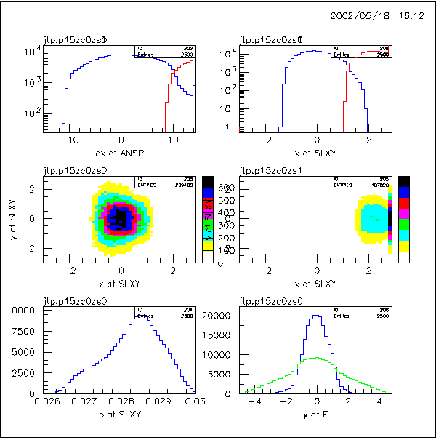
Figure 14: jtp
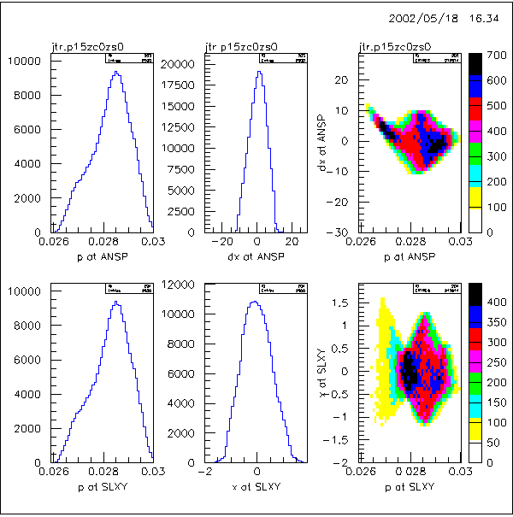
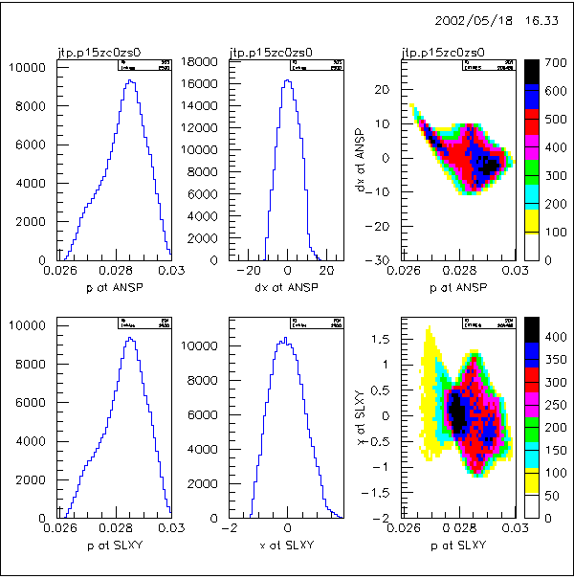
Figure 15: more comparison jtr and jtp, small sep effects
Finally we check the effect of the SLXY position starting with jtr. We change
3.0 'SLXY' 0.80000; to 3.0 'SLXY' 1.20000
3.0 ' ' 1.20000; to 3.0 ' ' 0.80000;
and reoptimize. The magnification at SLXY changes but the separation is similar to jtr.
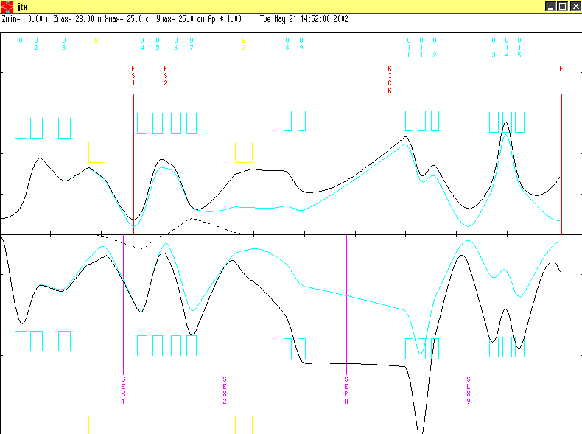

Figure 16: jtx

/*PLOT* jtx/
0
1.000000 ' ' 0.30000 150.00000 2.00000 30.00000
0.00000 4.00000 0.02800;
17. ' ' ;
3.0 ' ' 0.59750;
5.00 'Q1 ' 0.47400 0.59112 12.00000;
3.0 ' ' 0.12000;
5.00 'Q2 ' 0.47400 -0.41200 12.00000;
3.0 ' ' 0.62000;
5.00 'Q3 ' 0.47400 0.18584 12.00000;
3.0 ' ' 0.72130;
16. 'KR1E' 12.0 -0.9 ;
16. 'KR1A' 13.0 1.0 ;
16.00 ' ' 5.00000 9.00000;
16.00 ' ' 7.00000 0.30000;
16.00 ' ' 8.00000 2.80000;
2.0 ' ' 24.00000;
4.000 'B1 ' 0.65950 1.48302 0.00000;
2.0 ' ' 24.00000;
3.0 ' ' 0.40330;
3.0 'SEX1' 0.32000;
3.0 'FS1 ' 0.40350;
3.0 ' ' 0.14500;
5.00 'Q4 ' 0.39000 0.63094 12.50000;
3.0 ' ' 0.21000;
5.00 'Q5 ' 0.39000 -0.45737 12.50000;
3.0 'FS2 ' 0.13300;
3.0 ' ' 0.20000;
5.00 'Q6 ' 0.39000 -0.27195 12.50000;
3.0 ' ' 0.21000;
5.00 'Q7 ' 0.39000 0.53321 12.50000;
3.0 ' ' 0.82850;
3.0 'SEX2' 0.32000;
3.0 ' ' 0.37630;
20.0 ' ' 180.00000;
16. 'KR2E' 12.0 -0.4 ;
16. 'KR2A' 13.0 4.0 ;
16.00 ' ' 5.00000 9.00000;
16.00 ' ' 7.00000 0.340000;
16.00 ' ' 8.00000 2.80000;
2.0 ' ' 22.65000;
4.000 'B2 ' 0.69420 1.40891 0.00000;
2.0 ' ' 12.85400;
20.0 ' ' 180.00000;
-10. 1.0 6.0 0.0 .0001 /B16/ ;
-10. 2.0 6.0 0.0 .0001 /B26/ ;
3.0 ' ' 1.23620;
5.00 'Q8 ' 0.31400 -0.26 12.90000;
3.0 ' ' 0.21700;
5.00 'Q9 ' 0.31400 0.271 12.90000;
3.0 ' ' 0.64500;
3.0 'SEPA' 1.00000;
3.0 ' ' 0.70000;
3.0 'KICK' 1.00000;
3.0 ' ' 0.58600;
5.00 'Q10 ' 0.31400 -0.45479 12.90000;
3.0 ' ' 0.19600;
5.00 'Q11 ' 0.31400 0.75955 12.90000;
3.0 ' ' 0.19600;
5.00 'Q12 ' 0.31400 -0.45479 12.90000;
3.0 'SLXY' 1.20000;
-10. 2. 1. 0.0 .0001 /W21/ ;
-10. 4. 3. 0.0 .0001 /W43/ ;
3.0 ' ' 0.80000;
5.00 'Q13 ' 0.36600 0.60585 12.70000;
3.0 ' ' 0.13200;
5.00 'Q14 ' 0.36600 -0.90349 12.70000;
3.0 ' ' 0.13200;
5.00 'Q15 ' 0.36600 0.60585 12.70000;
3.0 'F ' 1.50000;
-10. 2. 1. 0.0 .0001 /W21/ ;
-10. 4. 3. 0.0 .0001 /W43/ ;
-10. -3.0 4.0 0.0 .0001 /R34/ ;
-10. -1.0 2.0 0.0 .001 /R12/ ;
SENTINEL
SENTINEL

Doublet-doublet, triplet-triplet, doublet-triplet optimization
Based on the studies of the previous section we take jtp or jtr as the input file for optimization of the last two focussing combinations (for the transport studies jtr, ignoring the Wien filter is used).
As a guidance we first check jtr (jtrt indicates modifications of SLXY, AQ15 slits). The shaping of the y focus is mainly achieved with a SLXY slit in y. The AQ15 slit is only marginally used to cut the x tail. The F vs. AQ15/SLXY correlation plots indicate that smaller foci can be achieved with these slits at a cost of intensity. Comparison with jtp gives very close results, so – given the simplistic separator simulation – we stay with jtr.
The detailed studies below lead to the following conclusions
- jdr2 and jdr3 roughly equivalent, but 50 % loss compared to jtr.
- With same transmission jtrt allow much better y focus.
- jtx is similar to jtr.
Table 4: x and y width and transmission at F position

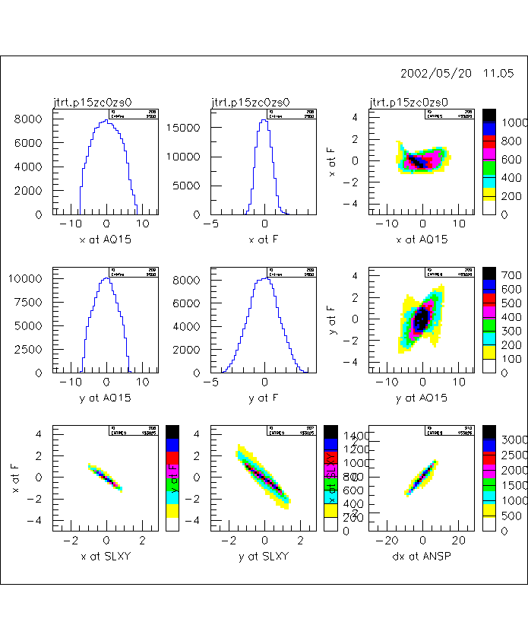
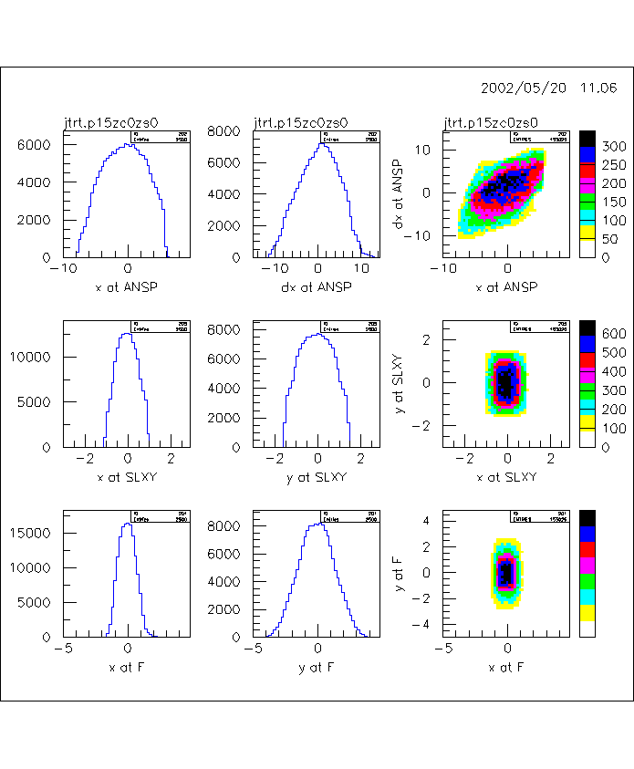

Figure 17: jtrt

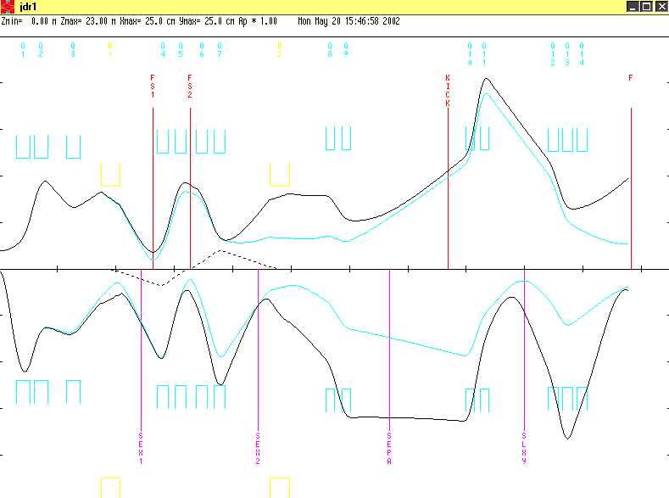
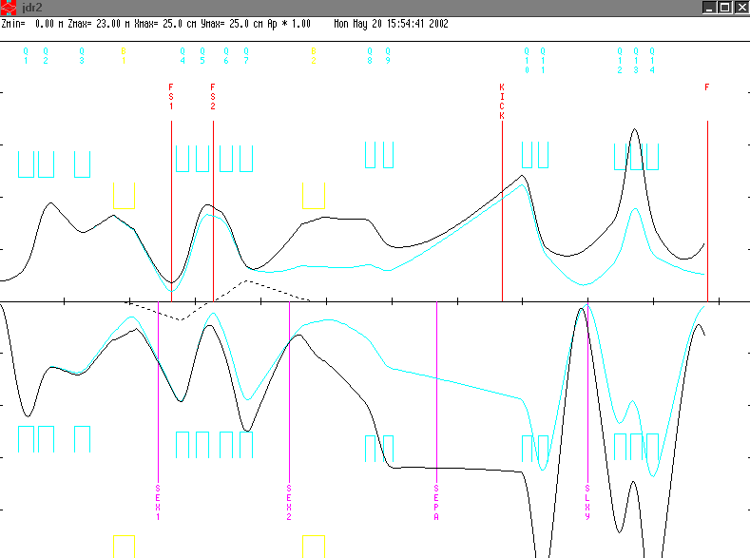
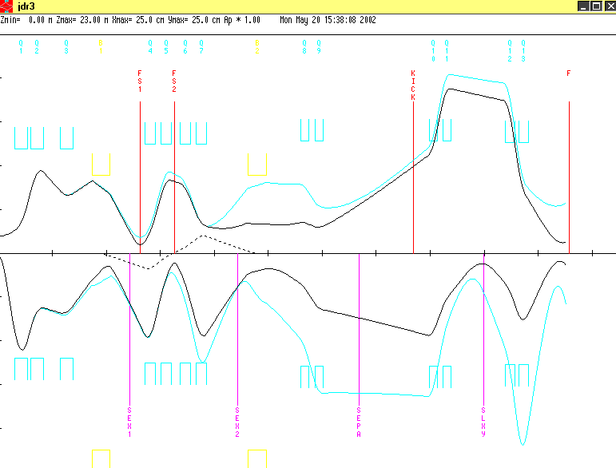
Figure 18: jdr1, jdr2, jdr3

tune | last quads
jdr1 | 5.00 'Q10 ' 0.31400 0.42017 12.90000;  3.0 ' ' 0.19600;  5.00 'Q11 ' 0.31400 -0.41208 12.90000;  3.0 'SLXY' 1.20000;  3.0 ' ' 0.80000;  5.00 'Q12 ' 0.36600 -0.18 12.70000;  3.0 ' ' 0.13200;  5.00 'Q13 ' 0.36600 0.435 12.70000;  3.0 ' ' 0.13200;  5.00 'Q14 ' 0.36600 0.0 12.70000;  3.0 'F ' 1.50000; | no reasonable y focus in revmoc
jdr2 | 5.00 'Q10 ' 0.31400 -0.54930 12.90000;  3.0 ' ' 0.19600;  5.00 'Q11 ' 0.31400 +0.6837 12.90000;  3.0 'SLXY' 1.20000;  3.0 ' ' 0.80000;  5.00 'Q12 ' 0.36600 +0.5994 12.70000;  3.0 ' ' 0.13200;  5.00 'Q13 ' 0.36600 -0.8741 12.70000;  3.0 ' ' 0.13200;  5.00 'Q14 ' 0.36600 +0.5994 12.70000;  3.0 'F ' 1.50000; | looks promising.  The x focus at SLXY is very narrow (HWZM=1.2cm).  However, ~50% intensity is lost compared to jtr.  Advantage compared to jdr3 that SLXY relatively narrow in both planes (measurable with MWPC).
jdr3 | 5.00 'Q10 ' 0.31400 0.39 12.90000;  3.0 ' ' 0.19600;  5.00 'Q11 ' 0.31400 -0.3235 12.90000;  3.0 'SLXY' 1.20000;  3.0 ' ' 0.80000;  5.0 'Q12 ' 0.36600 -0.4001 12.70000;  3.0 ' ' 0.13200;  5.00 'Q13 ' 0.36600 0.6388 12.70000;  3.0 'F ' 1.50000; | 2 doublet combination also promising. Similar performance as jdr3, but again at least 50% loss.
Table 5: jd comparison

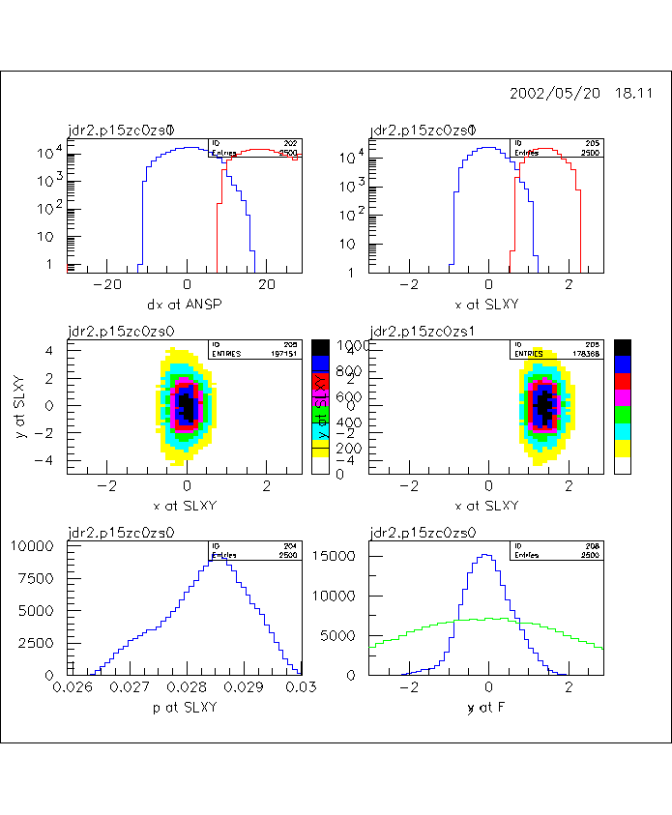
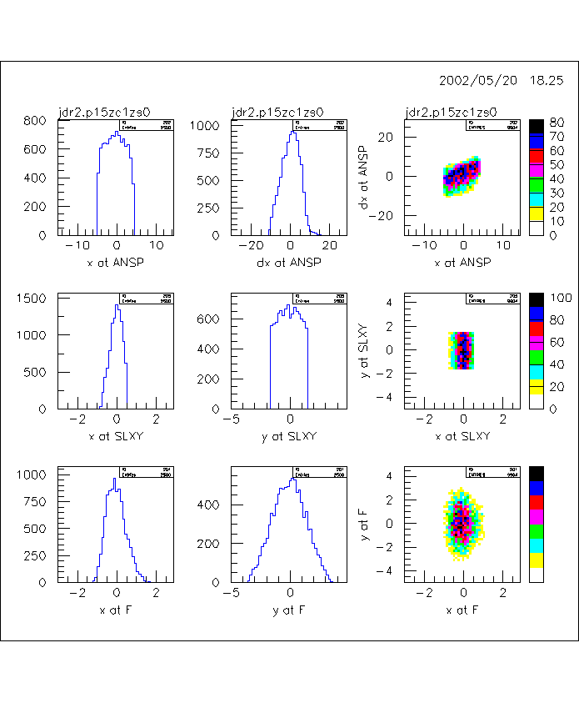
Figure 19:jdr2
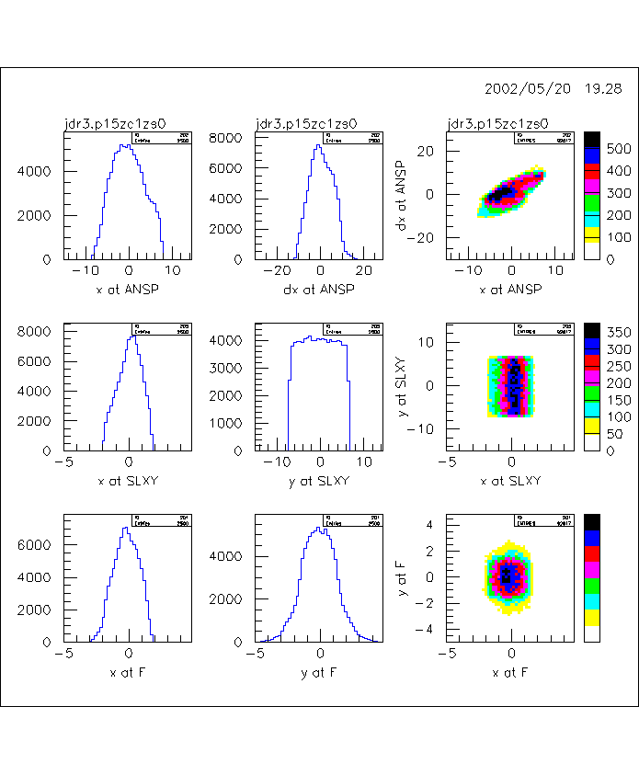
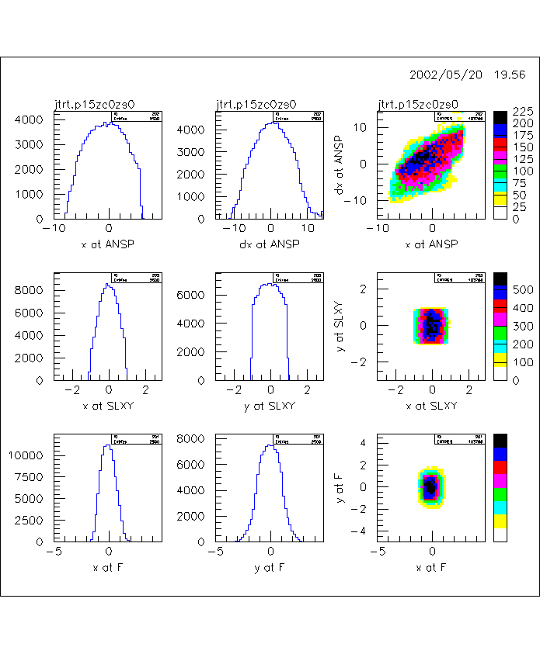
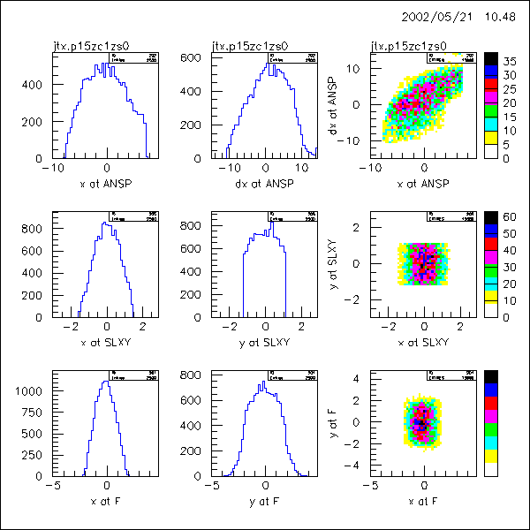
Figure 20: jdr3, jtr narrow, jtx
A tight selection in x and y, as imposed for kciking and to make the y focus narrow (jtrt narrow), changes the momentum acceptance compared to the open slit situation in jtr. This is due to the chromatic aberations in second order.
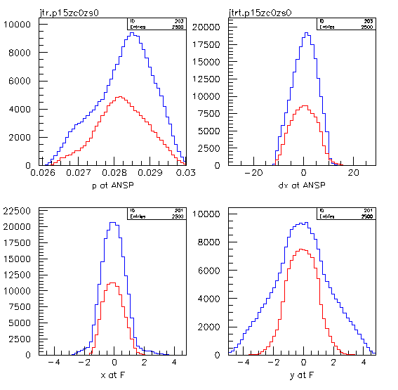
Figure 21: comparison p acceptance for wide and narrow SLXY cuts

1 jdr3
T T .00001 0.00001 0. 0. 0. 0.00
D BEG 0.00001 100.
D 0.59750 11.40
D AQ1 0.00001 11.40
QUAD Q1 0.47400 0.59112 12.00
D 0.00001 11.40
D 0.12000 11.40
QUAD Q2 0.47400 -0.41200 12.00
D 0.00001 11.40
D 0.62000 11.40
QUAD Q3 0.47400 0.18584 12.00
D 0.00001 11.40
D 0.72130 15.00 -15.00 8.50 -8.50
FRIN 9.00 0.3 2.8
ENTR 24.0
BEND B1 0.65950 1.48302 0. 0. 0.028
EXIT 24.0
D 0.00001 15.00 -15.00 8.50 -8.50
D 0.40330 11.900
SEXT SEX1 0.320000 0.00000 12.50
D 0.00001 11.900
D 0.40350 11.900
D 0.00001 9.10 -9.10 9.10 -9.10
D 0.14500 11.90
QUAD Q4 0.39000 0.63094 12.50
D 0.00001 11.90
D 0.21000 11.90
QUAD Q5 0.39000 -0.45737 12.50
D 0.00001 11.90
D 0.1330 11.90
D 0.00001 9.10 -9.10 9.10 -9.10
D 0.20000 11.90
QUAD Q6 0.39000 -0.27195 12.50
D 0.00001 11.90
D 0.21000 11.90
QUAD Q7 0.39000 0.53321 12.50
D 0.00001 11.90
D 0.82850 11.90
SEXT SEX2 0.32000 0.00000 12.50
D 0.3763 15.00 -15.00 8.50 -8.50
ROTATE 180.
FRIN 9.00 0.34 2.8
ENTR 22.65
BEND B2 0.69420 1.40891 0. 0. 0.028
EXIT 12.854
D 0.00001 15.00 -15.00 8.50 -8.50
ROTATE 180.
D 1.23620 12.30
QUAD Q8 0.31400 -0.26 12.90
D 0.00001 12.30
D 0.21700 12.30
QUAD Q9 0.31400 0.271 12.90
D 0.00001 12.30
D 0.64500 6.5 -6.5 10.0 -10.0
SEP POSI 0.700 5.0 0.064 0.0 0.0 0.0 0.0 0.0
D 0.00001 6.5 -6.5 10.0 -10.0
D 1.00000 7.5 -7.5 10.0 -10.0
SEP KICK 1.00 0.0 0.0 0.0 0.0 0.0 0.0 0.0
D 0.00001 7.5 -7.5 10.0 -10.0
D ANSP 0.58600 12.30
QUAD Q10 0.31400 0.39 12.90
D 0.00001 12.30
D 0.19600 12.30
QUAD Q11 0.31400 -0.3235 12.90
D SLXY 1.20000 11.0 -11.0 15. -15.
D 0.80000 12.1
QUAD Q12 0.36600 -0.4001 12.70
D 0.00001 12.10
D 0.13200 12.10
QUAD Q13 0.36600 0.6388 12.70
D AQ15 0.00001 6. -6. 15. -15.
D 0.00001 12.10
D F 1.50000 100.
XSIZE 0.6001 400.00001
YSIZE 4.0001 100.00001
P 0.02800 0.0042 0.028 .00001 0. 0.00
MASS * .105659 0. 0. 1000000.
1. .05
GROUP 1. 1000.000 0. 0.0 0. 1.
NSPAC 10. -1.
2. 2. 2. 2. 2. 2. 2. 2. 2. 2.
X F 50. 10.
Y F 50. 10.
X ANSP 50. 30.
DX ANSP 50. 60.
P ANSP 50. 0.0042 0.028
DX ANSP 50. 60.
P SLXY 50. 0.0042 0.028
X SLXY 50. 10.
X SLXY 50. 10.
Y SLXY 50. 30.
X SLXY 50. 10.
X F 50. 10.
Y SLXY 50. 30.
Y F 50. 10.
X AQ15 50. 30.
X F 50. 10.
Y AQ15 50. 30.
Y F 50. 10.
DX ANSP 50. 60.
X SLXY 50. 10.
END

1 jtx
T T .00001 0.00001 0. 0. 0. 0.00
D BEG 0.00001 100.
D 0.59750 11.40
D AQ1 0.00001 11.40
QUAD Q1 0.47400 0.59112 12.00
D 0.00001 11.40
D 0.12000 11.40
QUAD Q2 0.47400 -0.41200 12.00
D 0.00001 11.40
D 0.62000 11.40
QUAD Q3 0.47400 0.18584 12.00
D 0.00001 11.40
D 0.72130 15.00 -15.00 8.50 -8.50
FRIN 9.00 0.3 2.8
ENTR 24.0
BEND B1 0.65950 1.48302 0. 0. 0.028
EXIT 24.0
D 0.00001 15.00 -15.00 8.50 -8.50
D 0.40330 11.900
SEXT SEX1 0.320000 0.00000 12.50
D 0.00001 11.900
D 0.40350 11.900
D 0.00001 9.10 -9.10 9.10 -9.10
D 0.14500 11.90
QUAD Q4 0.39000 0.63094 12.50
D 0.00001 11.90
D 0.21000 11.90
QUAD Q5 0.39000 -0.45737 12.50
D 0.00001 11.90
D 0.1330 11.90
D 0.00001 9.10 -9.10 9.10 -9.10
D 0.20000 11.90
QUAD Q6 0.39000 -0.27195 12.50
D 0.00001 11.90
D 0.21000 11.90
QUAD Q7 0.39000 0.53321 12.50
D 0.00001 11.90
D 0.82850 11.90
SEXT SEX2 0.32000 0.00000 12.50
D 0.3763 15.00 -15.00 8.50 -8.50
ROTATE 180.
FRIN 9.00 0.34 2.8
ENTR 22.65
BEND B2 0.69420 1.40891 0. 0. 0.028
EXIT 12.854
D 0.00001 15.00 -15.00 8.50 -8.50
ROTATE 180.
D 1.23620 12.30
QUAD Q8 0.31400 -0.26 12.90
D 0.00001 12.30
D 0.21700 12.30
QUAD Q9 0.31400 0.271 12.90
D 0.00001 12.30
D 0.64500 6.5 -6.5 10.0 -10.0
SEP POSI 0.700 5.0 0.064 0.0 0.0 0.0 0.0 0.0
D 0.00001 6.5 -6.5 10.0 -10.0
D 1.00000 7.5 -7.5 10.0 -10.0
SEP KICK 1.00 0.0 0.0 0.0 0.0 0.0 0.0 0.0
!SEP KICK 1.00 1.5 0.0 0.0 0.0 0.0 0.0 0.0 ! kick on
D 0.00001 7.5 -7.5 10.0 -10.0
D ANSP 0.58600 12.30
QUAD Q10 0.31400 -0.45479 12.90
D 0.00001 12.30
D 0.19600 12.30
QUAD Q11 0.31400 0.75955 12.90
D 0.00001 12.30
D 0.19600 12.30
QUAD Q12 0.31400 -0.45479 12.90
D 0.00001 12.30
D SLXY 1.20000 11.0 -11.0 15. -15.
D 0.80000 12.1
QUAD Q13 0.36600 0.60585 12.70
D 0.00001 12.10
D 0.13200 12.10
QUAD Q14 0.36600 -0.90349 12.70
D 0.00001 12.10
D 0.13200 12.10
QUAD Q15 0.36600 0.60585 12.70
D AQ15 0.00001 6. -6. 4. -4.
D F 1.50000 100.
XSIZE 0.6001 400.00001
YSIZE 4.0001 100.00001
P 0.02800 0.0042 0.028 .00001 0. 0.00
MASS * .105659 0. 0. 1000000.
1. .05
GROUP 1. 100.000 0. 0.0 0. 1.
NSPAC 10. -1.
2. 2. 2. 2. 2. 2. 2. 2. 2. 2.
X F 50. 10.
Y F 50. 10.
X ANSP 50. 20.
DX ANSP 50. 30.
P ANSP 50. 0.0042 0.028
DX ANSP 50. 60.
P SLXY 50. 0.0042 0.028
X SLXY 50. 4.
X SLXY 50. 6.
Y SLXY 50. 6.
X SLXY 50. 6.
X F 50. 10.
Y SLXY 50. 6.
Y F 50. 10.
X AQ15 50. 30.
X F 50. 10.
Y AQ15 50. 30.
Y F 50. 10.
DX ANSP 50. 60.
X SLXY 50. 6.
END

Conclusions and further work

Conclusions

basic beamline geometry
- Present Q6, Q7 distance ok
- 1 m distance between SEP and KICK assumed, should be as short as possible
- KICK dimensions in present study: deflector electrodes 1 m long, gap 15cm, width 20 cm
Two beam pipe collimator inserts of this dimensions should be prepared in Boston (additional alternative insert geometry depends on Gerco’s studies).
- If possible the two last focusing elements should be two triplets for the summer run. This gives us the highest rate and flexibility. Second best choice is doublet, then triplet.
- SLXY should be located at 1.2 m from last Q, with distance 0.8 m to next Q.
- If possible we should have an AQ15 slit.
- Beam pipe should extend all the way to F for beam tests and have the full 30 cm diameter window (0.126 mm thick?). We don’t want to mix up beam properties and scattering effects.

Basic measuring program
- geometries

JP | Johny chamber close to window, SC behind last chamber
JM | Johny chamber close to window, SC behind first chamber
ES | telescope beam scan
RS | range scan
SiS | Silicon beam scan
BC | little beam chamber

comments:
JP, JM pretty obvious
ES could be a larger area eye scintillator arrangement for muons, but RS probably more precise. Also eyes don’t have an electron veto. Perhaps just to a telescope with 5x5 cm2 scintillators.
RS is small scintillator telescope mounted on the beam scanner (see Figure 22: sketch of RS). It consists of
  - RS1 (0.1mm thick): to determine low energy tails
  - RS2 (3mm thick): main mu stop counter
  - RS3(1cm thick): electron veto
High rate compatible. Potentially a collimator should be used to better define the acceptance. With that device we should be able to measure chromaticity and space vs p correlations. In particular we should be sensitive to low energy tails. This method should be compared to SiS measurement.
SiS alternative to RS or combination?
BC perhaps useful at F location.
Best detector arrangement should be discussed in more detail.

- measurements at SLXY

 | measurements | particles
1 | JP phase space for promising tunes | pi-
2 | JP augment with ES for large beam sizes
3S | JM separator tunes | mu+
3 | JM for promising tunes
4 | RS for best tunes
3’ | as 3 but kicked beam
4’ ? | as 4 ES or RS but kicked beam, see mu and e

- measurements at F

 | measurements | particles
3 | JM or BC | mu+
4 | RS for best tunes
3’ | as 3 but kicked beam
4’ | as 4 but kicked beam, see mu and e, PID

mu- measurements in last week.

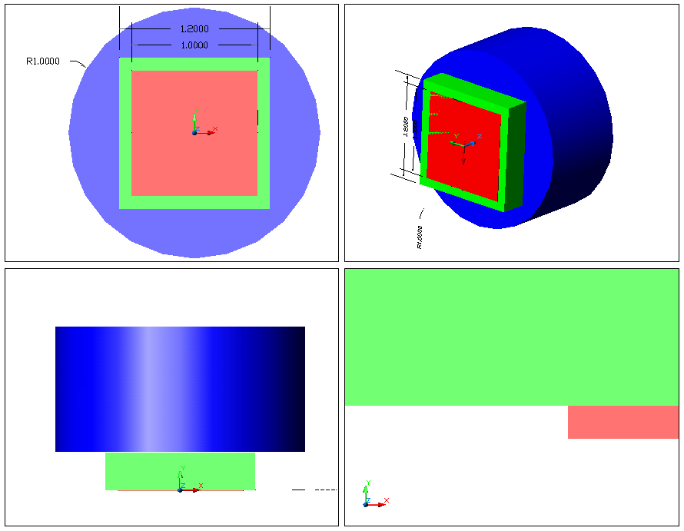
Figure 22: sketch of RS

Further work
- Comparison with turtle (Gerco)
Originally we planned a comparison with turtle for one specific example. As a first comparison indicated some differences it would be worthwhile to redo the full optimization above for the best case to check whether one arrives at similar conclusion as with revmoc.
- Momentum selection studies (Gerco)
Mixed tune studies are certainly important to find a tune that allows momentum selection. Tentatively I found a such a tune, starting with the mixed setup for the first 3 quads and then tuning Q4-Q7 for achromaticity.
In the jtr, jdr exercises above I improved the focus by sacrificing more than 50% of the beam. The y optimization was done primarily to reduce chromatic effects. Probably the same can be achieved by momentum selection, with the additional benefit of a smaller range width. A full optimization has to be worked out.
- Find better (i.e. higher transmission) doublet-doublet or triplet-doublet combinations
- Kicker with smaller gap (Gerco). Scaling laws for RF supply.

- y kick studies (Peter?)
If time permits I will try that.

- sexupole corrections?
There are pretty strange behaviours in the x,x’ vs p plot. Can that we improved with sexupoles? Can the y focusing be improved with sexupoles?

- Zgoubi ?
Jaap recommends the use of Zgoubi, but also warns that a lot of work is involved. We would have to use the quad maps to properly account for end shimming. Who will do that job?

- Measuring program and tuning strategy (Peter&Paul)
We should have a plan 10 days in advance of the run. If hardware preparations are involved (beamline, detectors) even earlier.

- Contact Lee
We have to contact Lee concerning the pseudo kicker collimators.
- Prepare detectors

Appendix: Summer 2001 tunes: Paul (x1) and Jaap(d1)

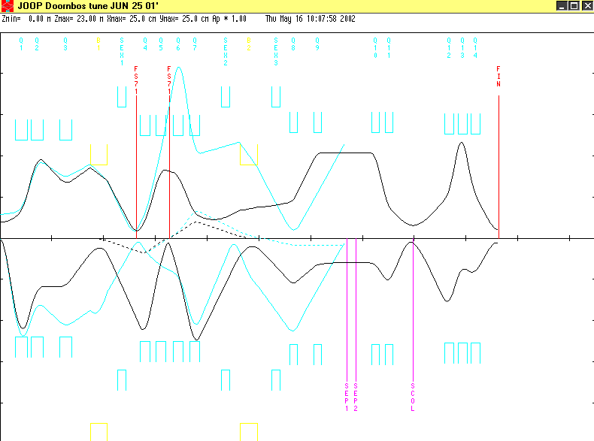
d1.dat

'*PLOT* d1'
(use Doornbos labels)
(no quad fringe field in original file-leave option in)
(sextupoles set to zero in original file)
0
1. .20 150.0 2.0 30.0 0.0 5.0 .0280 /BEAM/ ;
-17. /ZWEI/;
3. .5975 ;
-16. 25.0 .157 ;
-16. 26.0 -.023 ;
-16. 27.0 .049 ;
-16. 28.0 -.306 ;
-2. 1000.00 ;
(Q1 = QTD71)
5. .474 .60112 12.0 /Q1/ ;
-2. 1000.00 ;
3. .12 ;
-2. 1000.00 ;
(Q2 = QTD72)
5. .474 -.4120 12.0 /Q2/ ;
-2. 1000.00 ;
3. .62 ;
-2. 1000.00 ;
(Q3 = QTB71)
5. .474 .18584 12.0 /Q3/ ;
-2. 1000.00 ;
3. .72130 ;
(no pole face curvatures in original file)
-16. 12.0 -.9 /KR1E/ ;
-16. 13.0 1.0 /KR1A/ ;
16. 5.0 9.0 ;
16. 7.0 0.3 /K1/ ;
16. 8.0 2.8 /K2/ ;
2. 24.0 /IN1/ ;
(B1 = ASK71)
4. .65950 1.48302 .0 /B1/ ;
2. 24.0 /OUT1/ ;
3. .40130 ;
18. .320 0.000 16.0 /SEX1/ ;
3. .4135 /FS71/ ;
(fit for focus in both planes at first slits)
-10. -1.0 2.0 0.0 .001 /A12 / ;
-10. -3.0 4.0 0.0 .001 /A34 / ;
3. .1350 ;
-16. 25.0 .117 ;
-16. 26.0 -.0113 ;
-16. 27.0 .036 ;
-16. 28.0 -.265 ;
-2. 1000.00 ;
(Q4 = QSK71)
5. .39 .63212 12.5 /Q4/ ;
-2. 1000.00 ;
3. .21 ;
-2. 1000.00 ;
(note change of polarity from standard tunes)
(Q5 = QSK72)
5. .39 -0.45737 12.5 /Q5/ ;
-2. 1000.00 ;
3. .14150 /FS71/ ;
(fit for focus in non bend plane at second slits)
-10. -3.0 4.0 0.0 0.001 ;
3. .14150 ;
-2. 1000.00 ;
(Q6 = QSK73)
5. .39 -.27195 12.5 /Q6/ ;
-2. 1000.00 ;
(next drift should be 0.21)
3. .26 ;
-2. 1000.00 ;
(Q7 = QSK74)
5. .39 .52178 12.5 /Q7/ ;
-2. 1000.00 ;
3. .8285 ;
18. .320 0.000 16.0 /SEX2/ ;
3. .3763 ;
20. 180.0 ;
(no pole face curvature in original file)
-16. 12.0 -.4 /KR2E/ ;
-16. 13.0 4.0 /KR2A/ ;
16. 5.0 9.0 ;
16. 7.0 .34 /K1/ ;
16. 8.0 2.8 /K2/ ;
2. 22.65 /IN2/ ;
(B2 = ASK72)
4. .69420 1.40891 .0 /B2/ ;
2. 12.854 /OUT2/ ;
20. 180.0 ;
(fit for zero dispersion and ang dispersion)
-10. 1.0 6.0 0.0 .0001 /B16/ ;
-10. 2.0 6.0 0.0 .0001 /B26/ ;
3. .5475 ;
18. .320 0.00 16.0 /SEX3/ ;
3. .36 ;
-2. 1000.00 ;
(Q8 = QSB71)
5. .314 .43737 12.9 /Q8/ ;
-2. 1000.00 ;
(next drift is larger by 40 cm than present beam line)
3. .617 ;
-2. 1000.00 ;
(Q9 = QSB72)
5. .314 -.24501 12.9 /Q9/ ;
-2. 1000.00 ;
3. .64500 ;
-16. 3.0 206.77 /MU/ ;
3. 0.35 /SEP1/ ;
(fit for focus in both planes at center of separator)
-10. 2. 1. 0.0 0.001 /C12 /;
-10. 4. 3. 0.0 0.001 /C34 /;
3. 0.35 /SEP2/ ;
3. 0.5869 ;
-2. 1000.00 ;
(Q10 = QSB73)
5. .314 -.50942 12.9 /Q10/ ;
-2. 1000.00 ;
3. 0.1960 ;
-2. 1000.00 ;
(Q11 = QSB74)
5. .314 .83167 12.9 /Q11/ ;
-2. 1000.00 ;
(two long drifts before triplet)
3. 0.80 /SCOL/ ;
(fit for focus in both planes)
-10. 2.0 1.0 0.0 0.001 ;
-10. 4.0 3.0 0.0 0.001 ;
3.0 1.20 ;
(quad triplet before for last focus)
5.0 0.36600 0.69743 12.70000 /Q12 /;
3.0 0.13200 ;
5.0 0.36600 -0.92859 12.70000 /Q13 /;
3.0 0.13200;
5.0 0.36600 0.55342 12.70000 /Q14 /;
3.0 0.75000 /FIN /;
(fit for focus in both planes)
-10. 2.0 1.0 0.0 0.001;
-10. 4.0 3.0 0.0 0.001;
SENTINEL
SENTINEL

x1.dat

/*PLOT* x1/
0
1. .15 160.0 3.0 20.0 .0 0.0 .0287 /BEAM/ ;
-17. /ZWEI/;
3. .5975 ;
16. 25.0 .157 ;
16. 26.0 -.023 ;
16. 27.0 .049 ;
-16. 28.0 -.306 ;
2. 1000.00 ;
5. .474 .5694 12.0 /QTD1/ ;
2. 1000.00 ;
3. .12 ;
2. 1000.00 ;
5. .474 -.3709 12.0 /QTD2/ ;
2. 1000.00 ;
3. .62 ;
2. 1000.00 ;
5. .474 .1209 12.0 /QTB1/ ;
2. 1000.00 ;
3. .7213 ;
16. 12.0 -.9 /KR1E/ ;
16. 13.0 1.0 /KR1A/ ;
16. 5.0 9.0 ;
16. 7.0 .3 /K1/ ;
16. 8.0 2.8 /K2/ ;
2. 24.0 /IN1/ ;
4. .6595 1.5277 .0 /ASK1/ ;
2. 24.0 /OUT1/ ;
3. .4033 ;
18. .320 0.2263 16.0 /HSA1/ ;
3. .4135 /FS71/ ;
-10. -1.0 1.0 1.5 .001 /A11/ ;
-10. -1.0 2.0 0.0 .001 /A12/ ;
3. .1405 ;
16. 25.0 .117 ;
16. 26.0 -.0113 ;
16. 27.0 .036 ;
-16. 28.0 -.265 ;
2. 1000.00 ;
5. .39 .5684 12.5 /QSK1/ ;
2. 1000.00 ;
3. .21 ;
2. 1000.00 ;
5. .39 .1244 12.5 /QSK2/ ;
2. 1000.00 ;
3. .1666 /FS72/ ;
3. .1666 ;
2. 1000.00 ;
5. .39 -.5952 12.5 /QSK3/ ;
2. 1000.00 ;
3. .21 ;
2. 1000.00 ;
5. .39 .59 12.5 /QSK4/ ;
2. 1000.00 ;
3. .8285 ;
18. .320 0.0435 16.0 /HSD2/ ;
3. .3763 ;
20. 180.0 ;
16. 12.0 -.4 /KR2E/ ;
16. 13.0 4.0 /KR2A/ ;
16. 5.0 9.0 ;
16. 7.0 .34 /K1/ ;
16. 8.0 2.8 /K2/ ;
2. 22.65 /IN2/ ;
4. .6942 1.4228 .0 /ASK2/ ;
2. 12.854 /OUT2/ ;
20. 180.0 ;
-10. 1.0 6.0 0.0 .0001 /B16/ ;
-10. 2.0 6.0 0.0 .0001 /B26/ ;
3. .5662 ;
18. .320 0.0320 16.0 /HSD1/ ;
3. .350 ;
(no changes beyond this entry)
2. 1000.00 ;
5. .314 .3725 12.9 /QSB1/ ;
2. 1000.00 ;
3. .217 ;
2. 1000.00 ;
5. .314 -.031 12.9 /QSB2/ ;
2. 1000.00 ;
3. 0.2 ;
(now the 320 ISO shutter and "balg")
3. 0.27 ;
(now the SEP, first a drift until plates)
3. 0.175 ;
16. 3.0 206.77 /MU/ ;
(next line is drift up to center of Sep)
3. 0.35 /SEP/ ;
3. 0.35 ;
( 20. -90. ;)
( 21. 0.7 0.1 /SEP/ ;)
( 20. 90. ;)
(another drift until the end of SEP)
3. 0.175 ;
(next ISO 320 shutter with additional tube)
3. 0.215 ;
3. 0.196 ;
2. 1000. ;
5. .314 -.6795 12.9 /QSB3/ ;
2. 1000. ;
3. .196 ;
2. 1000. ;
5. .314 .8904 12.9 /QSB4/ ;
2. 1000. ;
(from viewing the Quads in the area the QSB74 stops now)
(there is no additional drift length, so, "our" drift length start now)
3. .814 ;
3. 0. /TAR/ ;
-10. 3.0 3.0 2.5 .001 /Y/ ;
-10. -3.0 4.0 0.0 .0001 /R34/ ;
-10. -1.0 2.0 0.0 .001 /R12/ ;
-10. 1.0 1.0 0.2 .001 /X/ ;
-10. -1.0 6.0 0.0 .001 /R16/ ;
13. 4.0 ;
SENTINEL
SENTINEL

transport distances from Paul’s evaluation
